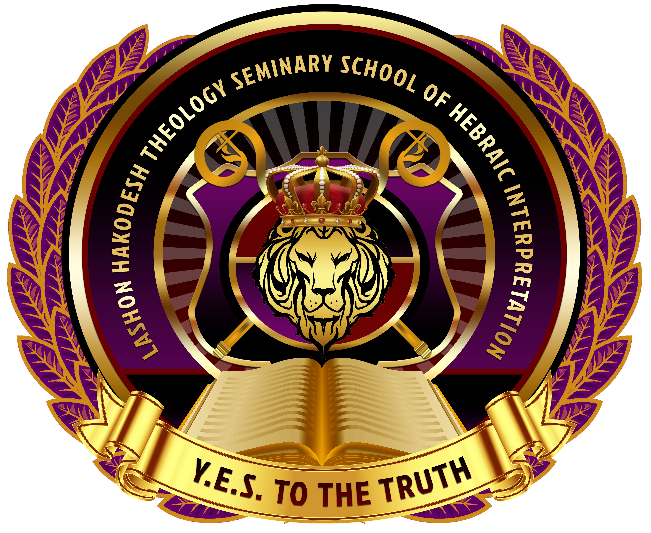

Lashon Hakodesh Theology Seminary School Of Hebraic Interpretation

DATE: ______________________________
SSN: ___________________ DATE OF BIRTH___________________________
NAME: ________________________________________________________________________
ADDRESS:___________________________________________________________________________
EMAIL ADDRESS:_________________________ _____________________________________
TELEPHONE: (______)________________________ CELL: (______)___________________________
DEGREE PROGRAM DESIRED: ____________________________________( See Classes Offered)
NAME OF CHURCH: __________________________________________________________________
PASTOR’S NAME: _______________________________________________________
PHONE NUMBER____________________________________
List Your Degree (If Applicable)________________________________ ____________________________
Name of University you earned the Degree___________________ _____________________________
YEAR TO DATE ATTENDED: FROM_________________________ TO: ____________________
If there is more data add an extra sheet also submit resume. Please bring official transcripts and Degrees.
Email: Aposltecqlee@gmail.com
Apostle Cequana Lee, Vice President/Registrar/ Instructor (409) 571-9102

MINISTRIES IN WHICH YOU HAVE ASSISTED PLEASE DESCRIBE YOUR ROLE
1. ________________________________________________________________________________________________________________________________________________________________________
2. __________________________________________________________________________________________________________________________________________________________________________
3. __________________________________________________________________________________________________________________________________________________________________________

MISC. INFORMATION:
______________________________________________________________________________________________________________________________________________________________________________________________________________________________________________________________________________________________________________________________________________________________________________________________________________________________________________________________________________________________________________________________

*THE INFORMATION REQUESTED IS OPTIONAL BUT NECESSARY TO COMPLETE YOUR APPLICATION.
(BBC)

Additional Information

$100 Non-Refundable Registration Fee For All Courses
$25.00 Application fee ( Summer Courses/application fees will go towards Tuition)

- By signing this application you agree not to forward or share any information given to you from the school concerning written assignments, curriculum , or syllabus.
- You are at liberty to share the cost of tuition, courses offered
- All students Participate in Graduation
- Payment plans offered
- Certificate programs Graduation fee is $50
- Masters , Doctoral, Bachelors ( Student will Purchase a robe and a ring)
- We consider previous work history and education, Masters, Bachelors, Doctoral,Bachelors
LaShon Hakodesh (The Holy Tongue)
(BBC)

