Connections

A monthly publication of Bethany Evangelical Lutheran Church – Axtell

What’s inside

Pastor Marcia pg 2

Opportunities to Worship pg 3

TEAMS Updates pg 4

Church Council

Meeting Minutes pg 5

Opportunities to Serve pg 6



Bethany Lutheran Church

903 25 Rd

Axtell, Ne 68924

308.743.2597

From the desk of Pastor Marcia

Spring! April is one of my favorite months. If we look closely we can see the subtle signs are there. Daffodils and crocuses are beginning to poke through, Some new birds are singing and of course the sandhill cranes have arrived. With some much anticipated rain the green will appear.

Of course, thoughts of spring also include our anticipation of Easter, the resurrection celebration of Christ. We continue our journey through Lent for a couple more weeks as we meet on Wednesdays and look at the Holy Word of God and the relevance the Bible has in our everyday lives. Our worship on Sunday mornings includes parables told by Jesus to remind us of the never-failing love of God.

Our Lenten journey for this year will again culminate with Holy Week and Easter Sunday!

We celebrate with our families- good food is shared-good fellowship enjoyed-hidden eggs searched for and found, and then…. Then, we once again begin the busyness of our lives. For many that includes the work of spring, preparing, planting and sowing. We go back to our vocations, our work of making a living.

As we go forth from Easter Sunday we are called once again for much more. You see, every day is a new “Easter.” A celebration in which we are free to live each day trusting in God through Christ, knowing that Jesus is the “the resurrection and the life” for us. All of us!

We go forth empowered by God’s Spirit living and active within us to live in the joy of the resurrection as “every day” witnesses. Just as the women at the empty tomb and the eleven disciples, we are “every day” witnesses and participants in the resurrection of Jesus. As believers baptized in the Holy Spirit, we have hope. We have the joy of the resurrection living in us. Also, like the women at the empty tomb and the eleven disciples, we have vocations or stations in life that God has given to us as gift. Each of these callings comes with a set of duties and responsibilities. We are called to share the “Good News!”

We are called to live our lives in such a way that others see God’s love for us and for all God’s children. Every day, in every way! Happy Spring and a Joyous Easter!

*In their fright the women bowed down with their faces to the ground, but the men said to them,*

*“Why do you look for the living among the dead?*

***6 He is not here; he has risen!***

*Remember how he told you, while he was still with you in Galilee: 7 ‘The Son of Man must be delivered over to the hands of sinners, be crucified and on the third day be raised again.’ ” 8 Then they remembered his words. Luke 24:5-8*

In the name of the Risen Christ,

Pastor Marcia

Opportunities for Worship and fellowship in April

Sunday Schedule

10:00 am Sunday School & Coffee Fellowship

10:45 am Worship with Holy Communion

**April 14 – Maundy Thursday**

Worship with Holy Communion at 7:00pm

**April 15 – Good Friday**

Community Worship at Trinity Lutheran Church in Axtell at 7:00pm

**April 16 – Easter Vigil - Holy Saturday**

A day of prayer and reflection

**April 17 – Easter Sunday**

Worship with Holy Communion at

10:45 am



Bethany’s Annual Rogation Worship Service

Sunday, April 24th!

As agriculture is an important part of our lives

we will praise God for his gifts

and ask for blessings for the seed, the soil

and all who labor in God’s creation

in agricultural vocations.

**Bethany Teams to Meet!**

**Sunday, April 3rd**

**After Worship all teams of Bethany will gather in the Fellowship hall.**

**Pizza, salad and cookies will be provided.**

**As we share our food members of individual teams will meet!**

**Please plan to attend!**

**Teams are the way we do God’s work at Bethany**

**Love God. Love People.**

.

**Faith Formation Team**

*Faith formation is the very way we form our faith.*

Members: Jackie Gregory*, Ann Overleese, Nicole Cederburg, Mandy Strolberg,

Patricia Youngmark, and Lois Thurber

**OutReach Team**

*Outreach is “reaching out” to members and others in meaningful and loving ways.*

Members: Shawn Soderquist*, Josh Jelden, Stephanie Cederburg, Bryan Danburg, Dudley Nelson, and Deeon Cederburg

**Worship & Music Team**

*Oversee aspects of worship that express our reverence and adoration of God.*

Members: Kendra Brown*, Jan Schneider, Travis Arner, Amy Behrhorst, and Clark Abrahamson

**Property Team**

*Oversee the upkeep and needs of our physical space that God*

*has gifted us so generously with.*

Members: Scott Nelson*, Blaine Jelden, Al Schneider, Tom Brown, Eric Nelson, Connor Strolberg, Josh Jelden, Brad Youngmark, Jon Abrahamson, and Wyatt Abrahamson.

**Stewardship Team**

*Supervising and taking care of what God has first given us*

*using our time, talents and tithes..*

Members: Kathy Abrahamson*, Matt Strolberg and Heidi Drew

**Thank you to the council representatives * and all members of**

**Bethany Teams for 2022 for their time and service to Bethany**

March Church Council Meeting Minutes

Opportunities to serve at Bethany in April

Volunteers needed!

Bethany is needing volunteers to handle the paper recycling form the church. If this interests you, please see Pastor Marcia. Thank you!

April Worship Servant List

Lectors: Connor/Logan Strolberg & Wyatt Abrahamson

Altar Committee: Dan & June Wiese & Lois Thurber

Ushers: Connor/Logan Strolberg & Wyatt Abrahamson

Acolytes: Connor Strolberg & Ashlynn Nelson

LaVon Abrahamson  
Joyce Almquist  
Rod Behrhorst  
Ron Bergstrom  
Beverly Carlson  
Bob Freeland  
Calvin Gleason  
Lanette Gleason  
Randy Lemmon  
Diana Moore  
Amy Nelson  
Marshall Poole  
Isaiah Sinachack  
  
Residents and Staff at Mosaic as well as Bethany Home



Bethany Circle

Sunday, April 3rd

6:30pm ~ Bethany Fellowship Hall

We would love to have you join us!

If you have questions, please reach out

to Amy Nelson (402) 224-0065



Community Bible Study

Monday, April 4th

4:00 pm - Fellowship Hall

We will be starting Session 4.

Contact Jeanie Poole for more information at 308-830-0927

***Spending Time in God’s Word***

Faith Formation is a life-long endeavor. Spending time in God’s Word through devotions or guided reading of the Bible are important ways we grow in our faith.

Here are some free online resources for you to explore. Also available quarterly are the printed devotionals “Christ in Our Home” in large print as well as the regular size.

. <https://www.luthersem.edu/godpause/>

<https://www.elca.org/Faith/DailyBible>



<https://cac.org/daily-meditations/>



https://www.womenoftheelca.org/blog/category/daily-grace



Our website: <https://bethanyaxtell.org/>

**Bethany Lutheran Church ELCA - Axtell, NE** @axtellbethanylutheranchurch

Connections… share your good news with Bethany!

Items for the newsletter are due to the church office by the third Monday of the Month. Please email an announcement to bethanyaxtell@gmail.com or provide a hard copy of your announcement to the church office. Submissions may be edited due to space available.

*We are only able to publish items of which we have been made aware of.*

**Would you like to see**

**Connections in COLOR?**

Visit: bethanyaxtell.org

To arrange for notification of the online

*Connections* newsletter, Please contact the

office at BethanyAxtell@gmail.com

Bethany

Contact

Information

Pastor Marcia Dorn

308-380-4256

Church Office Manager

Jessica Fulmer

Church Office

308-743-2597

Bethany Email

BethanyAxtell@gmail.com



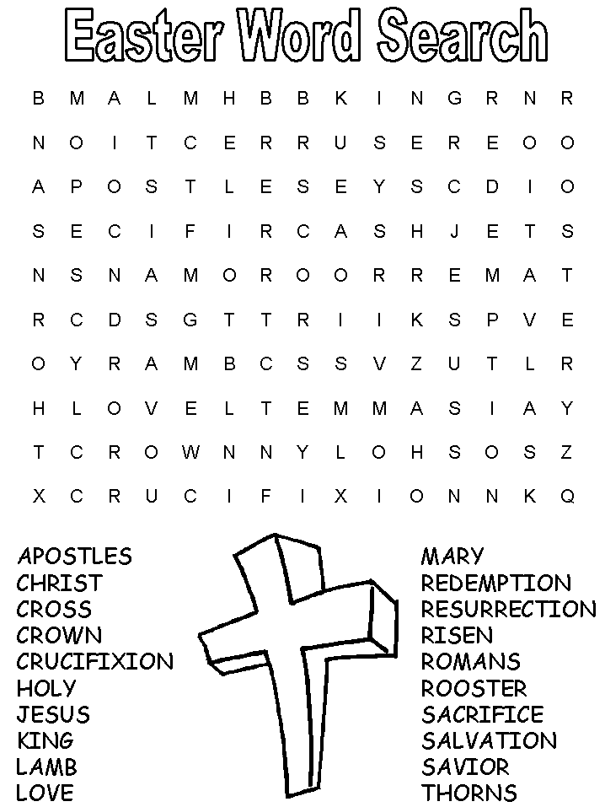

**April 14 – Maundy Thursday**

Worship with Holy Communion at 7:00pm

**April 15 – Good Friday**

Community Worship at Trinity Lutheran Church in Axtell at 7:00pm

**April 16 – Easter Vigil - Holy Saturday**

A day of prayer and reflection

**April 17 – Easter Sunday**

Worship with Holy Communion at

10:45 am

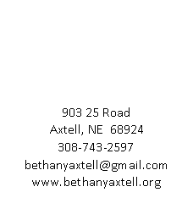

Non-Profit Organization

U.S. Postage

PAID

Permit Number 1

Axtell, NE 68924

*Address Service Requested*