Sunday November 4, 2018
Visitors, we encourage you to fill out the tear off portion of this bulletin and place it in the offering plate, so that we are able to minister to you and your family.
Members, please write any reminders for Scott or Derek, prayer requests to be added to prayer list, or any other info on the tear off portion of the bulletin.
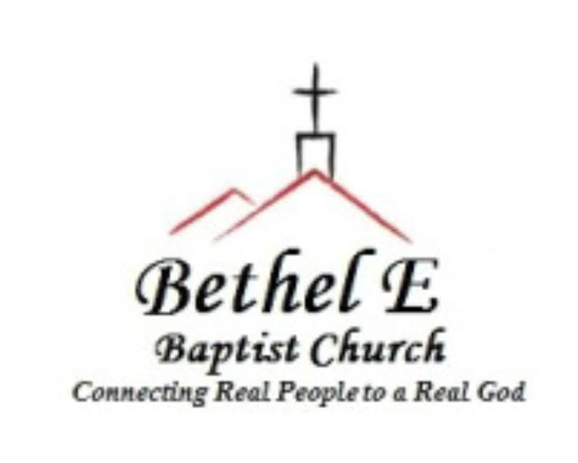
Sunday Schedule
10:00am Sunday School 11:00am Worship Service
Wednesday Schedule
ENCOUNTER Students & AWANA Kids 6:30pm/Adults 6:45pm

Church Website: bethelebaptist.org
Church Phone: (706) 283-7610

Senior Pastor: Scott Mize (706) 498-1888
scottmize@bethelebaptist.org
Youth Pastor: Derek Milton (229) 224-1582
derekmilton@bethelebaptist.org
Deacon of the Month: Clay Johnson (706) 296-3467
Chairman of Deacons: Robbie Childs (706) 988-9101

To our visitors: Welcome, we are glad you are here. We trust you will feel the presence of the Holy Spirit as you worship with us today. Please allow us to care for your small children in our nursery during the worship service. If you would
Winter Coat Drive
We will be collecting winter coats for Smokey Mt. Area Rescue Ministries. Jackets can be placed on the stage in the gym. Deadline is December 2.
like to know more about our church, please take a few moments and fill out the tear-off portion of this bulletin and drop it in the offering plate or hand it to the pastor as you leave. Bethel E is focused on "Connecting Real People to a Real God," so if you are looking for a church home, we would like to invite you to come connect with us.
Today’s Order of Worship
Opening Hymn
Welcome/Announcements
Opening Prayer
Hymns of Praise
Receiving of God’s Tithes & Offerings
Worship Songs
Sermon: A Life of Praise
Psalm 113

Nursery Workers:
This week: Patsy Johnson and Connie Garrett
Next week: Brandye Childs, Joan Jordan, Tina Mewborne
SALT & LIGHT
Join us on Wednesday nights at 6:45pm for adult bible study, prayer and outreach planning as we strive to be SALT & LIGHT to the world.
Thanksgiving Dinner – Thursday, November 15 at 6:00pm
Join us for a church-wide thanksgiving meal and fellowship. Please sign-up in the back if you plan to attend.
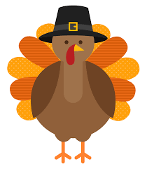
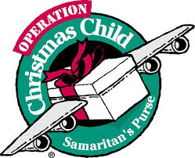
Operation Christmas Child
Boxes are due by November 18.
Celebration Sunday – Novemeber 18
We will be having a special service of praise. If you or your Sunday School class would like to do special music or responsive reading, please sign up in the back.
Backpack Program
We are collecting canned or nonperishable food items for our schools’ backpack programs. Contact Jessica Mobley or Bridgette Matthews for more info.
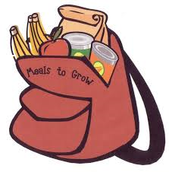
Baby Shower for Cory & Emily Parham
November 11 at 2:00-3:30pm

Youth Programs: Wednesdays 6:30 – 8pm

Fortnite Study: “Back to the Basics.”

Tuesdays @ Bojangles at 7am

Derek provides transportation from Bojangles to middle and high school.

SNL (Sunday Night Live) – November 11 at 6-9pm

Hosted by Andy and Patsy Johnson.

Operation Christmas Child Shoebox Sorting Facility Mission- December 12

Volunteering at the Atlanta sorting facility from 5-10pm. See Derek for more details.

Follow us on Instagram @encounter_student_ministries

November
Birthdays

2 – Jim Corder
4 – Teresa Williams
4 – Vera Carroll
5 – Joyce Suttles
9 – Mia Parham
15 – Aaron Corder
17 – Rachel Suttles
18 – Walker Layne
18 – Marc Albertson
20 – Bentz Johnson
21 – Jillian Johnson
21 – Joe Dye
22 – Paula Dye
25 – Sonya Corder
28 – Connie Garrett

November
Anniversaries

Upcoming Events:

November

2nd-4th – D-NOW Weekend

11th – Baby Shower for Emily
& Cory Parham

15th- Thanksgiving Dinner

18th – Celebration Sunday
(Thanksgiving)

18th- Operation Christmas
Child Shoeboxes Due

22nd – Thanksgiving Day

Be looking for upcoming events.

*If we have missed your
birthday, please let us know so we
can add it to our calendar.
*Please be in prayer for these upcoming events. If you have an event to be added, please let Scott or Tara know.

