Attendance and Offering

To Date: 9-30-18

Attendance SS-17 MW-31

Number on Roll 147

General Fund 1,190.00

Needed Weekly 2,042.88

Year to Date 82,682.20

Amount Needed 77,628.64

Building Fund 0

Memorial Fund 170.00

(John Willis)

Rev. Brown’s Office Hours: As needed 8 a.m.-9 p.m.

(Sunday-Friday)

203-650-1404 828-221-7900

A nursery is available in the Educational Building.

Portable hearing assistance devices are available in the Narthex.

Find us on Facebook at

facebook.com/gamewellumc
or gamewellumc.com
www.foothillscooperativeparish.com
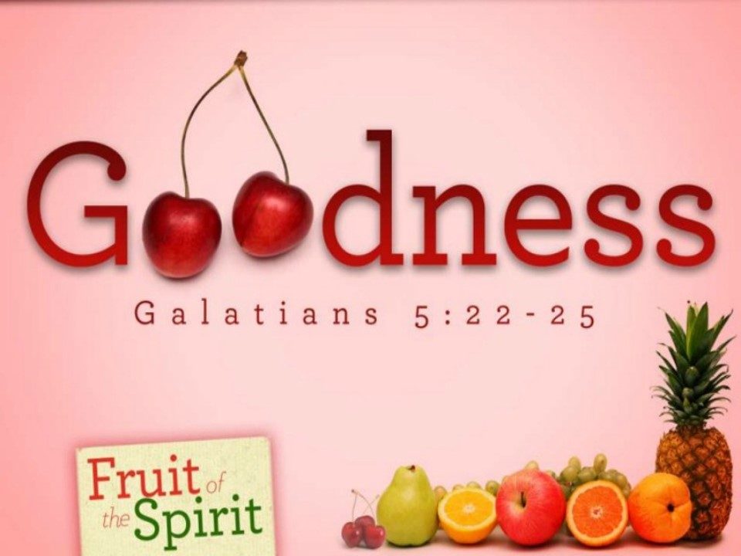
Happy Birthday!

Willie Frank Houck on Oct 7
Shirley Haas on Oct 8
Andie Longo on Oct. 10
Royce Coffey on Oct 11
Cole Staley on Oct 12
Linda Davis & Tracie Presnell on Oct 13

Serving in Today’s Worship

Acolyte- Katherine Mabe

Scripture Reader- Barbara Whittington

Responsive Reader- Kimberly Willis

Greeters- Barbara Presnell & Mary Ellen Kendall

Ushers- Wayne Cassavaugh & Clyde Whittington

Gamewell United Methodist Church

“Loving God and Each Other”

2897 Morganton Blvd. Lenoir, NC 28645

(828) 758-9805

Rev. Peter Brown, Pastor

203-650-1404

pbrown@wnccumc.net

Claricea Mitchell, DCYM

clmitchell@caldwellschools.com
Sunday School: 9:45 am Morning Worship: 11:00 am

2897 Morganton Blvd. Lenoir, NC 28645

(828) 758-9805

Rev. Peter Brown, Pastor

203-650-1404

pbrown@wnccumc.net

Claricea Mitchell, DCYM

clmitchell@caldwellschools.com
Sunday School: 9:45 am Morning Worship: 11:00 am

2897 Morganton Blvd. Lenoir, NC 28645

(828) 758-9805

Rev. Peter Brown, Pastor

203-650-1404

pbrown@wnccumc.net

Claricea Mitchell, DCYM

clmitchell@caldwellschools.com
Sunday School: 9:45 am Morning Worship: 11:00 am
Welcome  October 7th, 2018  Twentieth Sunday after Pentecost  *Entrance of the Light  *Hymn Blessed Assurance 369  *The Apostles’ Creed 881  *Passing of the Peace  Announcements  Joys and Concerns  Call to Prayer  Pastoral Prayer  The altar is open for those who would like to pray there.  Offertory  *Doxology  Responsive Reading Psalm 25: 1-10 756  Special Music  Scripture Galatians 5:22-23, 6: 1-10  Message “Good, Better, Best”  Pastor Peter  Holy Communion 12  *Hymn God is So Good 2056  *Benediction Awesome God 2040  *Please stand as you are able. |  |  | This Week’s Opportunities  Join Us as We Celebrate Willie Frank Houck’s 100th Birthday today at 3:00 p.m. at the GUMC Fellowship Hall! Help us celebrate by writing a short note of encouragement and well wishes that will be presented to him today!  Admin. Council will be on Tuesday, October 9 at 6:30 p.m.  Community Meal on Wednesday, October 10th at 6:00 p.m. at Whitnel UMC. Desserts are needed for anyone willing!  Choir Practice is on Wednesday, Oct. 10th at 5:30 p.m.  Peter’s Life Study will continue Thursday, Oct. 11th at 6:30 pm at the GUMC Parsonage. Everyone is invited to attend! If you are interested, please sign-up in the narthex.  Brotherhood of Christ will meet Saturday, October 13th at 8:00 a.m. Gamewell UMC.  Upcoming Opportunities  Blessing of the Animals is Sunday, October 14th from 3:00-4:00 p.m. at Whitnel UMC.  UMW will meet on Tuesday, October 16th at 6:00 p.m.  JOY Lunch Bunch will gather on Wednesday, October 17th at noon for fellowship and refreshments. All are welcome!  Trunk-or-Treat will be on Wednesday, October 31st from 6:00-8:00 p.m. If you are willing to help in the form of a trunk, kitchen help, parking lot, candy, or donations please sign-up in the narthex at your earliest convenience!  Mission Projects  Gamewell Fruit Loops: Don’t forget to bring canned fruit for Yokefellow! Donations can be left in the Fellowship Hall.  September/October Mission is Operation Christmas Child shoeboxes! It’s never too early to start collecting items for your shoeboxes! Be on the lookout for more information!

