537 Rountree
P.O. Box 26
Hillsboro, IL. 62049
217-532-3734

Hillsboro United Methodist Church

October/November 2019 Newsletter
Through Jesus, therefore, let us continually offer to God a sacrifice of praise—the fruit of lips that openly profess his name. And do not forget to do good and to share with others, for with such sacrifices God is pleased.
Hebrews 13:15-16
October 2019

Dear Friends,
It’s been a busy summer and I think we’re all ready to slow down and catch our breath before we head into the Thanksgiving and Christmas season. I want to continue to encourage you to make time for rest and renewal. It was so important to God that he included rest in the 10 Commandments.

There’s a great deal of excitement brewing with new Sunday morning classes beginning added. Carol Booher will be leading a study for women titled “The Kindness CHALLENGE”. And John Cooper will begin a new class in November. If you’re not currently attending a Sunday School class now is a good time to check out all that’s available. You’ll grow leaps and bounds in the small group setting.

You’re always welcome to join the Wednesday night Bible Study that meets in the Fellowship Hall at 6:00. We’re studying “Anxious for Nothing”.

Lots of other events are on the calendar that you won’t want to miss. Marty and Patty Niehaus are hosting an evening of Food and Fellowship at their home on Sunday, October 13th for the Good Shepherd Parish. Trunk or Treat will be held in the church parking lot on October 27th. This is a great opportunity to share the love of Jesus Christ with a number of guests of all ages.

Confirmation classes for the Parish will begin Sunday, September 29th and continue for 8 weeks. Will you please keep these students and their families in prayer?

December kicks off with the Walk to Bethlehem scheduled for Saturday and Sunday evening, December 7 & 8, 4:30 – 7. Leaders from every church in the parish have been working together to make this a huge outreach event.

I continue to look forward to spending more time in fellowship and service with each of you. Thank you for your selfless generosity and the assurance of your prayers for the church family. Your prayers for me are felt. My health continues to improve every day. I will continue to receive injections monthly for the next 6 months and if all goes well that will conclude the monthly treatments for Leukemia.
You are often in my thoughts and always in my prayers.
Pastor Mike



Fun
Food
Fellowship
By the fire

The Good Shepherd Parish is invited to an evening around a campfire at Marty and Patty Niehaus’ on Sunday, October 13th. Grilled pork patties, hot dogs for roasting, buns, marshmallows, smores, and beverages will be provided. Those joining us are encouraged to bring lawn chairs and finger foods. The activities will begin at 5:30pm at 106 Lakecrest Lane, near the east side of Lake Hillsboro. Call or ask for directions if necessary, our numbers are 217-532-3197 or 217-246-5478. Besides visiting around the campfire, you’re welcome to fish in our pond (bring your own gear), play cornhole, volleyball, or take a walk in the woods, etc. Please come join in our fun and fellowship, with a side of food.

October 8, 1977 Pastor Mike & Nelma Lawton
October 10, 1985 Brett & Kathy Reynolds
October 20, 1979 Doug & Brenda Byers
October 20, 1979 Jerry & Tami Moler
October 21, 2000 Brett & Michelle Brown
October 21, 2006 Chad & Amber Kalaher
October 22, 2005 Luke & Mindi Armbruster
October 25, 2014 Adam & Megan Beeler
October 25, 2014 Chris & Sherri Gutierrez
October 00, 2016 Kaleb & Nikki Northcutt
November 2, 1968 Dick & Judy James
November 11, 1978 John & Susie Galer
November 11, 0000 Tyler & Jamie Cooper
November 30, 2002 John & Peggy Cooper

Anniversaries:

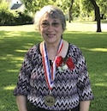
Betty Rhodes would like to extend a special “Thank You” to her Church family in selecting her to represent the church as a part of the Hillsboro Old Settlers 2019 Honor Society. Betty stated “it has been a great experience and honor to be a part of the 2019 Honor Society.” Congratulations Betty on your selection to this year’s Honor Society!

College Boxes: We will be sending care packages to the following college student:
Alana Bader, Washington University, 6985 Snow Way Dr., MSC 7365, St. Louis, MO. 63130; Macey Eddington, SIU-E, Box 6128, 74 Circle Dr, Edwardsville, IL. 62025; Reba Morrison, Missouri State; Nikki Northcutt, Lewis & Clark;
Broke Roemelin, SIU-E, 2 Campus Edge Dr, Apt. 301, Edwardsville, IL. 62025; and Erica Wood, Blackburn, 700 College Ave., Box 637, Carlinville, IL. 62626.

Dr. David Becker of Emmaus Road Ministries, writes to let us know their trip to the States was a very positive one and thanked us for our continued support to their ministry. As they met old friends in Texas and made new friends, their trip through the Midwest strengthened ties and opened doors for new ones to develop. While their goals of getting together with supporters, and building up their support was only partially met due to time constraints, Dr Becker asked for prayer for this need to be met. Also, the meeting Dr Becker had scheduled with the Chaplin’s of the armed services of Zambia did not happen “due to austerity measures put in place by the government.” Presently they are working to find a way to work around this issue. Finally, Annie and David were featured on a local radio program, “How we met.” This was on a Radio Christian Voice and they said the response was so overwhelming that they are going to do a repeat broadcast.
Thank you, again, and we pray for you and for your walk with God. Be blessed and go, be a blessing. Follow us on Facebook at “Emmaus Road Ministries, Inc.”
Have you noticed the new sign outside? What a great improvement and new tool for our church to have. We can display the worship and love we have for our Saviour in so many different ways. We now can show our open invitations to come in and worship, pray, and learn with us 24 hours a day, 7 days a week. NO more just one short verse.
Thanks to God and to our great Church family!
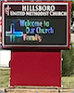


Wednesday, October 16th : 6:00pm – 8:00pm on Sawyer field, free food, guest speakers, games, and a live band!
Students from Hillsboro will be joining thousands of other youths on athletic fields all across the nation to share their Christian faith with fellow students during the 16th annual national Field of Faith event. This event is for EVERYONE!! You will not want to miss this year’s guest speaker. Also, Pursuit band from Greenville University will be there! Free meal at 6:00pm with service starting @ 6:30pm

Trunk or Treat
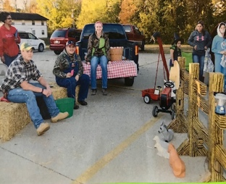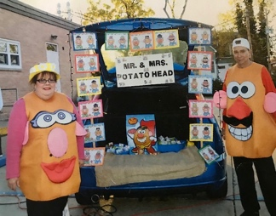
October 27th from 5:30pm to 7:30pm will be our annual Trunk or Treat. We will need donations of hot dogs, buns, individual bags of chips. popcorn, individual bags of candy, hot chocolate, and bottled water. We will also need kitchen workers and trunk decorators. There are sign-up sheets at the welcome center or you may also call Chris in the office from 9am-1pm, Monday – Friday @ 217-532-3734.

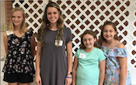2019 Confirmation Class started September 29th after worship with the following students from l-r; Kaycee Nave, Emilee Roemelin, Amber Carroll, and Kinsley Trader. There is still time to honor your invitation.
Preschool Pulled Pork Fundraiser
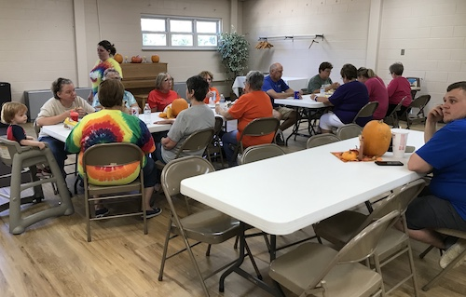The Preschool Pulled Pork Fundraiser was an awesome success. Thank You to all those that volunteered or donated. A Special “Thanks” to John Cooper for smoking the Pork. We Praise and Thank God for such an awesome Church Family.

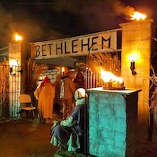
The Walk in Bethlehem is fast approaching and the following items are needed: 6 rolls of black plastic, 9 rolls of clear packing tape, 2 packs of tick/tack poster mounting, 8 – 10 packages of various size command strips, White Christmas light stands, 4 bamboo tiki torches, spray paint 1 can of each color yellow, white, blue, red, green, and gold, fake fruit olives bread cheese, tropical plants (will be returned), 30lbs hamburger, 10-15 packages of frozen vegetables, beef broth, barley, large material, curtains or sheets with old patterns, and cash donations. If you have any questions contact Kyle Furness or attend the next meeting October 3rd @ 6:00pm @ the Hillsboro United Methodist Church.

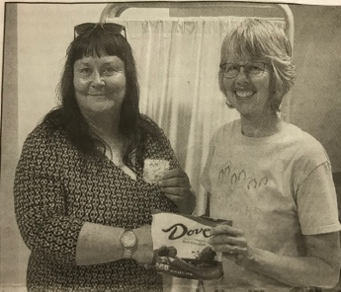Hillsboro United Methodist Church Member, Dr. Denise Bader was voted the Best Table Topics speaker after she had to give an impromptu speech of one to two minutes at The County Toastmasters Club meeting Aug 1st. After she unwrapped a Dove chocolate bar she had to read the saying inside and speak about that subject. Her topic was “There’s Always Time for Love.” What a great Christian Subject, while we all know John 3:16 we should remember what Mark wrote in Mark 12:33 – And to love him with all the heart, and with all the understanding, and with all the soul, and with all the strength, and to love his neighbor as himself, is more than all whole burnt offerings and sacrifices.

Praise God for the following joys received:
Susie McPhail’s great grandson, Nate, is home but still needs our prayers.
Cooper Duff, Nancy & Don Harrell’s great grandson and Chris and Sherri Gutierrez’s great nephew had successful leg surgery after a motorcycle accident. Cooper is now in a walking boot and doing well.
Sherri and Chris Gutierrez’s granddaughter, Isabella, had successful ear surgery in August.
Bev Burton is blessed to have such a loving church family and thanks everyone for their calls to help her get to Springfield to see her Cardiologist. All of Bev’s test have been good.
Fred Blevins had a very successful quadruple heart by-pass with friends and family there. Praise and Thank God for the doctors and nurses that took care of him.
Irene Graden had asked for prayers for her hometown pastor in Ohlman, Pastor Steve Nance, who suffered a heart attack. The doctors put in a few stints and thanks to our awesome God, Pastor Nance is doing well.
Laura Sturm praised God for learning that her grandchildren in South Carolina are all safe after Hurricane Dorian had struck their area. Laura also thanked God for keeping her granddaughter, Christina, safe after a typhoon struck Tokyo, Japan where she lives.
Sandy Morrison would like to thank everyone that sent Reba cards and/or a care package while she has been in ATI. Reba will graduate from Military Police School on 10/24/2019. Congratulations Reba!
Tommy Stokes can’t thank his church family enough for the graduation lunch and cards/gifts he received.
Lori Bergbower praised God and thanked everyone for praying for her Aunt Carol, who has made a full recovery.
Martha Long enjoyed the company of her church family at Olive Garden on September 22^{nd.}
As we praise God for joys, we graciously ask him to hear our prayer request and lift us up:
Please keep Lori Berbower’s son, Gabe, in your prayers.
Mary Herschelman and Susie Galer have requested prayer for a Casey’s employee named Dana.
Fred Blevins ask us to keep his sister, Sharon, and nieces, Jamie and Stephanie all in prayer, as they all have a rare disease that is medically difficult to treat.
Michelle Brown ask for prayers for Cheyene Fry, the preschool high school helper for the last 2 years, who lost her dad, August 10th.
Peggy Cooper ask for prayer for 12 y/o Isabella Flynn who has neurofibromatosis, an incurable cancer.
Please keep the Steve Cullison family in prayer after the loss of Steve’s mother, Loretta.
Wally Siltman ask for prayers for a friend that has breast cancer.
Wally also ask for prayer for his grandson whom is getting deployed.
Jerry Moler ask for prayers for his brother, Mike, who unexpectedly loss his wife, Laura, August 23rd.
Sandy Morrison ask for prayer for her son-in-law Kaleb, who just found out his dad has lung cancer.
Tina Furness ask for prayers for her Aunt’s family, Beaulah McLaughlin, her dad’s sister, whom passed in August. Tina also ask for prayers for Lahys Altenberger who has found out she has breast cancer.
Patty Niehaus ask that we keep Donna Springer in prayer as her COPD has worsened.
Patsy Bourdomis ask for prayers for Nick as he battles kidney stones.
Janice Galer needs continued prayer after her eye surgery.
Pat Siltman ask for prayers for Joyce Lipe, whose cancer has returned.
Laura Sturm ask for prayers for the family of Al Schumacher whom passed September 19th.
Please keep the family of Jim Summer in prayer as he lost his battle with cancer.
Please keep the family of Mary Chesser in prayer as she succumbed to her injuries, and continue praying for Pastor Randy Sands, the Free Methodist Church, and the Hillsboro Police Department as they move forward from the tragic events they were involved in. Also pray for Dave Chesser as he faces the repercussions from what he did and pray he repents for his actions.
Laura Sturm ask for prayers for Martha Long who is in Memorial Hospital Room 210 bed 2 for test.
Please keep those in prayer that remain silent or that we may have accidently omitted.
October
Sunday Monday Tuesday Wednesday Thursday Friday Saturday
 |  | 1 | 2  BIBLE STUDY 6PM | 3  Morgan Lovelace | 4  Linda Hamm | 5  Tina Furness
6  Audrey Holcomb  Communion  & World Communion Day | 7  Steven Sturm  Nurture Group 10am | 8  Eric Trader  Gianni’s Preschool Fundraiser | 9  BIBLE STUDY 6PM | 10  Anne McLaughlin | 11  Austin Furness | 12
13  Leland Armbruster | 14  Tami Moler   | 15 | 16  BIBLE STUDY 6PM | 17  Pastor Mike Lawton | 18 | 19
20 | 21  Carl Miller | 22  Roy Sturm | 23 | 24 | 25 | 26
27  Ben Frazier | 28  Raelyn Brown  Greg Matthews | 29  Melissa Trader | 30 | 31    Halloween

Ushers: Steve Cullison, Gary Satterlee, Brett Reynolds, Robb Hamm
Lay Leaders: Chris Gutierrez, Carol Booher, Janet Ward, Peggy Cooper
Nursery: Nikki Northcutt, Susie Galer, Anne McLaughlin, Susie Galer

November

Sunday Monday Tuesday Wednesday Thursday Friday Saturday
 |  |  |  |  | 1 | 2
3  Joan Luttman | 4 | 5 | 6  Doug Galer  Kayli Ward  Jacob Province | 7 | 8 | 9
10 | 11  John Galer  Jennifer Whitlock | 12 | 13 | 14  Patsy Bourdoumis | 15  Jane Spencer | 16
17 | 18 | 19  Ron Deabendefer  John Downs  Karen Wayne | 20 | 21  Dick James  Killian kay Kimbro | 22  Melissa Wood | 23
24 | 25 | 26 | 27  Sandy Morrison | 28  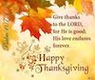 | 29  Keith McLaughlin | 30  Owen File
Ushers: Dave Ball, Roger Reeves, Steve Ernst, Volunteer Needed
Lay Leaders: Melissa Wood, Chris Gutierrez, Carol Booher, Melissa Wood
Nursery: Ruth Ernst, Kathy Reynolds, Peggy Cooper, Mary Herschelman
Thank You to all the Volunteers, for all you have done!!!

Missed Sunday Worship? Did you know if you miss a Sunday Worship or want to hear the message again you can visit HillsboroUMChurch.org/sermons.

