Emotional Intelligence Training for Pastors and Staff
led by Phil Reynolds
March 24th from 9:00 - 3:00
FaithPointe Baptist Church, Norman

About Emotional Intelligence

Emotional Intelligence Is...
“Emotional intelligence is your ability to recognize and understand emotions in yourself and others, and your ability to use this awareness to manage your behavior and relationships.”
Drs. Travis Bradberry and Jean Greaves

Emotional Intelligence Is the Other Kind of Smart.

When emotional intelligence first appeared to the masses in 1995, it served as the missing link in a peculiar finding: people with average IQs outperform those with the highest IQs 70% of the time. This anomaly threw a massive wrench into what many people had always assumed was the sole source of success—IQ. Decades of research now point to emotional intelligence as the critical factor that sets star performers apart from the rest of the pack.

Emotional intelligence is the “something” in each of us that is a bit intangible. It affects how we manage behavior, navigate social complexities, and make personal decisions that achieve positive results. Emotional intelligence is made up of four core skills that pair up under two primary competencies: personal competence and social competence.

Objectives and Outcomes
- Gain insight into emotional intelligence, what it is and how you can use it.
- Develop your understanding of Daniel Goleman’s framework for EI and workplace application.
- Build your awareness and regulation skills.
- Assess your emotional intelligence on the four EI dimensions.
- Recognized emotions in others and how to respond to those emotions in order to inspire high performance.
- Take an Emotional Intelligent Appraisal to gain a better understanding of your current Emotional Intelligence skills.
- Implement a personal plan for strengthening your emotional intelligence as a leader.

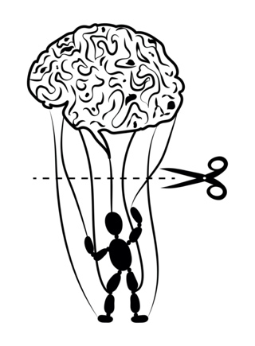
Are you a puppet to your emotions?

