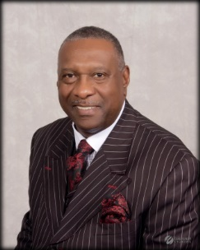

SERIES: A DECEMBER TO REMEMBER
HOLLYWOOD BAPTIST CHURCH
EDWIN W. SCOTT, PASTOR
DECEMBER 24, 2017

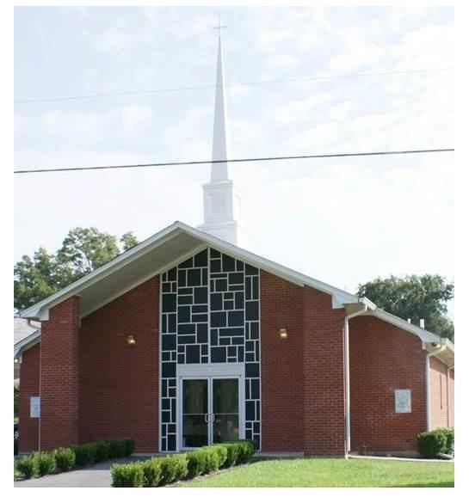
TEXT: MATTHEW 2: 1-2; 9-12

1 Now when Jesus was born in Bethlehem of Judaea in the days of Herod the king, behold, there came wise men from the east to Jerusalem, 2 Saying, Where is he that is born King of the Jews? for we have seen his star in the east, and are come to worship him. 9 When they had heard the king, they departed; and, lo, the star, which they saw in the east, went before them, till it came and stood over where the young child was. 10 When they saw the star, they rejoiced with exceeding great joy. 11 And when they were come into the house, they saw the young child with Mary his mother, and fell down, and worshipped him: and when they had opened their treasures, they presented unto him gifts; gold, and frankincense, and myrrh. 12 And being warned of God in a dream that they should not return to Herod, they departed into their own country another way.

WHY DID YOU REALLY COME?

In outlining these first twelve verses, we see:

- Wise Men Watched for the Messiah
- Wise Men Worshiped the Messiah
- Wise Men Warned through a Message.

INTRO.

In this passage we see where the wise Men or the magi came to Bethlehem seeking the promised Messiah. In seeking Jesus they encountered a a stumbling block in the person of King Herod who wanted to do harm to the baby child, in spite of the evilness that stood in their path they came to worship Jesus . The question for you and I today is why did you really come?

When we come to worship Jesus we will discover these things.

- I came to worship my Savior _______________________________________.
v. 1.“Now when Jesus was born in Bethlehem of Judaea in the days of Herod the king, behold, there came wise men from the east to Jerusalem, 2. Saying, Where is he that is born King of the Jews? for we have seen his star in the east, and are come to worship him.

2. I came to worship my Savior ________________________________________.
v. 9. “When they had heard the king, they departed; and, lo, the star, which they saw in the east, went before them, till it came and stood over where the young child was. 10. When they saw the star, they rejoiced with exceeding great joy. 11. “And when they were come into the house, they saw the young child with Mary his mother, and fell down, and worshipped him: and when they had opened their treasures, they presented unto him gifts; gold, and frankincense, and myrrh.”

3. I came to worship my Savior ________________________________________.
V 12 “And being warned of God in a dream that they should not return to Herod, they departed into their own country another way.”

