CHRIST LUTHERAN CHURCH

The eChronicle

FAMILY BINGO NIGHT
Saturday, April 18th at 5:30pm. Food, Prizes and FUN for the whole family. $5.00 donation. Bring a friend

ANNUAL YARD SALE
Saturday, May 9th between 9am and 4pm. Come in and browse and buy something for the amazing price of $1.

MOTHERS’ DAY BREAKFAST
Sunday May 10th at 8:30am. Special “Mother’s Day Breakfast” honoring the women of our congregation. The men of the congregation will show their appreciation by preparing a wonderful breakfast. Volunteers needed to cook and clean. Please see Pastor Bob to volunteer.

April 2015
INSIDE THIS ISSUE…

- Upcoming Events
- Our First Communion Class
- Farewell and Godspeed for Annie Pasqua
- Pastor’s Reflections
- President’s Page
- Committee News
- Little Sprouts Pre-School
- Contact us
UPCOMING EVENTS…join us

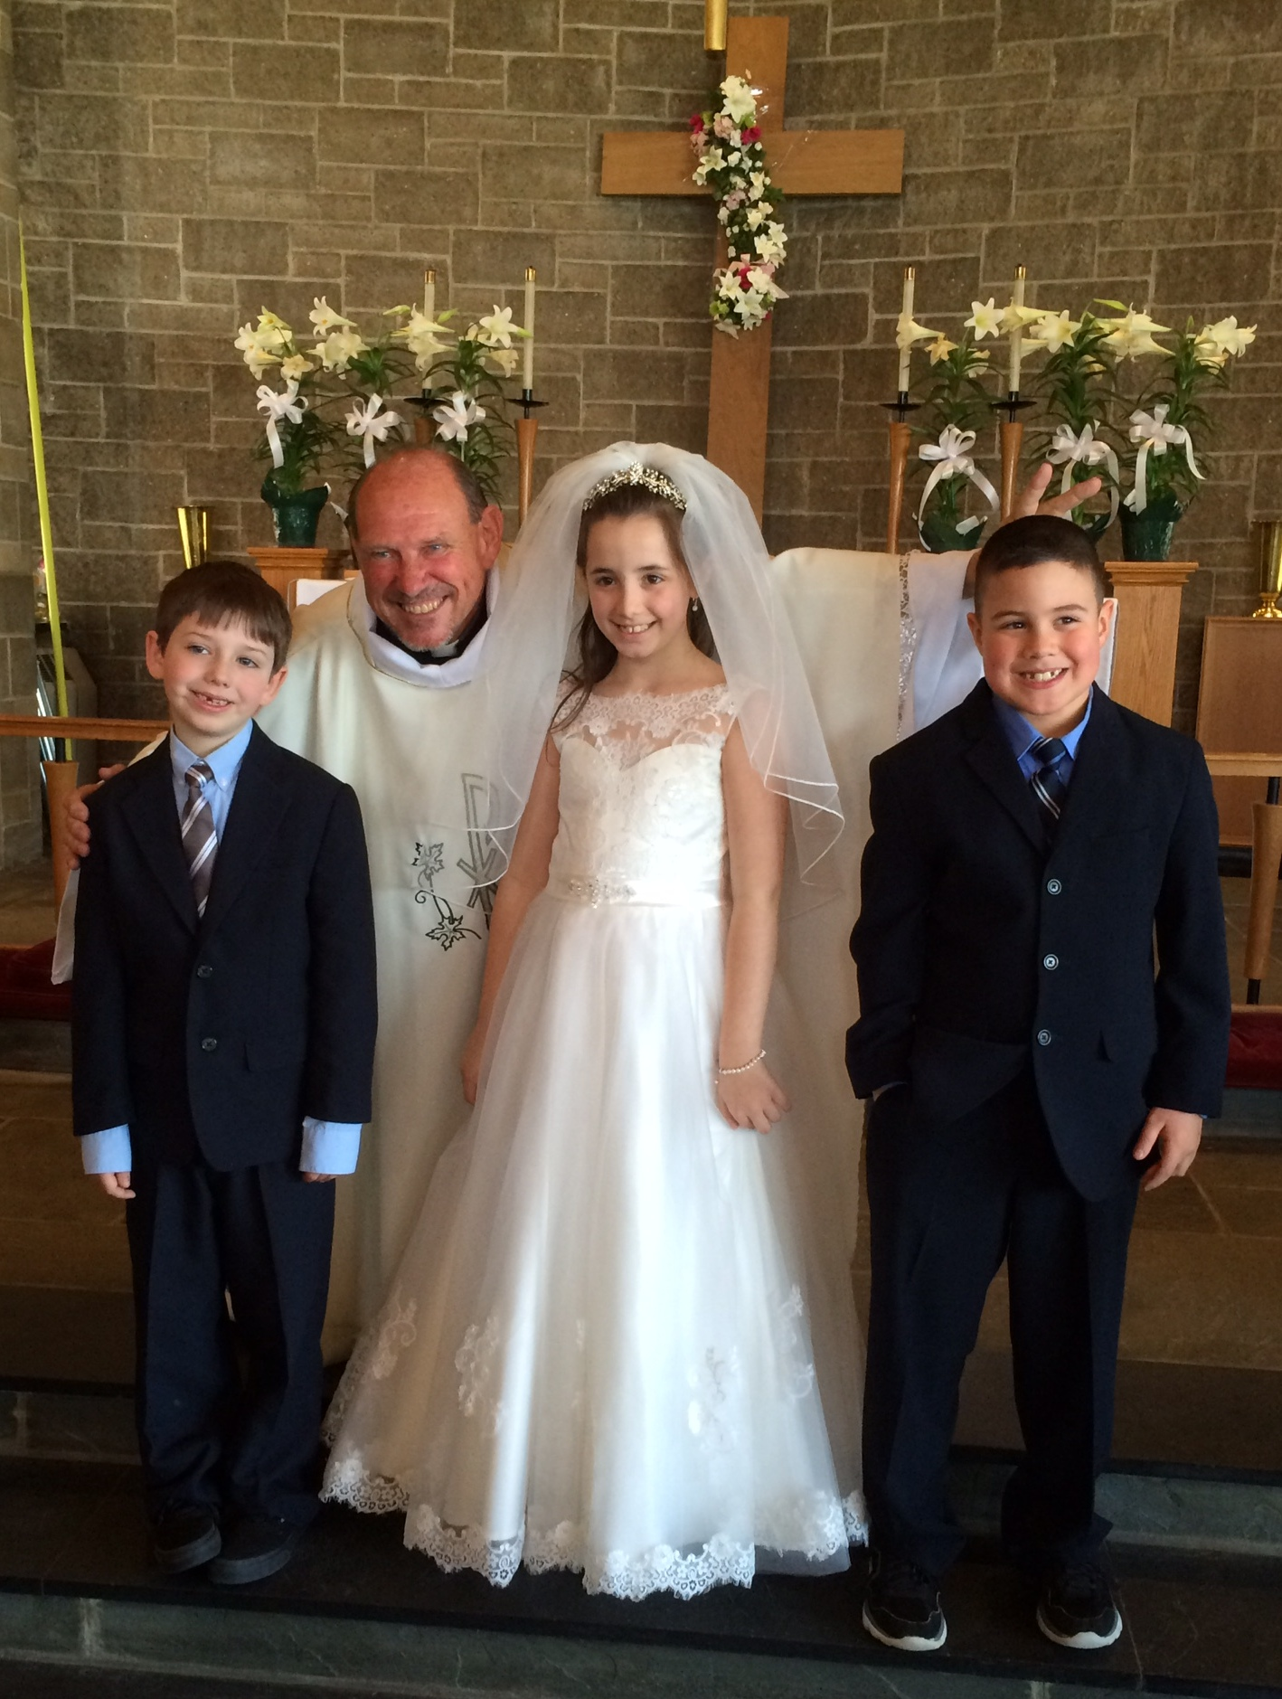
CONGRATULATIONS TO OUR FIRST COMMUNION CLASS OF 2015

- 
On April 12th, Cole Cella, Ava Palazzo and Christopher Luce (l to r) received the Sacrament of Holy Communion for the first time. It was a beautiful service attended by many family members and friends. As Cole, Ava and Christopher come to the Lord’s Table they will continue to celebrate this precious gift of bread and wine with the whole people of God in Christ Jesus. Congratulations and blessings on these three young people.


FAREWELL AND GODSPEED TO ANNIE PASQUA
After 12 glorious years as our Music Director, Annie Pasqua will be leaving us. She has been an absolute joy to our ministry during her time with us. Her talent and her spirit will certainly be missed, but we wish her well as she pursues other interests. Her last Sunday with us will be April 26th. We will have a special service of Farewell and Godspeed on that day and a reception in her honor following worship. We give thanks and praise to God for sending Annie to us and for being such a vital part of our ministry for the past 12 years.

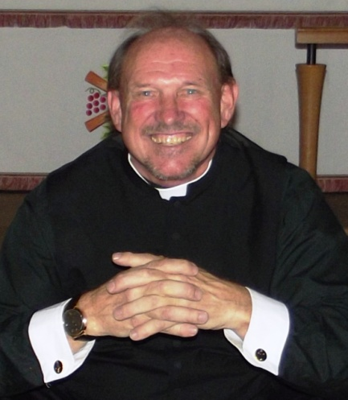
REFLECTIONS FROM PASTOR BOB

My Dear Sisters and Brothers in Christ –

Easter is such a special time of the year. It is a time of renewal and a time of hope. As nature renews herself from the doldrums and darkness of winter we too renew our faith, rejoicing in the news of the risen Christ. In Christ we have hope.

The first Easter wasn’t like that though. The followers of Jesus lived in deep despair, grieving the loss of their beloved friend and leader. Once filled with the hope of the Messiah, now they languished in hopelessness. Until…

…Until Mary encountered Jesus outside the empty tomb. One word “Mary” revealed the risen Christ to her. That one word wiped away her tears and restored her hope. She ran and told the disciples what had happened but they didn’t believe her. It wasn’t until Jesus appeared to them as they were cowering in a locked room. Again it was words from Jesus – “Peace be with you” – that restored their hope. Of course Thomas wasn’t there and so he too doubted, as Mary and the other disciples did before him. But Jesus appears to Thomas, greeting him with the same words “Peace be with you”. Immediately Thomas’ heart is filled with joy and hope.
That’s how it is with Jesus. He gives us hope – 24/7 365 days a year. When we doubt…turn to Jesus for hope. When we are sorrowful…turn to Jesus for hope. When our suffering seems unbearable and our lives seem empty…turn to Jesus for hope.

The resurrection is the fulfillment of God’s promise to always be with us. God, who gave His Son for us will never desert us. God who gave His Son for us will always hold us closely in His comforting arms. When we truly believe this we become the true people of the covenant. Let Christ into your lives and experience unquenchable joy. Let God into your life and live a life of hope knowing that whatever problems life brings to your door, God will wipe away

Easter blessings,
Pastor Bob

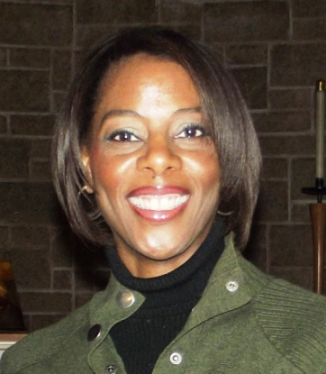
PRESIDENT’S PAGE

Inspired by Romans 12:5, each one of us is unique with respect to our gifts and talents and how we have used our gifts to uplift one another and the church as a whole. I would like to thank each and every one of you for sharing your gifts whether it is through your generosity, service or whatever your contribution is. The “life” of the church is bustling and thriving through the work of our committees and ministries. We are known to be a very generous and giving congregation, graciously donating goods and money for various initiatives. Now we are turning that generosity to ourselves with the outpouring support for the $1 weekly of “extra giving”. I encourage you all to continue to use your gifts and talents as you see fit and may we continue to lift up one another.

In Christ,
Angela Tigner, President
Church Council

Sunday School
The children continue to study the Old Testament. We spent a great deal of time learning about the legacy of Moses and the Ten Commandments. We have now started studying the legacy of Joshua. The children continue to be enthusiastic about their learning and are very much engaged in the process. One of the main goals is for the children to learn how to apply the principles from the Bible and the Bible stories to their own lives. These themes usually involve trusting in God, prayer and forgiveness. . We introduced the children to the Bible by reading the text in Exodus of the Ten Commandments and are continuing to incorporate Bible reading by the children into the Sunday School curriculum. We look forward to continue chronicling the Old Testament and our wonderful fellowship.

God bless,
Angela Tigner,
Sunday School Teacher

COMMITTEE NEWS

Helping Hands Ministry – Our Helping Hands Ministry is currently making lap blankets, baby blankets and prayer shawls to be distributed to those in need. All our prayer shawls come with a written prayer and blessings from our congregation. We are always looking for new members. Speak with Susan Carentz if you are interested in joining this ministry.

Buildings and Grounds Committee - We are continuing to maintain the church property. We have engaged a new landscaper and will be putting new floors in the Epiphany Room and the Classrooms. We are are also planning to put new windows throughout the buildings. We are always looking for new members.

Business and Finance Committee – We are looking for Tellers. Please see Harry Taylor if you are interested.

Fellowship Committee – We are looking for people to volunteer as Sunday Morning Fellowship Hosts. Please see Gina Hahn if you are interested.

Hospitality Team – We continue to welcome visitors and send cards to members for all occasions.
Parish Education - Our Bible Study group meets on Thursday Evenings at 7pm. We are looking at the Gospel text for the upcoming Sunday. All are invited. Karina and Khaya Sokol are continuing with their confirmation studies. They have completed the 10 Commandments and are working on the Lord’s Prayer.

Publications Committee - We are continuing to enhance our eChronicle and our website. We are also preparing a new brochure for our Outreach Ministry

Scholarship Board - Our previous Scholarship Fund has been exhausted and our Scholarship Board members Lori Luce, Barbara Place and Harry Taylor have crafted new guidelines for the management of the new fund. In the past month we have received several very generous donations. We encourage you to continue to donate to the fund - It is a wonderful way to help our youth with the ever growing expenses of a college education. If you wish to contribute to the fund, simply put your donation in a pew envelope and place it in the offering plate and mark it “Scholarship fund”. Please watch for announcements on how and when to apply for a scholarship,

Worship and Music Committee - Anyone interested in serving during worship please see Bob Stuhmer (lectors), Dick Hahn (ushers), Dorothy Pineman (acolytes) or Pastor Bob (assisting ministers).


LITTLE SPROUTS PRE SCHOOL
Spring has finally sprung and I'm not sure who's happier- - the children who can finally play outside or the teachers who have been stuck inside with the children the past few months! Hard to believe but we are fast approaching the final stretch of the school year. Teachers are already busy planning for our Mother's Day tea and moving up ceremonies for May and June. Dads and Donuts will be held in late April this year. Lots to do before school officially ends! Registration is currently underway for next school year. If you or anyone you know is looking for a great preschool experience, please send them our way. Camp registration is also underway and almost completely full. Should be a fun filled summer for all children attending.
See You in Class,
Emily Cella, Pre School Director
CHRIST LUTHERAN CHURCH
300 Hillside Drive South, New Hyde Park, NY 11040
Office: 516-746-4889 FAX: 516-739-5744
Email: christchurchnhp@optonline.net
Website: christchurchnhp.org
Office Hours Mon – Fri 9am to 3pm
Sunday worship and Sunday School 9:30am
The Reverend Robert Cederstrom, Sr. Pastor (cell 631-672-1858)
Ms. Emily Cella, Pre-School Director
Ms. Lynore Keating, Admin Assistant

