*Please stand if you are able.
Brief announcements (church and community happenings, etc.)

Prelude

Call to Worship
Leader: May those who love your salvation say continually, “Great is the Lord!”
People: Yea, our heart is glad in God, because we trust in God’s holy name.
Leader: Let us make a joyful noise to God with songs of praise!
People: We praise you, O God; we acknowledge you to be the Lord.

Opening Prayer
Most merciful Father, send your heavenly blessings upon this your Church, that all its members may dwell together in unity and love. Keep far from us all self-will and discord. Endue your pastors with righteousness, and enable them faithfully to fulfill their ministry, to bring again the outcasts, and to seek the lost. And grant to us so to receive their ministrations, and to use your means of grace, that in all our words and deeds we may seek your glory and the advancement of your kingdom; through Jesus Christ our Lord. Amen

*Hymn Great is thy faithfulness 140

*Gloria Patri 71
*Affirmation of Faith 881
Sanctuary The Faith We Sing 2164
Tithes & Offerings/*The Doxology 95
Offertory
Children’s Time
Joys and Concerns (including signs of God's love in our daily life)
Pastoral Prayer

Proclamation and Response
Scripture 1 John 4:7-20
Hymn Hymn of Promise 707
Message “The task before us”
*Closing Hymn Victory in Jesus 370
Passing of the Peace
 | Upcoming Events
Today | We are taking donations for Maggie’s Kids. Please place in the blue basket in the sanctuary. Please write checks to VUMC with Maggie’s Kids on the memo line.  1:00 pm Youth Group picnic
July 11 | 7:00 pm Worship Meeting
July 9-13 | Maggie’s Kids Camp  Please tell you friends and family and see if they would like to help out as well. If you have any questions, let me know! Dottie
July 14 | Chicken BBQ – 4:30 pm til sold out
July 18 | 6:30 pm Finance Meeting  7:15 pm Church Council Meeting
July 19 | 7:00 pm SPPRC Meeting
July 22 | Redwings game with Fellowship Committee
July 28 | Family Promise Bed Race
August 1 | 11:30 am Lunch Bunch
August 5 | Picnic @ Gavin’s with Fellowship Committee
Aug. 6-10 | Vacation Bible School

Bishop Mark J. Webb
District Superintendent Rev. Vonda Fossitt
Pastor Ben Lalka
(518)779-5991
pastorbenlalka@gmail.com
Office hours: Mon. – Thurs. 9am – 2pm

Victor United Methodist Church
July Lectionary Calendar
July 8
7th Sunday after Pentecost
2 Samuel 5:1-5, 9-10
Psalm 48
2 Corinthians 12:2-10
Mark 6:1-13
July 15
8th Sunday after Pentecost
2 Samuel 6:1-5, 12b-19
Psalm 24
Ephesians 1:3-14
Mark 6:14-29
July 22
9th Sunday after Pentecost
2 Samuel 7:1-14a
Psalm 89:20-37
Ephesians 2:11-22
Mark 6:30-34,53-56

http://www.umcdiscipleship.org
Join Pastor Lalka to prepare our hearts and minds for worship. Meet Wednesday mornings at 10am. Come as you are, come when you can, join the Lectionary Bible Study in the church office or from your home in prayerful preparation.

Please feel free to use this space below to write notes from the Sermon

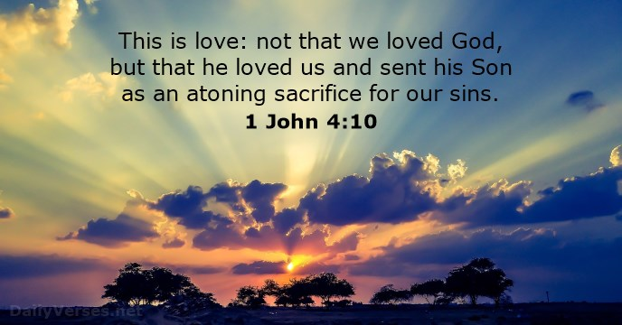

Victor United Methodist Church

Pastor Ben Lalka

July 8, 2018

