Sunday School Lesson for Younger Children
February 6, 2022

Scripture: Luke 5:1-11

Background information: We are still in the season of Epiphany. We have seen shimmering glimpses of the abundance of the Kingdom of God. Have we seen the star that the Wise Men did and follow it? Did we lead someone else to the gift of faith? Or did someone else lead me to that gift? Wherever we are on our path, it now is our turn to take the light of the Jesus—the really Good News—out in our own communities and share our faith.

A Notation for this week’s Gospel
This week, Jesus has a boat as a pulpit. Amid the crowd are two exhausted fishermen who had worked all night long without catching anything. Casting nets, pulling in empty nets, all night long. Jesus used these two men as his “sermon illustration.” Jesus tells them to let down their nets for a catch. They muster up the courage to try one more time. They follow Jesus’ suggestion, take the risk, and find an abundance of fish.

Theme: Become fishers of men

Before Class: Be sure to have supplies you need for activities and crafts for today’s lesson. You will need drawing paper, construction paper, scissors, glue sticks and crayons. For the story, you will also need orange and yellow tissue paper and some small sticks. (Just look under a tree for some that have fallen from the tree for the sticks.)

Beginning: Ask the child/children is any of them have ever been fishing. Listen to their stories and be willing to share your own as well. Let them know that today’s story is about a different kind of fishing. What or who do you think we may be trying to catch?

Opening Prayer: God, thank you for sending Jesus to show us how we can be a part of the disciples. Help us to see how we can catch as the fishermen in our story today learn to catch. Amen.

Story Preparation: How do you think we can stay warm if we are outside on a cold/chilly night? You are right, we could warm up around a bonfire! Let’s pretend that we are sitting around a bonfire. First, we have to build that fire. (Crumple up a few sheets of orange and yellow tissue paper, put them on the floor and cover with a few small sticks so this resembles a bonfire.) Just imagine that this fire is nice and warm. Can you feel the heat coming from the flames? Now listen carefully as I tell you the story about Jesus and some of the people who are going to become his disciples.

The Story as it is told in the Spark Story Bible
Jesus told everyone he met, “Repent! Stop the bad things you are doing and start doing good!” One day Jesus was at the seashore and a crowd gathered to listen and hear what He had to say. Jesus hopped onto a fishing boat so more people could see and hear him.
“Thanks for letting me use your boat,” Jesus said. Then he said to the fishing brothers Simon and Andrew, “I want to thank you with lots of fish. Throw out your nets!”
“We’ll try,” they sighed. Simon and Andrew put their nets into the water. “But we fished all night and caught absolutely nothing,” they explained to Jesus.
Suddenly, they felt their nets tug. They were 0verflowing with fish! Rip! Pop! Snap! The nets were so full that they were breaking. The brothers pulled in so many fish that their boat started to sink. “Help!” they called to their friends in another boat. “We have too many fish!” James and John rushed to their rescue. The weight of the fish almost took their boat under too!
They knew that their new friend, Jesus, must be someone special. He was the one who told them to catch those fish.
“Hey, Simon and Andrew! Hey, James and John! Follow me!” Jesus called to them. “Let’s catch people instead of fish.” Splash! The two sets of brothers dropped their nets into the sea. They were not fishermen anymore. Now they were disciples! Now they would follow Jesus.

Reinforcement videos:
Jesus and His First Disciples | Bible Story | LifeKids - YouTube
Jesus Calls Peter - YouTube
God's Story: Peter Fishes for Men - YouTube

Reflection Questions:
- Where was Jesus when he was talking to lots of people in this story? (by the lake)
- What did Jesus get into so that more people could see and hear him better? (a fishing boat)
- Who did the boat belong to? (Simon and his brother Andrew)
- What did Jesus ask the fishermen to do? (go out into deeper water and put their fishing nets out in the water)
- Did the brothers think they would catch more fish? (no, because they had fished all night and didn’t catch anything)
- What happened? (there were so many fish in the nets that the nets began to break)
- What do you think the brothers thought when this happened? (accept any reasonable answer)
- What did Jesus want the brothers to do after they caught so many fish? (follow me, and I will make you fish for men)

Would it be hard or easy to follow the things I am going to ask you to do next? (expect the answers to be different from different children)
- Share your favorite toy with your best friend.
- Say something nice to someone who has been mean to you.
- Invite someone to your party who didn’t invite you to theirs.
- Make a card for your sister or brother saying what you like about them.
- Share a piece of candy someone gave you with someone else.
- Give a bigger piece of dessert to your brother or sister.

Songs to sing:
I Will Make You Fishers Of Men - YouTube
I Will Make You Fishers of Men - YouTube
We're Following Jesus with Song Lyrics - YouTube

Other activities:

Activity: Glow Stick Ring Toss
Before the Activity:
- Set up three 2 liters of pop to serve as a poles for the ring toss.
- Provide each child with a round glow stick.
During the Activity: Dim the lights and try to toss the glow sticks around the pop bottles. They may need several chances to do this
Say: The glow sticks help us see in the dark, but like a bonfire on the beach would have helped the fisherman see while fishing at night. Light goes everywhere and touches everything in its path. Sometimes Jesus is called the light because He is very good and His goodness goes everywhere.

Craft: Light Pictures
Before the Activity:
- Tape a large piece of white paper to the wall.
- You will need a flashlight.
During the Activity: Use a flashlight to shine light onto the paper. Have the kids put their hands in front of the paper and then use a crayon to trace their shadows.
Say: Jesus is the light. Look at how the light just goes everyone and touches everything. That is like Jesus.

Closing Prayer: Thank you Jesus for learning more about you and the way you called your first followers. I know that I can be a follower too. Help me learn how to share your love with others. Amen

Other coloring and activity pages

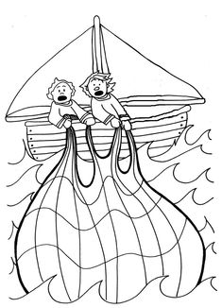

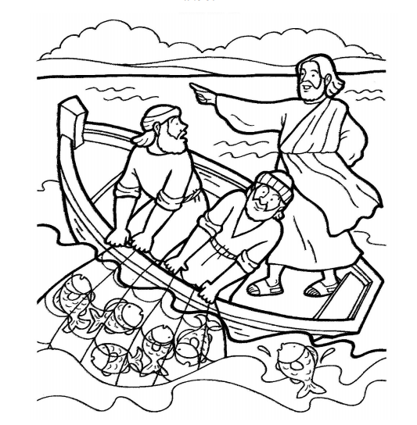

Simon and Andrew caught so many fish that it looked like their boat would sink.

