Kinderhook Reformed Church, 9:30 A.M. August 18, 2019

“To Know Christ and to Make Him Known”
Rev. Rudolph Visser, Pastor

Greetings visitors, and welcome to our worship celebration! Please fill out a visitor’s card and place it in the offering plate. Following worship, all are invited for refreshment and fellowship at the lemonade stand hosted by Jane Deane outside on the front lawn.

Thanks to today’s ushers, Colby Lane, Jamie Lane, Phil Hurst, Andrew Welcome
Thanks to today’s greeter, Sally Heimroth. Nursery facility available downstairs.
Guest Organist, Mienie Siebert

Prelude, Welcome, and Announcements
The Lord’s Greeting

Drawing Near to God
Call to Worship (Responsive) Adapted from Psalm 71:1-6
In you, O Lord, I take refuge; let me never be put to shame.
In your righteousness deliver me and rescue me; incline your ear to me and save me.
Be to me a rock of refuge, a strong fortress, to save me,
for you, are my rock and my fortress.
Rescue me, O my God, from the hand of the wicked,
from the grasp of the unjust and cruel.
For you, O Lord, are my hope, my trust, O Lord, from my youth.
In you, I have trusted since my birth,
and continually the praise on my tongue is of you.
*Hymn of Praise #26 Praise My Soul, the King of Heaven
Morning Prayer
Allowing God to Shape Us
Call to Confession
Psalm 32:1-2 says, " Blessed is the one whose transgressions are forgiven, whose sins are covered. Blessed is the one whose sin the Lord does not count against them and in whose spirit is no deceit". Seeking the blessing of forgiveness, let us now acknowledge our transgressions.
Prayer of Confession (Unison)
Gracious Lord God, our sins are too heavy to carry, too real to hide and too deep to undo. Forgive what our lips tremble to name, what our hearts can no longer bear and what has become for us a consuming fire of judgment. Set us free from a past that we cannot change; open to us a future in which we can be changed; and grant us grace to grow more and more in your likeness and image, through Jesus Christ, the Light of the World. Amen.
Assurance of Pardon (Responsive) Psalm 103.8, 10-12
Brothers and sisters in the Lord, know that the LORD is merciful and gracious, slow to anger and abounding in steadfast love. ... He does not deal with us according to our sins, nor repay us according to our iniquities. For as the heavens are high above the earth, so great is his steadfast love toward those who fear him; as far as the east is from the west, so far, he removes our transgressions from us. Hear the good news: In Jesus, we are forgiven. Thanks be to God! Amen!
Coming Before God’s Open Word
Prayer Hymn for Illumination #536 Open Our Eyes, Lord
Scripture Reading Hebrews 11:29-12:2
Message “Questioning Our Faith . . .Again”
Prayer of Blessing
Responding Together to the Word Proclaimed
Silent Prayer for Those Seeking to Acknowledge Christ as Their Savior:
"Dear Jesus, I confess that I'm a sinner, and not right with you. I repent and ask forgiveness. I believe that you died on the cross to take my punishment and to pay the price for my sins. I believe that you rose from death to give me new life. Wash me clean from all sin, shame, and guilt, and come into my heart as my Lord and Savior. In your name I pray. Amen."

Celebrating God, His Care, and His Abundance
Offering/Offertory
*Doxology #809 Praise God from Whom All Blessings Flow
*Offertory Prayer (Unison)
Exalted Lord, how can we sufficiently prepare our hearts to stay firm in your love? We praise your name with songs and prayers, yet are we truly ready to stand in faith on your promises and risk persecution for being fully-committed Christians? Thank you for this opportunity to dedicate these gifts and ourselves to your service, to become bold in our faith, and let your stream of living water flow as we share your Good News. Amen.
Prayer Requests, Pastoral Prayer, and Lord's Prayer
*Hymn of Thanks #374 Now Thank We All Our God
*Benediction, Blessing, and Response Hymn My Friends May You Grow in Grace
My friends, may you grow in grace, and in the knowledge of our Lord and Savior.
My friends, may you grow in grace, and in the knowledge of Jesus Christ.
To God be the glory, now and forever, now and forever, amen. (2x)
Postlude

“ROAR” VBS 2019
An African Adventure for the Entire Crew
9 am to NOON BEGINNING TOMORROW, AUGUST 19 – 23 AT KRC
Ages 3 (Potty Trained) To Grade 8

Students will learn that
"God is good" and will stay with them forever:

VBS Day 1 - Bible Point - When life is unfair...God is good!
VBS Day 2 - Bible Point - When life is scary...God is good!

VBS Day 3 - Bible Point - When life changes..God is good!
VBS Day 4 - Bible Point - When life is sad......God is good!
VBS Day 5 - Bible Point - When life is good....God is good!

(“ROAR” VBS - Continued from previous page.)

Advanced registration for VBS is required so that we are sure to have enough supplies for everyone. To register your child: Pick up a registration form from the back table and return it to Patti Varga or the church office; or call the church office, 518-758-6401, on Thursday mornings, 9 am – 11 am; or call Paul at 518-859-4158. We hope you’ll join us!

~NEW MEMBERS CLASS TO START SEPTEMBER 3~

Pastor will start a new members class on September 3, and will continue on September 10, 17, and October 8 and 22. Meeting time and place will be announced.

L KING AHEAD

~RISE AGAINST HUNGER MEAL PACKAGING EVENT SEPTEMBER 7~

RISE AGAINST HUNGER packages and ships food and life-saving aid to the world’s most vulnerable people and works to end global hunger in our lifetime. Again this year, tens of millions of meals will be packaged and distributed to needy locations around the world. A RISE AGAINST HUNGER food-packaging event is an immensely-rewarding experience of easy, hands-on work, fun, and fellowship that you will not want to miss! A group of 40 to 50 volunteers (any age) can package over 10,000 meals in just two hours. Our local packaging event will take place Saturday, September 7, noon to 3 pm, at the Kinderhook Town Hall (formerly Martin H. Glynn school) on Church Street, Valatie.

~BROOKS BAR-B-CUE AT KRC SEPTEMBER 25~

The Kinderhook Reformed Church Cemetery is sponsoring a BROOKS BAR-B-CUE again this year from 3:00 - 6:30 p.m. Wednesday, September 25. All proceeds will go toward operation and maintenance of the cemetery which, over the years, has become an increasingly costly community ministry.

PLEASE KEEP IN YOUR PRAYERS OUR MISSIONS AND MISSIONARIES
Alight Pregnancy Center, Hudson
Perry Jones and Capital City Rescue Mission, Albany
Alex and Fran Knauss, Trans-World Radio
Maureen Menard, Youth with a Mission
The Silvas, RCA missionaries, Hungary
Seth and Melissa Rogati, missionaries, Young Life Ministry, St. Thomas
Betty Ann Stedwell, Christar International Mission
PLEASE TAKE A FEW MOMENTS TO READ THE THANK-YOU NOTES
ON THE MISSIONS BULLETIN BOARD IN THE FELLOWSHIP ROOM
FROM SOME OF OUR MISSIONARIES.

REMEMBER TO PRAY FOR
- those who do not know Christ or who are struggling in their faith journey. Pray also that God will provide opportunities for us to witness for Jesus, and give us the courage and winsome words needed to make the most of these opportunities.
- Pastor Rudy, as he fulfills his ministerial duties.
- KRC ministries, programs & projects, and those planning & administering them as they seek new directions and God’s wisdom and blessing in moving our church toward a greater and more effective impact on our surrounding communities: KRC’s 2019-2020 Consistory as both continuing and incoming members take up their ordained duties and new group dynamics develop; KRC’s administrative ministries; KRC’s Youth Group; REACH; Sunday School; VBS; Rise Against Hunger; KRC’s small group ministries and Bible studies; Community Prayer Group; 1st Friday Free Community Dinner; Community Conversations; Parents’ Night Out; Wee Care; and other outreach programs.
- our state, national, and world leaders, especially President Donald Trump and all of the government officials now in office, that God will grant them the leadership skills and wisdom needed to govern effectively.
- our military men & women, their families, and friends, that they may know God’s presence, protection, and peace, especially: Brian Shanagher Jr., now in basic training in the Army; and Jason, serving in Poland, Hungary, and various NATO countries,
- victims world-wide suffering natural and other hardships and tragedies; those suffering economic instability; poverty, hunger, & poor health; political oppression, unrest, war, displacement, gun violence, and terrorism.
- families and friends grieving the loss of loved ones, especially the Arciero Family, Florida friends of Glenn and Cricket Warren, grieving the death of Rob Arciero. Remember especially Rob's wife, Judy; the Leggett family and friends grieving the recent death of Jim Leggett, brother of Gary Leggett; survivors of the recent shootings in El Paso and Dayton, their families, and the families and friends grieving for those who lost their lives in these tragedies.
- those who, even after many years, still hurt from the loss of loved ones.
- reassurance, comfort, peace, and dignity for those in hospice care and others nearing the close of this life.
- David Smith, following recent shoulder repair surgery. David is in good spirits, and recuperation is going along pretty much as expected.
- Carly Rippel, dealing with muscular and neck issues as she begins her first year at Vermont Law School.
- Jim Baker, recovering from intestinal issues.
- Barbara Vosburgh, as she works with her doctors to to manage her cardiac valve issues with medication alone.
- others awaiting test results or surgery; recovering from surgery, injury, or illness; or chronically ill: Peter Clinton; John Bowen; Elize Visser’s parents; Natalie; Fred Borrelli; Joan Draus, friend of Kay Haber; Pat Arnold; Nancy Call; Robert Gardinier; sister of Noreen Dick’s friend; Jen (Deane) Anderson; Xana; Olivia, daughter of Justine Dyer; Merrill Johnson; Kenny Van Allen; John Bowen; Stacey Baker.
- Donald, Patti Varga’s uncle, recovering from brain surgery this past week.
- Dave Ennis and his wife, Beth, and family, as they help Dave work his way through each day, some of which are better than others.
(Continued on next page.)
- others battling or recovering from cancer: Don Morse, brother of Kay Haber; Kayla Samascott Wilson; 4-year-old Olivia; Dave Ennis; Lucy Miller; Jeff; John Brady; Jimmy Cozza; Jen Damiano; Bob, resident of Valatie; Barb, resident of Syracuse; Charlie of the Ghent Fire Department; 12-year-old Issy Kwei; Judy Alvarez; Charles Roppolo.
- Residence-bound KRC family, Art Gross and George Clowe; and those caring for the elderly, displaced, disabled, or ill, especially: the Bakers, caring for Nancy’s mother, Vickie Metzger, 99.
- those facing new challenges, stressful circumstances, or difficult decisions: Jean Skipper, now in hospice care; victims and their families suffering due to the ongoing opioid addiction crisis; Crystal, whose deep desire is to have a full-term, healthy baby; all those dealing with unspoken issues - spiritual, health, financial, psychological, emotional, family-related, job-related, etc. - and who just need some help along the way; a member of our church family struggling with a serious and unsettling unspoken issue; our students as they make plans for or begin higher education or seek and make work and career choices.
- traveling mercies for those traveling or making traveling plans, especially Aaron Clause and family as they vacation in the Canyonlands and fly home from Las Vegas this coming Tuesday; and Jean (Deane) Anderson and family traveling to and from California.

REMEMBER TO THANK & PRAISE GOD FOR
- Pastor Rudy Visser, our Spirit-filled minister and leader of vision, and for the Christ-centered messages God gives to Pastor each and every Sunday for the spiritual nourishment and growth of our church family.
- the inspirational ministries of our guest preachers, Perry Jones, Tom McCrossan, John Bowen, Derek DeJager, and others who lead KRC worship from time to time.
- the good news that Jack Morse, brother of Kay Haber, is doing so well following a mild heart attack recently. Kay and family thank you for and appreciate your prayers.
- all those of KRC's family and friends who volunteer their time, talent, and energy so generously and so selflessly to the various ministries and programs of our church, and who often do this quietly behind-the-scenes with little notice or recognition.
- answers to prayer that a member of our church family struggling with a serious and unsettling unspoken issue has recently received some positive encouragement.
- those men and women who have served or are now serving in our country’s military, and those who have sacrificed their wellbeing and lives for the peace & liberty we enjoy.

Kinderhook Reformed Church has email chains for sharing prayer and praise requests and for notifying the church family and friends about special events, change of service times and venues, and emergency closings. If you have not been getting notifications but would like to, we will need your email address. Please take one of the yellow announcement slips in the holders on the back of each pew, write your name and email address on the slip, and place it in the offering plate. We will put your mailing information on our listings, and you will soon be getting KRC notifications.
In addition to our email chains, please consult our church website, kinderhookreformedchurch.com, for emergency and other notifications that may be in your interest to be aware of

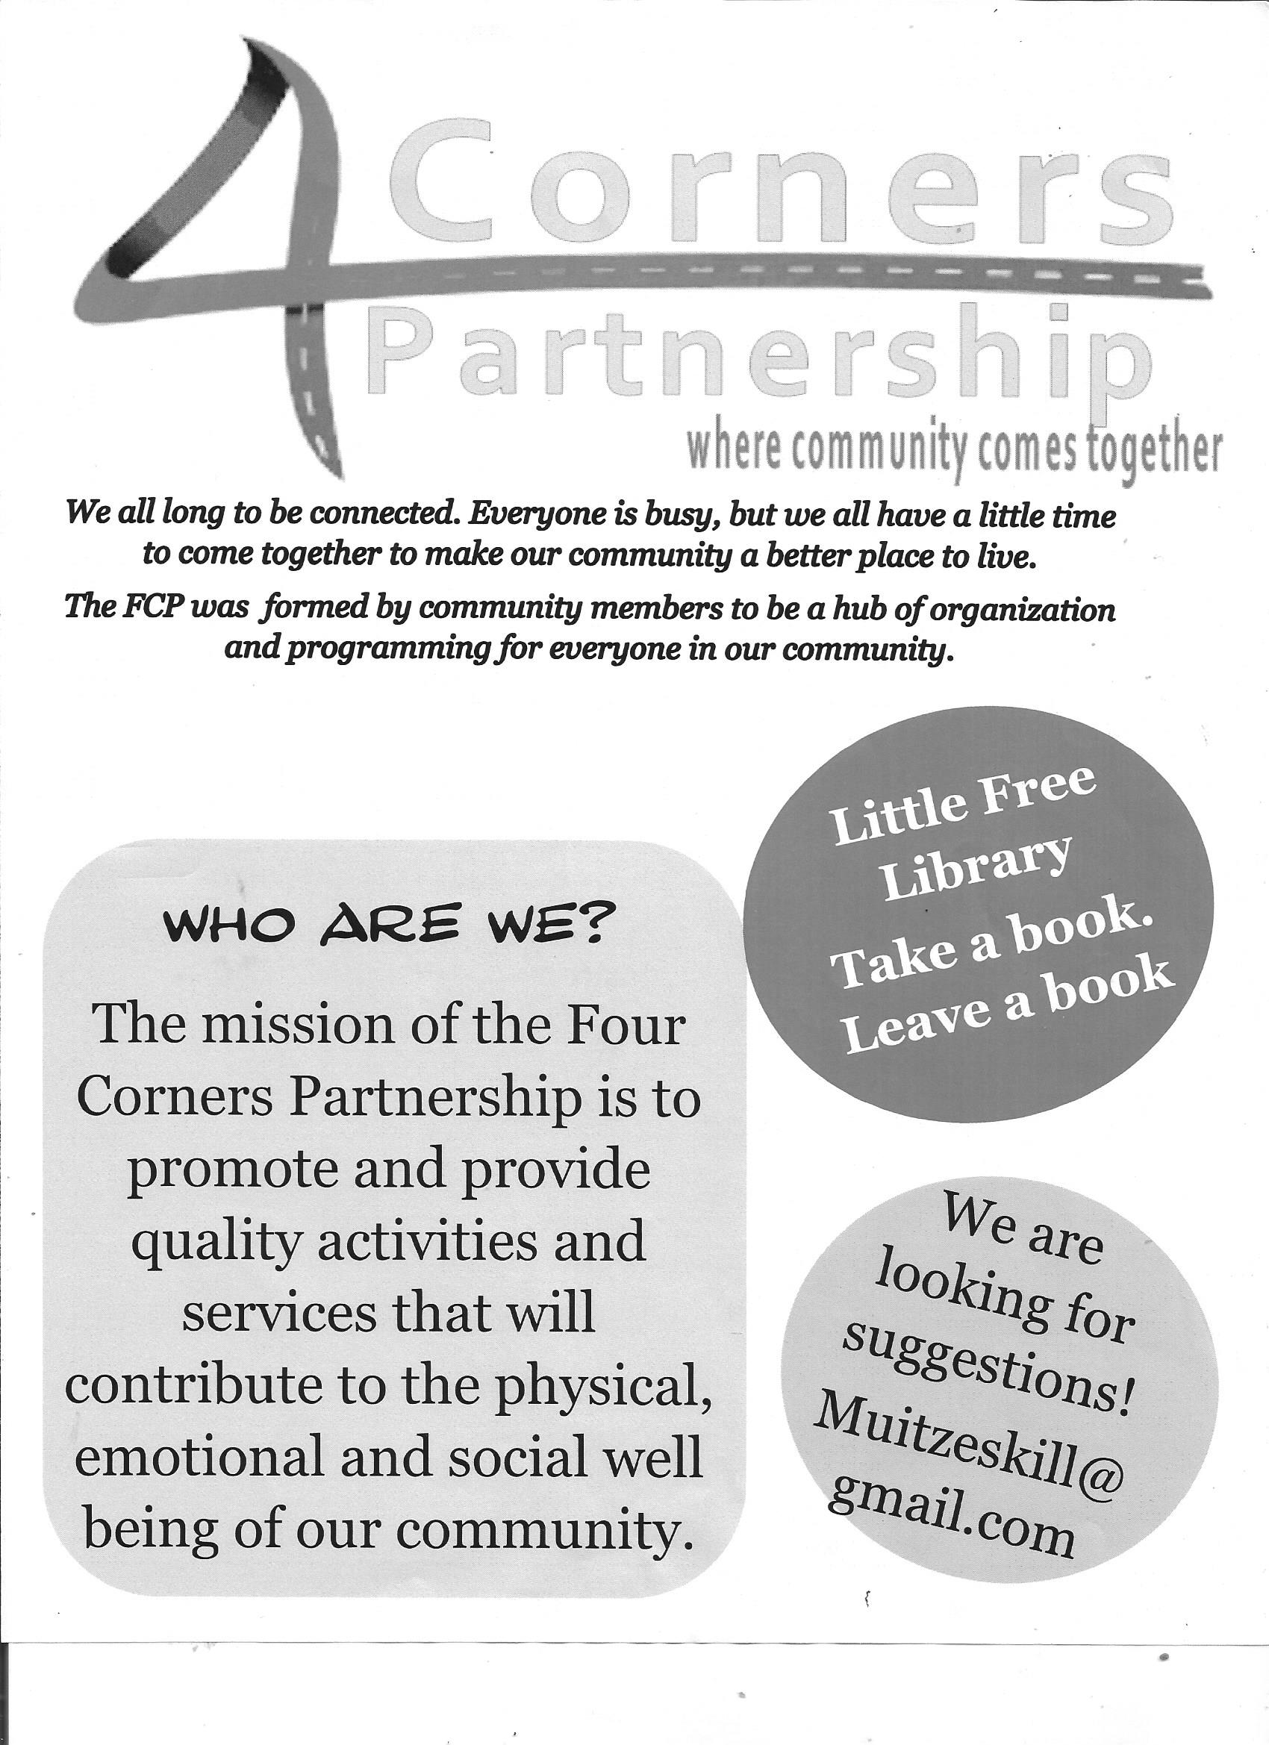

STEWARDSHIP WEEKLY UPDATE
Our offering last Sunday was $2,129, close to $900 dollars short of the $3,000 needed weekly to cover KRC’s daily operating expenses. We are now running a deficit of $4,643 after meeting this past week’s expenses.
Income to date: $97,557 Expenses to date: $102,200
Stewardship Ministry reminds everyone to prayerfully consider how they might adjust their giving so we can avoid falling further behind and having to tap into our limited reserves to meet budgetary obligations.
Inspired by the abundance with which the Lord has blessed us,
let us continue, as his faithful stewards, to be ever mindful of the need
to maintain a weekly offering sufficient to cover our commitments.

CLASSIS ASSESSMENT 2019
Each member’s share of this year’s classis assessment has been set at $97.69 All who are able to do so are encouraged to offer, over and above regular giving, their share of this support. The full share may be given in as many increments as are convenient. If offered weekly, that’s $5.14 per week for the remaining weeks (19) in this year. Please designate contributions, “Classis Assessment.”

Sara Schubert (3rd), Jim Dunham (7th), Carly Rippel (13th),
Dolly Petith (18th), Suzy Nieman (27^{th,}), Jean Hurst (27th),
Melissa Welcome (28th), Thomas Carroll (28th), Erika Johnson (31st)

KRC 2019 CONSISTORY
Pastor Rev. Rudy Visser, President of Consistory
Deacons
Susan Patterson – ’19 Outreach . . . . . . . . . . . 518-755-4909 susanpatterson1014@gmail.com
Beth Anne Rippel – ’20 Stewardship,
Church Family. . . . . . .518-392-5044 combarippel@yahoo.com
Deborah Spaulding – ’19 Church Family . . . . .518-758-7316 ber00519@fairpoint.net
Wayne Van Allen – ’20 Property. . . . . . . . . . . 518-339-8972 wayne@ctmdky.com
Elders
Jane Deane – ’19 Christian Education. . . . . . . 518-758-7051 jdeane1943@gmail.com
Jean Hacker – ’19 Outreach. . . . . . . . . . . . . . . 518-758-9412 jch9412@aol.com
Dawn Van Buren – ’20 Cemetery, Pastoral Relations, Personnel,
Consistory Vice-President. . .518-758-7564 dawnandleo@fairpoint.net
Patti Varga – ’20 Worship, Clerk of Consistory,
Classis Representative . . . . . 518-755-3054 patvarga@aol.com

KRC TREASURER
Derick LaTorre – 518-376-1882 derick.latorre@gmail.com

KRC STAFF
KRC Office Manager KRC Office Assistant
Paul Clause – 518-859-4158 Courtney Wood – 518-852-7172
KRC Sexton KRC Cemetery Supervisor
Steven Green – 518-505-4918 Greg Clause – 518-369-8472

Coming Events
Today, August 18
9:30 am Worship Service
10:45 am Sunday Bible Study Group meets, main floor conference room.
Mon – Fri, August 19 – 23
9:00 am – Noon “ROAR” VBS @KRC
Wed, August 21
7:00 pm Bible Study w/Jean Hacker - Group will begin Book of Job Aug. 7
Call Jean at 518-603-2450 for meeting location.
Thur, August 22
Please Note: Small Group Bible study, KRC Prayer Group,
and KRC Youth Group will not meet during VBS week.
Sun, August 25 Celebrating VBS Week
9:30 am Worship Service
10:45 am Sunday Bible Study Group meets, main floor conference room.
Mon, August 26
6:30 pm Outreach Ministry meets
Sun, September 1
9:30 am Worship Service
10:45 am Sunday Bible Study Group meets, main floor conference room.
Tues, September 3
New Member’s Class to begin, time and location to be determined
*class continuing on Sept 10, Sept 17, Oct 8, Oct 22*
Sat, September 7
Noon – 3 pm Rise Against Hunger meal-packaging event,
Kinderhook Town Hall, Church Street, Valatie
Sun, September 8
9:30 am Communion Worship Service
10:45 am Sunday Bible Study Group meets, main floor conference room
Wed, September 25
3:00 – 6:30 pm Brooks BBQ Cemetery Fundraiser @KRC

Servers Next Sunday, August 25, 2019

Ushers: Colby Lane, Jamie Lane, Phil Hurst, Andrew Welcome
Greeter(s): Jean and Stacey Hurst and Chris Halvax
Lemonade Stand Host(s): VBS Sunday - Christian Ed

Sermon Notes
Hebrews 11:29-12:2
“Questioning Our Faith . . .Again”

