A huge shout out to the five squads who proudly represented the Merrimack Valley in the 4th Annual Massachusetts Senior Games Softball Tournament on the Cape May 29-31. Two of those teams, MV 65s & MV 70s, brought home the Championship hardware. (OK, T-shirts, but what the heck.)
Our MV 65s team was managed by Gary Johnson. The team went undefeated (5-0) and came back from a 19-16 deficit in the 7th inning of the final game vs a very strong Cape Cod team to win 20-19. The 65s opened the tournament on Friday with a slugfest against the Falmouth Sentinels, winning 18-14, then beat the rain on Saturday to win both games, 7-3 vs the Cape and 11-10 vs Eastern MA. MV 65s beat Falmouth on Sunday morning in the semi-finals in a mercy rule game, 15-2, and then took home the championship in exciting fashion vs the Cape team. Congratulations to all members of the team: Dave Ciampa, Ray Cox, Mel Doucette, Kevin “Skinny” Hayes, Coach Gary Johnson, Steve Kelliher, Mike McDevitt, Mike Perrone, Dave Roy, Kevin Simoneau, Mike Smith, Austin Spinella, and Dave Tokanel. Bruce Botelho and Jack Gilhooly made cameo appearances on Sunday to help in the team’s 2 wins.
Our MV 70s, managed by Jack Gilhooly, with help from Paul Nalette, lost their first game to the defending MASG 70s champ, a very strong Eastern MA team, 22-14, but came back to take out the Western MA Relics 19-5 later that day. Saturday’s game with the Cape team was cancelled due to the horrible weather. On Sunday, the seedings matched up the Cape team anyway, and the MV 70s team came back from an early 9-5 deficit, then shut down the Cape lineup the rest of the way to win 11-9. On to the finals vs EMass, a team that beat the MV 70s in the 2025 finals, consisting of many players who our guys have battled against many times as 65s in other tournaments. Again, the MV 70s came back the whole game, and finally took a 2-run lead in an exciting top of the 7th, then held on for dear life to win the game 18-17. The team went 3-1 in the tournament and survived despite injuries to Larry Kittle and Rich Rosen. Congratulations to the following players: Gary Atkinson, Perry Delisle, Butch Dunham, Coach Jack Gilhooly, Larry Kittle, Jerry Lazaris, Jim McNamara, Paul Nalette, Ed Patterson, Dave Roy, Rich Rosen, and Rusty Schwarzenberg. Thank you also to Bob Lamontagne for filling in when needed. A special shout-out to Butchie and Rusty, who were amazing, playing all 4 games with the 70s as well as 5 games with the 75s.
The MVSSA 50s Storm team, managed by Vinny Indeglia, made their first appearance in the MA Senior Games and played very well, losing in the finals to a very strong Western MA Relics team 16-10. The team went 3-2 in the tournament, beating Western MA 28-24, and Eastern MA 12-4, while losing to the Cape team 10-9, in pool play. The Storm beat the Cape team 21-13 in the semis, before falling to the Relics 16-10 in the finals. The team is loaded with young players with tremendous skills, and they will be a force to be reckoned with in future years, for sure.
The Merrimack Valley 60s team, managed by Ron Aquino, was a bit under-manned this year, and struggled against some strong competition, but clearly had a great time and represented the Merrimack Valley with class. The team won the 1st game vs Western MA 23-11 on Friday, but fell to the Cape 19-16, and Eastern MA 12-5 on Saturday. The rematch with the eventual champion EMass in the semifinals ended with a 10-6 loss. I’m quite certain that team will reload and be ready for next year.
The MV 75s team, with Coach Gary Royal at the helm, had a great tournament, going 3-2, and dropping a heartbreaker in the finals to a very strong EMass team 18-17 in 8 innings. The MV 75s put up 94 runs in their 5 games, showing they can hit and run with the best of them. On Friday, the team beat the Western MA Relics 18-13 and the Cape Cod team 26-14. They came back on Saturday but got beat by EMass (and the rain) by a score of 27-16. In the semifinals on Sunday, our 75s team crushed the host Cape team 16-4 before losing a very exciting final game in 8 innings. That included a Houdini act in the bottom of the 7th when they escaped from a bases-loaded, no out situation to force the extra frame. Great job by everyone on that team, as they showed that old-timers up this way can still play some great softball.
Congrats and thanks to all who participated. We are all proud of the classy way our teams represented the MVSSA and Nashua spirit of community, sportsmanship, and competition. Let’s get 5 championships next year when we host the annual tournament in Haverhill (no date has been determined).
Regards,
Jack G
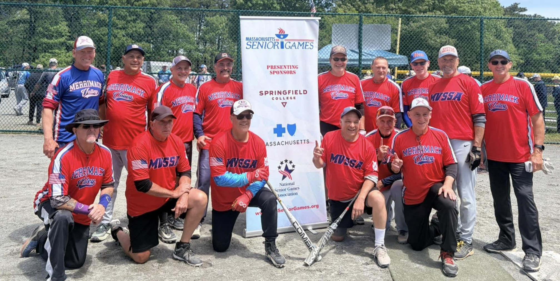
Above: Merrimack Valley 65s
Front L-R: Mike Smith, Gary Johnson, Bruce Botelho, Dave Ciampa, Ray Cox, Mike Perrone
Standing: Jack Gilhooly, Austin Spinella, Mel Doucette, Kevin Simoneau, Mike McDevitt, Kevin Hayes, Steve Kelliher, Dave Roy, Dave Tokanel
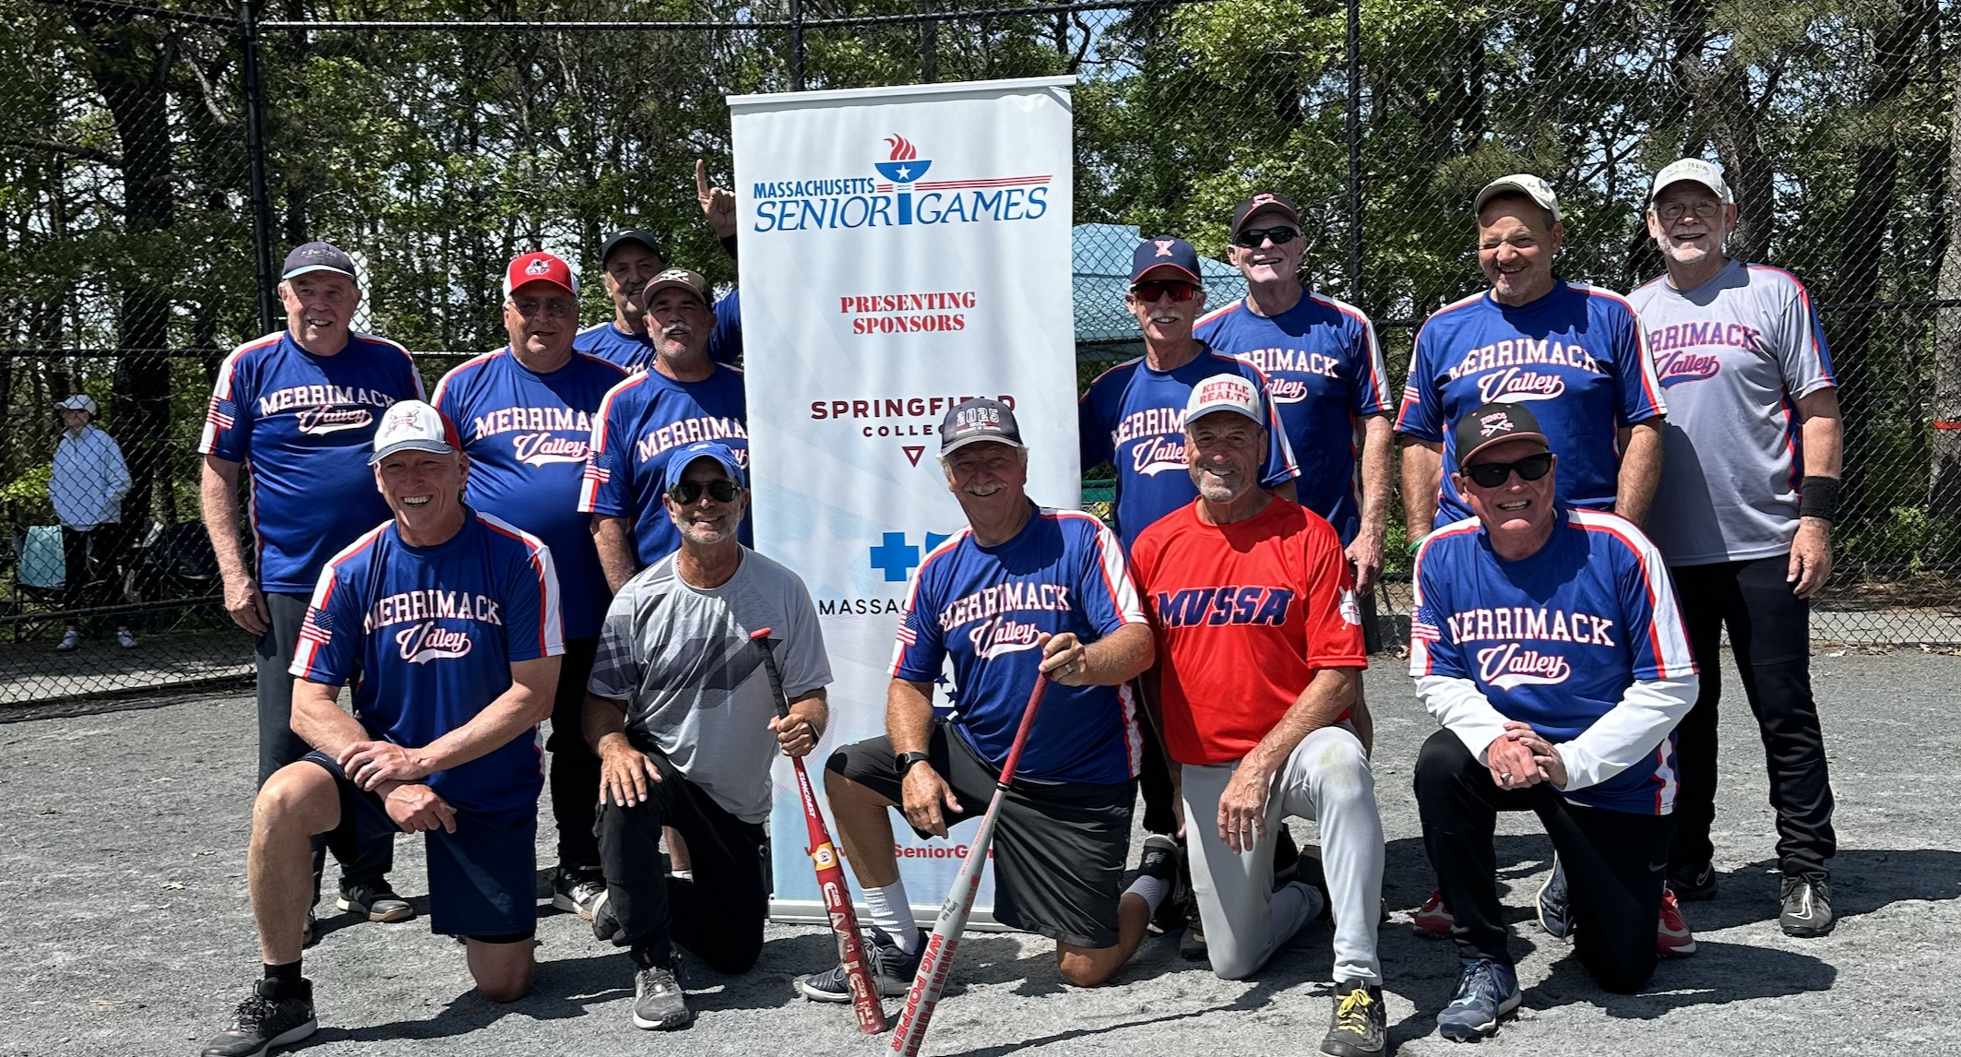
Above: Merrimack Valley 70s
Front L-R: Jack Gilhooly, Rich Rosen, Rusty Schwarzenberg, Dave Roy, Paul Nalette
Standing: Jim McNamara, Butch Dunham, Jerry Lazaris, Perry Delisle, Gary Atkinson, Ed Patterson, Larry Kittle, Bob Lamontagne

