Banner Order Form
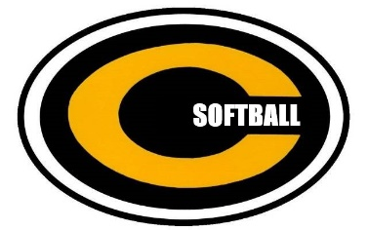

Centerville Elks Softball
“All-In”

ADVERTISE YOUR BUSINESS AT CENTERVILLE HIGH SCHOOL'S SOFTBALL FIELD IN 2021!

Purchase a high-quality banner, professionally prepared, advertising your business or organization.

• 48” x 96” full color banner
• Displayed for Spring, Summer and Fall Seasons
• Annual Fee for 2021 season: $500

Banner Purchase (Check here -- Follow instructions below) ____
Banner Renewal (Check here – We will use last year’s banner) ____

Name of Business: _________________________________________________

Address: _________________________________________________________

Telephone Number: ________________________________________________

Contact Person: ___________________________________________________________

Note: Artwork must be in EPS or PDF Format sized to fit a 4’x 8’ banner

Please make checks payable to: Centerville Softball Dugout Club

Mail to:
Attn: Wendell Hutchinson, Varsity Softball Coach
Centerville High School
500 E. Franklin Street
Centerville, Ohio 45459

For questions regarding banners or artwork please call Mark Schutter (937) 602-3772, or email at mark.schutter@culmenservices.com

Thank you for supporting Centerville Softball!

