**Bolingbrook Tee-Ball Association**

**P.O. Box 1355**

**Bolingbrook, IL 60440**

**Sponsorship Packet**

**2025 Season**

***We are now taking sponsors for the 2025 season!***

Bolingbrook Tee-Ball is a set of youth baseball leagues for both girls and boys from ages 4 to 8. We work to develop a solid understanding of the game of baseball while promoting teamwork, skill development, and a sense of community. We are currently in our 53rd year of youth baseball and our 4th year of Fall Ball. 2025 is looking to be an exciting year for our league. We are expanding our efforts to improve our social media presence and hold more special events to promote our league and give back to the community of Bolingbrook. Your sponsorship helps keep this tradition in Bolingbrook strong and is a great way to promote your business. Below is the updated list of benefits of being a sponsor for the league.

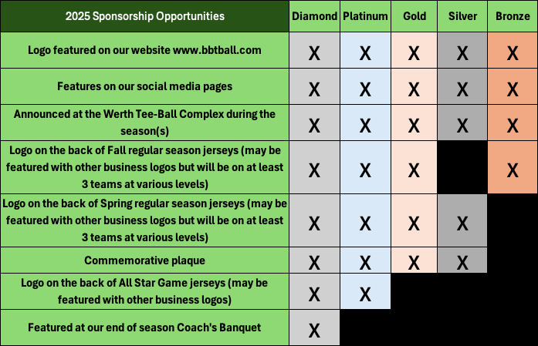

* Your logo will be featured on the back of the t-shirt jerseys of teams in our league. Teams consist of approximately 10-16 youth aged 4-8. Our seasons run for 8 weeks (10 games in the Spring and 8-10 games in the Fall). Your logo may be on the jerseys with the logos of other local businesses. This helps us ensure that we keep costs down on uniforms.
* Bolingbrook Tee-ball runs its own website ([www.bbtball.com](http://www.bbtball.com)), where your business’s name will be listed with a link to your webpage if you are interested in that feature. We also are working to increase our social media presence. This will include Facebook and YouTube. Our sponsors will be featured on our social media pages.
* Your business will be represented at the Bolingbrook Park District’s Werth Tee-Ball Complex during the entirety of our 10-game season (2025 season will consist of 8 weeks of regular season play for 10 games).
* We are continuing our All Star game this season for our CPKP level kids. This is a special game at the end of the season where the top players get to play. Players get special jerseys and there are special events surrounding this game. As an additional sponsorship opportunity this year, we are allowing sponsors to have an add on to help sponsor our All Star game. Every All Star sponsor will have their logo on the back of the jerseys so it may be smaller in size. There are approximately 28-32 players in our All Star game each year.
* This year we are also hosting a Coach’s Banquet as a thank you to all of our dedicated coach volunteers. There are sponsorship opportunities to help us support this event as well.
* At the end of the season, your business will receive a commemorative plaque with the photo of the team(s) that you have sponsored.

***The Bolingbrook Tee-Ball Association strives to give our children a fun, safe, and positive athletic experience. With sponsors like you, this opportunity is made possible.***

Please contact us by March 1, 2025, with your sponsorship contribution and business information so that shirts can be printed. In addition to monetary donations, we are also accepting product donations that can be included in raffle giveaways or as thank you gifts to our coaches during our Coach’s Banquet. Please note that if your business is only donating products, we cannot extend all of the above benefits to your company, but you will be mentioned at the banquet as a donor. If you have any questions or would like examples of a specific sponsorship benefit, please do not hesitate to contact us.

Erin Karpus, President Bolingbrook Tee-Ball Association

Ekarpus1342@gmail.com

**2025 Bolingbrook Tee-Ball Association Sponsorship Form**

I am interested in being a sponsor for the 2025 Season.

The cost of my sponsorship will be:

$1000-Diamond Level Sponsor

$800-Platinum Level Sponsor

$700-Gold Level Sponsor

_______ $500-Silver Level Sponsor

_______ $250-Bronze Level Sponsor

**Business Representative:** (please print)

**Signature:**  **Date:**

**Business Name: New Sponsor** (circle one)**: Y N**

**Address:**

**Telephone: Website:**

**How I want my Name/Business printed on the players’ shirts:**

(You may enclose your company logo, business card, or any clearly legible image. Black and white is preferred.)

**Tell us about your Business** (A statement about what you or your business do that our announcers can use during televised games):

Please make checks payable to: **Bolingbrook Tee-Ball Association**

Please mail completed form and payment to: Bolingbrook Tee-Ball Association

P.O. Box 1355

Bolingbrook, IL 60440

Alternative payment options can be arranged, please let us know if you prefer to pay a different way

***\*Forms and payment need to be received NO LATER than March 1, 2025, so that shirts can be printed and ready for our season start.\****

***\*\* Subject to COVID Restrictions and player safety***