Carey Junior High Girls Basketball
FREE-THROW-A-THON

When: Oct. 11-17th

Purpose: To raise money for the Carey Junior High School Basketball Program. Money raised will help pay for travel expenses and equipment (uniforms, basketballs, warm ups, etc.)

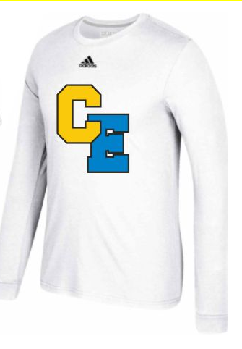
Rules: Each player will attempt 200 free throws in the first week of practice. Pledges will be obtained for either Free Throws Made or a Lump Sum. All pledges will be collected and turned into a member of the coaching staff no later than October 19th.

Goal: Our Goal is for every player raise $50.

Incentives: Every player who raises their goal will receive a shooting shirt.

Pledges: May be Lump Sum (i.e. $10.00) or Free Throws Made (i.e. 25 cents per made free throw). Example: 100 free throws made out of 200 @ $ .25 = $25.00

*** Please make checks payable to Carey C Club***

200
Players Name Free Throws Attempted Free Throws Made Total Pledge

Pledges
Name Phone # Lump Sum Pledge Free Throws Made Total

Coach Signature_____________________ Player Signature______________________

Name Phone # Lump Sum Pledge Free Throws Made Total

