**BAT STANDARDS**

Bat standards ensure that the bats are safe and perform consistently. A higher compression result means a barrel’s walls are more rigid, while a lower compression result means the barrel walls are more flexible or elastic. When a slow pitch softball bat loses its compression factor below the required limit, it;

* **Performance**: The bat may become more flexible, which can lead to increased ball exit speeds. This is because a more elastic barrel can create a “trampoline effect”, propelling the ball faster.
* **Durability:** The bat may be more prone to damage or breakage. Lower compression can indicate that the bat’s materials are wearing out, making it less durable.
* **Regulations:** The bat may no longer meet league standards. Centertown Youth League has a specific compression limits to ensure fair play and safety. Using a bat that fails below limits can result in penalties
* **Safety:** A bat with low compression can be dangerous. The increased ball exit speed can pose a risk to players, especially pitchers and infielders.

*If a bat fails a compression test, it typically means it doesn’t meet required standards for official play and should be replaced to avoid penalties or potential injury.*

|  |  |
| --- | --- |
| **Passing Barrel Compression Test**  *Approved Certification Stamp*  ASA/USA Slow Pitch: 1450 psi and above passing  *Approved Certification Stamp*  USSSA Slow Pitch: 240 psi and above passing  USSSA Slow Pitch: 220 psi and above passing  ISA Slow Pitch: 220 psi and above  NSA Slow Pitch: 220 psi and above | **Bat Performance Factor (BPF)**  ASA/USA Slow Pitch: 1.20  USSSA Slow Pitch: 1.20  ISA Slow Pitch: 1.20  NSA Slow Pitch: 1.20 |

*Note when testing ISA or NSA Stamp Bats follow the same guidelines as a USSSA Bat*

|  |  |  |  |
| --- | --- | --- | --- |
| **USSSA(psi) to USA (psi)** | | **USA(psi) to USSSA(psi)** | |
| **112.5** | **987** | **950** | **104** |
| **125** | **1041** | **975** | **109.74** |
| **137.5** | **1096** | **1000** | **115.48** |
| **150** | **1150** | **1025** | **121.22** |
| **162.5** | **1205** | **1050** | **126.96** |
| **175** | **1259** | **1075** | **132.7** |
| **187.5** | **1314** | **1100** | **138.44** |
| **200** | **1368** | **1125** | **144.18** |
| **212.5** | **1423** | **1150** | **149.92** |
| **225** | 1477 | **1175** | **155.66** |
| **237.5** | 1531 | **1200** | **161.4** |

|  |  |  |  |
| --- | --- | --- | --- |
| **USSSA(psi) to USA (psi)** | | **USA(psi) to USSSA(psi)** | |
| **240** | 1542 | **1225** | **167.14** |
| 250 | 1586 | **1250** | **172.88** |
| 262.5 | 1640 | **1275** | **178.62** |
| 275 | 1695 | **1300** | **184.36** |
| 287.5 | 1749 | **1325** | **190.1** |
| 300 | 1804 | **1350** | **195.84** |
| 312.5 | 1858 | **1375** | **201.58** |
| 325 | 1913 | **1400** | **207.32** |
| 337.5 | 1967 | **1425** | **213.06** |
| 350 | 2021 | 1450 | **218.8** |
| 363.5 | 2076 | 1475 | **224.54** |
| 375 | 2130 | 1500 | **230.28** |
| 387.5 | 2185 | 1525 | **236.02** |
|  |  | 1550 | 241.76 |
|  |  | 1575 | 247.5 |
|  |  | 1600 | 253.24 |
|  |  | 1625 | 258.98 |
|  |  | 1650 | 264.72 |
|  |  | 1675 | 270.46 |
|  |  | 1700 | 276.2 |
|  |  | 1725 | 281.94 |
|  |  | 1750 | 287.68 |
|  |  | 1775 | 293.42 |
|  |  | 1800 | 299.16 |
|  |  | 1825 | 304.9 |
|  |  | 1850 | 310.64 |
|  |  | 1875 | 316.38 |
|  |  | 1900 | 322.12 |
|  |  | 1925 | 327.86 |
|  |  | 1950 | 333.6 |
|  |  | 1975 | 339.34 |
|  |  | **2000** | 345.08 |
|  |  | 2025 | 350.82 |
|  |  | 2050 | 356.56 |
|  |  | 2075 | 362.3 |
|  |  | 2100 | 368.04 |
|  |  | 2125 | 373.78 |
|  |  | 2150 | 379.52 |
|  |  | 2175 | 385.26 |
|  |  | 2200 | 391 |

*Barrel Compression Test*

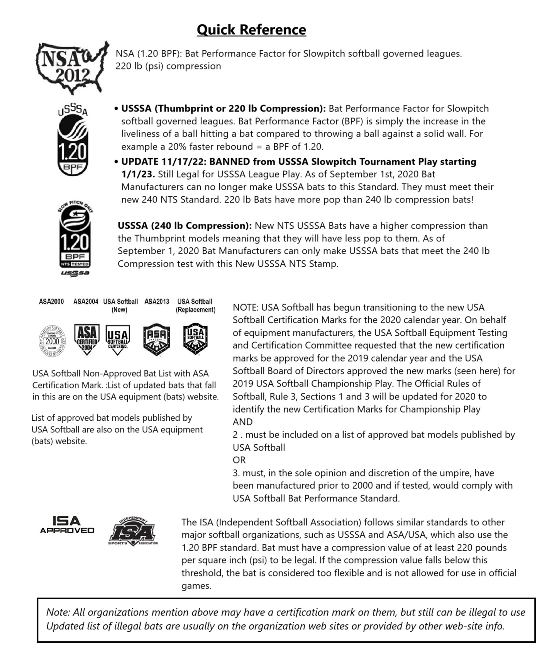

Allowed in

Youth League

**Allow in Le****ague Play**

**Bat Testing Procedures**

League Official or Umpire has the authority to have a bat tested to determine bat is illegal or not. Not a coach, parent or player.

1. Umpire to check for proper certification stamp.

* All bats must have a bat certification stamp on it.

1. Check to see if bat is approved by league play.
2. If the bat has to be tested;
3. Stop the game at that point (to get the bat that needs to be tested)- continue the game while bat is being tested for compression-bat cannot be use until test results are final.

* Approved by owner of bat and 1 parent of player that is involved can be involved during testing procedure.
* If bat owner refuses to allow bat to be tested the league will banned that bat for any play automatically.

1. If the test comes back in favor to use, it will be allowed in that game.
2. If the bat test fails, penalty will be to remove the bat in play and suspend that inning of play that bat was use, means 3 outs and no runs score will be counted.

* Second offense of same player, if using a different illegal bat will be automatic forfeit game in favor of the opposing team
* Third and Final Warning; the league will suspend the player for the remaining season or so many games into the next season if so seem deemed to and subject to be banned from the youth league play.