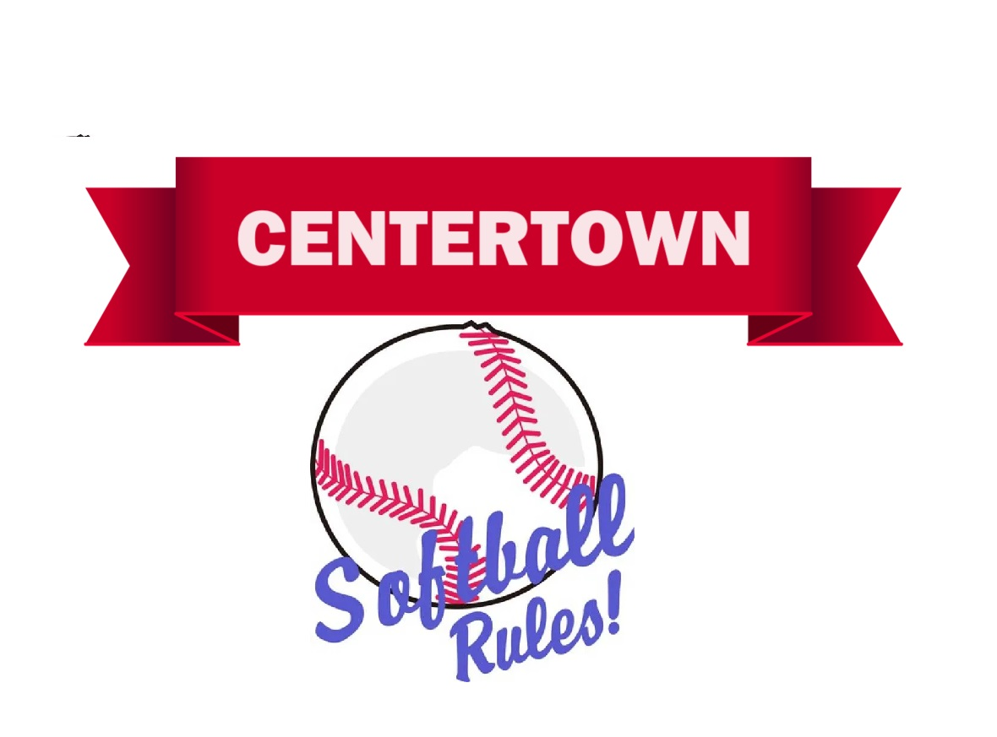
ADULT CO-ED
LEAGUE

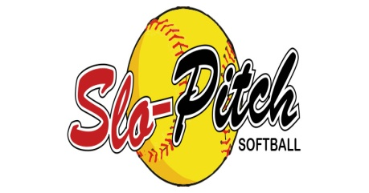
  ISSUE 03 DATE 06/01/26  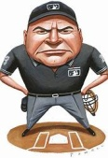 | 

TABLE OF CONTENTS

Rule 1: Adult Co-Ed Players Participation
Rule 2: Players and Coaches Conduct
Rule 3: Team Roster
Rule 4: Equipment
Rule 5: Game Time / Line-Ups
Rule 6: Short Hand and Substitutes
Rule 7: Game
Rule 8: Fielding
Rule 9: Pitching
Rule 10: Batting
Rule 11: Base Running
Rule 12: Forfeit Game
Rule 13: Suspended Game
Rule 14: Protest Game
Rule 15: Ejection(s)
Rule 16: Umpires

All other rules that are not listed here under Centertown Adult Co-Ed Rules will be under the 2026 USSSA Rules.

RULE 1: ADULT CO-ED PLAYERS PARTICIPATION

Section 1.Ages: Must be 19 or older to play (Must Be 19 during the physical year)

Section 2.Each team roster player must sign a waiver of release from the recreational park.

RULE 2: PLAYER /COACHES CONDUCT

The Official's jurisdiction to enforce the Code of Conduct shall extend prior to, during, and after the ballgame. Said jurisdiction exists from the Official's arrival at the game site to his/her departure from the game site.

Section 1. At any time lay a hand upon, push, shove, strike, or threaten to strike an official or another player or coach.

Section 2. Refuse to abide by official's decision.

Section 3. Be guilty of objectionable demonstrations by throwing gloves, bats, or any other forceful action.

Section 4. Be guilty of heaping personal, verbal abuse upon any official, player or coach for any real or imaginary wrong decision or judgment.

Section 5. Be guilty of using unnecessarily rough tactics in the play of the game against the body and person of any opposing player.

Section 6. Be guilty of physical attack as an aggressor, upon any player, official, or spectator.

Section 7. Be guilty of abusive verbal attack upon any player, official, or spectator.

Section 8.Use profane, obscene, or vulgar language in any manner, or at any time.

Section 9.SHALL NOT; appear on the field of play at any time in an intoxicated condition.

Section 10.Be guilty of discussing publicly with the spectators in a derogatory or abusive manner any lay, decision, or personal opinion of other players, officials and coaches during the game.

Section 11. SHALL NOT; use of any equipment or device which, in the sole judgment of the umpire, compromises the safety of the participants. This includes the use of radios or similar devices on the person of a player, in the dugout, or in the spectator viewing area, which might inhibit the ability of players to hear verbal calls and/or instructions by the umpire.

Section 12. Be guilty of using a bat that has been altered in any way. Altering includes, but is not limited to: sanding, filing, shaving, lengthening, shortening, weight-altering, heating and cooling.

Section13: ALCHOL AND SMOKING (Vaping) are not allowed in the dugouts are on the playing field. Teams will be giving 1 warning; further violation of this rule will result in the ejection of the offender. (Smoking is allowed in Park Designated Areas)

Section 14: COOLERS – If someone brings a cooler up to the field, you WILL BE ASKED TO SHOW THAT THERE IS NO ALCOHOL INSIDE IT. If there is alcohol inside, or you refuse to open it, you will be asked to remove it from the park immediately or risk forfeiture of the game as well.

NOTE: Any illegal drugs on park grounds, the sheriff department will be call.

RULE 3: TEAM ROSTER

Section 1.Team Roster Set-Up to 15 players (using the women to men ratio)

PLAYERS | WOMEN | MEN
15 | 5 | 10 (no more than if using this number)
14 | 5 | 9 (no more than if using this number)
13 | 4 | 8 (no more than if using this number)
12 | 4 | 8 (no more than if using this number)
11 | 4 | 7 (no more than if using this number)
10 | 3 | 7 (no more than if using this number)

NOTE: Can have more women on the roster as shown above in table on roster, with lesser men.

Section 2.Team player release waiver must be turning in before playing the first game.

Section 3.Final Team roster must be turn into league official by their second schedule game.

RULE 4: EQUIPMENT
OFFICIAL BATS
Can be use in Adult League
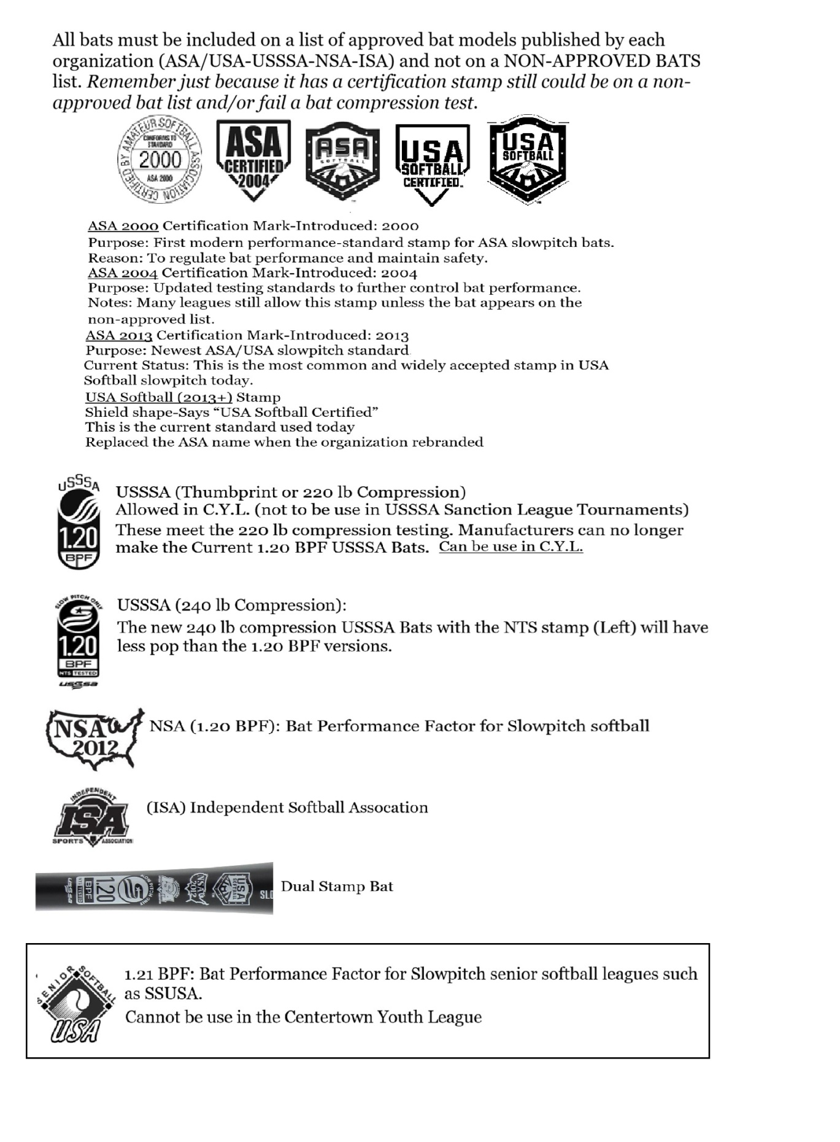
Cannot be use in Adult League

BAT COMPRESSION TEST

All bats used in league play must pass the league’s bat compression test and display the required certification stamp. Bats may be tested before the game, during the game and after the game at the umpire’s discretion, or upon request by league official. Only the umpire or league official may conduct the test. A bat that fails the compression test is illegal and must be removed from play.

Penalties are as follows:
[] 1st Occurrence: Bat Compression Test Fails-bat is removed from season games play, player is warned on 1st occurrence and recorded
[] 2nd Occurrence if caught using another fail compression bat is removed and player ejected from game and league may impose a 1-3 game suspension depending on intent.

If the player (or bat owner) refuses inspection, will be treated as the same as an altered bat.
- Player is removed from game
- Bat removed
- League Review

Bat Standards ensure that the bats are safe and perform consistently. A higher compression results mean a barrel’s walls are more rigid, while a lower compression results means the barrel walls are more flexible or elastic. When a slow pitch softball bat loses its compression factor below the required limit, it”
a. Performance: The bat may become more flexible, which can lead to increased ball exit speeds. This is because a more elastic barrel can create a “trampoline effect:, propelling
the ball faster
- Durability: The bat may be more prone to damage or breakage. Lower compression can indicate that the bat’s materials are wearing out, making it less durable.
- Regulations: The bat may no longer meet league standards. CYL has specific compression limits to ensure fair play and safety.
- A bat with low compression can be dangerous. The increased ball exit speed can pose a safety risk to players.

Passing Barrel Compression Test
Approved ASA/USA  1050 psi and above passing  Approved USSSA  240 stamp: 240 psi and above passing  220 stamp: 220 psi and above passing  Approved NSA  220 psi and above passing  Approved ISA  220 psi and above passing | Notes:  1] All bats must meet the 1.20 Bat Performance Factor (BPF)  2] Some USA slowpitch softball bat models have a lower than 1050 psi still will pass a test.. Have to check specific model cutoff value.
BATS NOT TO BE USE IN LEAGUE PLAY

- Illegal bats can’t be used in this league.
- No senior bats
- Banned bats by any softball associations that are on the banned list.
- Bats must be an official ASA or USSSA softball bat with the wording of official softball bat by the softball association stamp on it.
- No fast pitch softball bat.
- No baseball bat.
- No wooden bat.
- Altered bat.
- Should be free of rattles, dents, burrs, cracks, sharp edges, not broken or been painted.
- Double walled bat that do not have a BPF rating are illegal.
- No triple walled bat

NOTE(S)
- All bats or any bat is subject to be check by the umpires before game starts, during the game and/or after the game.
- All bats or any bat is subject to be check by league official before game starts, during the game and/or after the game.
- If the player (or bat owner) refuses inspection, will be treated as the same as an altered bat.
- Bat removed
- Player is ejected from game
- League Review for any other action(s)

OFFICIAL SOFTBALL

- Each team during the game will supply game balls.
- 12 Inches in diameter (for men and women) COR 52 – Compression 300Ibs.
- USA/ASA or USSSA Stamp Approved (markings must be on ball)
- Each team to provide at least two (2) new game balls per game at start of game and any additional game balls during the game.
- Each team will hit their own game ball.

FIELDING GLOVES
Notes:
- There are no specific color requirements for a glove.
- If there is any doubt to whether a glove is legal or illegal, it shall be ruled a legal glove.
- Legally adopted gloves may be worn by any fielder.

SHOES

Notes:
- Shoes must be worn by all players during the game.
- Shoes having metal cleats or hard plastic that screw on are illegal. The cleats must be of soft molded rubber.
- Metal cleats are not allowed
a. First offense will result in a 2 game suspension
b. Second offense will result in suspension for the remainder of the season.

ATTIRE AND JEWELRY

Notes:
- Must wear a shirt during the game.(sleeves are optional)
- It is optional for the team to wear same colors of shirts.
- Pants or shorts those are not baggy and loose not to be worn during the game.
- No Jewelry of any kind (except medical alert) shall be worn during a game. Any player at bat with noticeable jewelry on will be called out at the plate. Any player on the defensive playing side, time will be call and jewelry to be removed.

SAFETY
Safety Equipment
Notes:
- Catcher’s masks are optional. It is strongly recommended that women wear masks and chest protectors.
- Softball helmets may be worn by players and coaches at any time.
- Pitchers Mask, helmets and/or shin guards are optional.
- Pitching Screen; the league will provide a pitching screen. It will be mandatory to use regardless of whether the pitcher is wearing a mask or not. (See also Pitching about pitching screen)

RULE 5: GAME TIME / LINE-UPS

Section 1.Visitors/Home Teams; team listed first on the season game schedule will be the home team and must occupied first base dugout. The visitors listed second on the schedule are in the 3rd base dugout.

Section 2.Game Times; are set by the season schedule.
NOTES:
- Teams will be given a 5 minute grace period.
- Teams that fail to abide by their scheduled game time will forfeit their game after grace period.
- If both teams agree, game may be started before schedule game time.

Section 3.Game Team Line-Ups; shall be turn in to the scorekeeper 10 minutes before game time starts.

- The batting order does not have to alternate male and female. You can’t have more than 3 men batting behind each other.

Section 4.Line-Up: Players Need to Start a Game;
- Must have at least 8 team roster players or becomes a forfeit. At least 2 females.

NOTE: See Rule 6 Shorthand and Substitutes

Section 5.Line-Up: Players Need to Complete the Game; must have at least 8, unless the injuries rules come into play, than 7 players. See Rule 8 Fielding; section 3 and Rule 10 Batting; section 3 concerning injured player.

RULE 6: SHORT HAND AND SUBSTITUTES

Shorthand

Section 1. No team can pick-up another player from another league team or a player is not on the team roster.

Section 2: Players Need to Start a Game: 8 Players (must be at least 2 females)

Section 3.Players Need to Complete a Game: should have at least 8, unless a player becomes injured and has to leave a game, and there are no other subs, and then could finish with 7.

- If the injured person cannot come back into bat at their turn of bat, an out will be call if no sub is available.
- If the injured person cannot play the field; and no sub available, will have to play shorthanded, can’t add one. (unless player is a AH (additional hitter)
- If the injured person cannot run the bases
See Rule 11 Base Running section 3 Pinch Runner

Substitutes
- A male for a male only.
- A female may substitute for either female or male.

RULE 7 GAME

Section 1.Playing Field (Bases 65 feet) (Pitcher Rubber 50 feet)

Section 2.Regulation Game; shall consist of 7 innings (unless otherwise listed below)
- Game Time Limit
All games have a one hour time limit. No new inning will be beginning after the 55 minute mark.
- Game Run Rules
25 run after 2 innings
20 run after 3 innings
12 run after 5 innings
10 run after 6 innings.

Section 3.Start of Game
- Official Time Limit Starts by the Scorekeeper and announced by Home Umpire.
- Umpires, declares by signal “Hand Motion” or voice “Play Ball”

Section 4.Game Tie
If the game is tie after 7 innings or time limit expires, the game will played on or extra innings to decide the winning team. Home team does bat if behind.
- In the event of a tie game at the end of the 7th inning, each team will begin their half inning with a runner on second base. This runner must be the last person who batted in the prior inning.
Section 5 .Game calls due to;
- Weather. If game play has gone 4 full innings, or home team ahead in bottom of 4th the game score shall determine the winner.
- Darkness or other safety reasons. If the game has not started or play at least 4 full innings of play, the game will be reschedule to start from the beginning.
- During Playoffs or Tournament Play. If game play is stop by Part A or B above, the game will be reschedule to start from where the game was left off at if completed at 4 full innings or home team is ahead at that point. If not met the innings requirement in this Part C, the game will start as a new game from the beginning.

Section 6. Make up Games
- It is our intention to play all scheduled games. Every effort will be made to reschedule games that are missed due to inclement weather, field unavailability, or any other issues that arise. Make up schedules will not be issued until the regular schedule is nearly exhausted. Centertown Adult League Softball reserves the right to reschedule games in any order or night (date) that we determine.

RULE 8: FIELDING

Section 1. Maximum of 10 players on the field during play.

- No more than 7 men on the field at any time
Note: Subject to change if fielding injured rule comes into play; see section 3 below)
- When playing 10 fielders, must have at least one (1) female in the outfield and one (1) in the infield; catcher and pitcher counts as an infielder.
- All infielders must remain in the infield and all outfielders in the outfield until the ball is hit.
- Cannot have more than 4 outfielders in the outfield area.
- Outfielders must be at least 30 feet behind the edge of infield grass area when the ball is hit.

NOTE: No player may advance beyond the 30 feet area at that the time the ball is hit otherwise the batter has the option to be awarded first base or take the play outcome as is. If batter takes option of being awarded first base all other base runners on at time will be awarded 2 bases. bases.

Section 2.Injuries; If a defensive player becomes injured during the game;
- If have substitutes; male for male and female for female. Female can substitute for a male.
- If it puts the team down to 7 players
- Must still have at least 1 female on the playing field (either infield or outfield). Penalty if not the game becomes a forfeit

Section 3.Time By Umpire; Once an infielder has the ball in control the umpire may call time and runners may not advance. If a runner has advanced past the halfway point, they may proceed to the base. If not, they must return to the last base they crossed.

Section 4.All other Rules; regarding fielding will be under the 2026 USSSA Rules.

RULE 9: PITCHING

Section 1.Pitchers Screen; After a ball is pitched, the pitcher is required to step behind the screen and stay there until contact is made with the ball. At this moment the pitcher may come out from behind the screen and attempt to make a play on a batted ball.
NOTE: This is for the protection of the pitcher, if failed to do, a dead ball is call by the home plate umpire and batter is awarded 1st base and other base runners will advance one base.
- By using the pitchers screen, the pitcher can position their self around the edge of the screen to release the ball
- Any ball that is hit up the middle and makes contact with the screen will be called as a foul ball.
- The batted 2nd foul ball rule applies here to. (On the second foul after two strikes the batter is out-is allow one courtesy foul).

Section 2.Starting Pitcher is allowed one minute up to three warm up pitches before start of a game if needed.
- Relief pitchers are allowed the same.
- Starter and the same relief pitcher are allowed this one time during the game.

Section 3.Pitcher Changes; Allowed no more than two per inning.

Section 4.All other rules regarding pitching will be under the 2026 USSSA Rules.

RULE 10: BATTING

Section 1.Batting Order
- The batting order does not have to alternate male and female.
- You can’t have more than 3 men batting behind each other.
- Teams may bat up to two additional hitters in the line-up (one female and one male) not two males, can two females.
- Batting Order Requirements Chart Total Number of Players in a Game:
Batters | Women | Men | Comment
12 | 4 | 8 | Can add 1 additional male and 1 female or 2 females.  Cannot, bat no more than 8 males.8th male is additional batter
11 | 3 | 8 | Can add 1 additional male  Cannot, bat no more than 8 males.8th male is additional batter
11 | 4 | 7 | Can add 1 additional female
10 | 3 | 7 | No additional batters
10 | 2 | 8 | Can add 1 additional male  Cannot, bat no more than 8 males.8th male is additional batter  Out will be taken at turn of 3rd Female batter spot in line-up
9 | 3 | 6 | No out taken, due to 1 less male in line-up
9 | 2 | 7 | Out will be taken at turn of 3rd Female batter spot in line-up
8 | 2 | 6 | Out will be taken at turn of 3rd Female batter spot in line-up
8 | 1 | 7 | 2 outs will be taken at turn of 2nd and 3rd female batter spot
7 | 2 | 5 | Due to Injured Rule:  1 out will be taken at turn of injured Female and out taken at turn of male injured player.
7 | 1 | 6 | Due to Injured Rule:  Out for each female player missing. No out taken, due to 1 less male in line-up

Section 2: Batting

- Balls/Strikes (Pitch Count); All batters will start with a 1-1 (one ball, one strike count) from there, the umpire will determine all balls and strikes.

- Walks If a male is walk, and a female follows him in the batting order, the female has the choice whether to take a walk or to bat. The male automatically advances to second base in this situation, whether the female chooses to bat or not.

- Home Runs.(Over the Fence) Each team is allowed three (3) per game. All others an out will be call.

- Fouls; A foul counts as a strike; after two strikes on a batter, they are allowed 1 courtesy foul, on the second foul after the batter is called out.

Section 3.Injuries; If a batter player becomes injured during the game;
- If have substitutes, male for male and female for female. Female can substitute for a male.
- No substitute player is available; Penalty is when that player comes to bat in the batting order an out will be call.
- If it puts the team down to 7 players
- Must still have at least 1 female in the batting order. Penalty if not the game becomes a forfeit.
NOTE: See Section1 Batting Order: Chart for requirements on 7 batters in the game.

Section 4.All other rules regarding batting will be under the 2026 USSSA Rules.

RULE 11: BASE RUNNING
Section 1.Courtesy runner; Courtesy runners of the same gender will be allowed, one per inning.

NOTE: The runner should be the furthest from being up to bat. (Usually the last one may an out)

Section 2: Leading or stealing is not allowed. A runner leading off a base before the ball is hit is out. (Umpire judgment call, not an appeal play)

Section 3:Pinch Runner; due to injury or illness
- Must be of the same gender if possible. If not, the opposite gender runner will take the spot furthest from scoring. (Usually the person made the last out)
- Additional pinch runners will only be allowed if a player does not return to the game or to maintain the male/female batting order if there is a limited number of one gender.

Section 4: First and/or 3rd Base Runners: If a base runner is on either or both bases and a batter comes up to the plate and the runner(s) know of such a player that hits the ball sharply down the base line, before the batter takes a pitch the runner can request to the Home Plate Umpire, that they wish to step off the base to the side and behind the base path line to void of being strike by a batted ball. Once the ball is hit the base runner must establish and touch the base before advancing.

Section 5.All other rules regarding base running will be under the 2026 USSSA Rules.

RULE 12: FORFEIT GAME
A forfeited game shall be declared by the Umpire/Adult League Official in favor of the team not at fault in the following cases:
Section 1.If a team fails to appear upon the field or being on the field refuses to begin the game for which it had been scheduled, at the time the game was assigned

NOTE: Teams will be given a 5 minute grace period.
Section 2.A team that uses a player not on their roster will forfeit their game.

Section 3. Any team that forfeits three or more games will be ineligible for the playoffs.

Section 4. If after a game has begun a team refuses to play or resume play

Section 5.If a team uses tactics palpable designed to delay or hasten the playing of a game

Section 6.If an ejected player doesn't leave the field area immediately, when ordered to do so. (Out of sight and sound)
Section 7.If for any reason a team does not have the designated number of players to begin or continue the game
Section 8.If, after warning by the umpire, any one of these rules is willfully violated.
NOTES:
- The score will be 7-0 in favor of the team not at fault.
- League Officials and umpires are cautioned to employ best discretion to avoid forfeiture of any game, within the scope of good reasoning.

.RULE 13: SUSPENDED GAME

A suspended game can result if the umpire stops play for any reason such as power failure, darkness or other safety reasons.
NOTE: When a suspended game is resumed, it must be started at the point of interruption with the same identical situations as when the game was suspended if possible.
RULE 14: PROTEST GAME

Section 1.Protests and Disputes
- Protests and disputes must be filed on paper with the Adult League Scorekeeper by Head Coach of the Team only at the time of protest being made during the game, not after.
- Disputes based on official scorekeeper book at the end of the game will not be heard.
- Disputes based on umpires judgment calls (safe, out, etc.) will not be heard.
- A protest fee of $100.00 must be paid to the Centertown Recreation Adult League within 24 hours of a declared protest, along with a written statement about the protest. If the protest is won, the fee will be returned and the game will be resumed at that point at
a later date. However, if the protest is lost, the fee will be kept by the Centertown Recreation Adult League. (All protests during tournament games must be settled before the next pitch including the $100.00 protest fee).
RULE 15: EJECTION(S)
Section 1.Throwing the bat, is not allowed, neither in frustration nor after a hit. Players will be given a warning, then on the second time will be call out their time of bat. A third time automatic ejection from the game.

Section 2.Drug and alcohol use

Section 3.Excesses arguing calls

Section 4.Unsportsmanlike communication between opposing teams, both verbal and non-verbal:

Section 5. Foul language or behavior directed towards referees, spectators, players, or Centertown Adult League Officials.

Section 6. Arguing, yelling, pointing, questioning, misleading or confusing the other team with
incorrect rules, swearing and other foul language.
NOTE: Warnings should be given to BOTH teams at first. Moving in an intentional or threatening manner, physical abuse or posturing shall result in an immediate ejection.

Section 7. Foul language or behavior directed towards umpires, spectators, players, or Centertown Adult League Officials.

Section 8.Intentionally throwing a ball at a umpire, Centertown Adult League Official, or spectator.

Section 9.Sportsmanship and/or Several Game Ejections; Any player or team may be removed from the league for the remainder of the season, and denied registration for subsequent seasons due to unsportsmanlike conduct at the complete discretion of Centertown Adult League Officials if it is in the best interest of the league.
Section 11.Ejection Penalty
- Any player who is ejected from a game will be automatically suspended for a minimum of one additional game (byes do not constitute a game). If a player is ejected twice during a season he/she will be suspended for the remainder of season, including playoff games. Ejected or suspended players will not be allowed at the park while serving his/her suspension.
- In the event that a player is ejected anytime after the conclusion of a game, he/she will be automatically suspended for the next two (2) games, including playoff games.

- Any player or manager/coach/spectator who physically abuses an official, a player, a park supervisor or scorer will be subject to criminal prosecution as per the State of Tennessee.
2021 Tennessee Code
Title 39-Criminal Offenses
Chapter 17-Offenses against Public Health, Safety and Welfare
Part 3-Disorderly Conduct and Riots
Section 39-17-305 Disorderly Conduct
- Immediately following player ejections, the umpire will be responsible for suspending play in order to notify the scorekeeper that the one minute countdown has begun so it is clear that the offending team is in jeopardy of forfeiting the game. In the event that an ejected player chooses to use any or all of the countdown period to heap verbal abuse or profanity upon the umpire, opposing players and or spectators, Centertown Adult League reserves the right to rule the game a forfeit and or suspend or expel such players from the league.
- It is Centertown Adult League expressed intent to provide ejected players with sufficient time to collect their personal belongings and leave the premises prior to ruling a game a forfeit. However, Centertown Adult League will look to discipline severely any player who elects to use the one minute countdown period as an opportunity to degrade or abuse anyone.
- In cases of spectator harassment the umpire will use the following course of action:
- First Warning – manager/coach will be asked to take care of the problem spectator.
- Second Warning - spectator will asked to leave the park. If the spectator refuses to heed the umpire's request, the manager/coach will be subject to ejection from the game if the umpire determines that the spectator is associated with one of the two teams.
- Final Solution - in the event that neither the spectator nor the manager/coach leave the field within 60 seconds after the umpire's request the umpire will declare the game a forfeit.
- If a batter uses an illegal bat twice in the same game they will be ejected from the game plus 1 additional game.
- If a batter uses an illegal in the two separate games, they will be banned for the season.

NOTE: If toward the end of the season or during the playoffs, it will carry over for the next year season.
RULE 16: UMPIRES

1. Only team COACH may dispute calls with the Umpires.
2. All decisions by Umpires are final, with the head umpire having priority.
3. Any player who commits the following infractions shall be declared out at the Umpires’
discretion:
- No player shall use abusive language.
- No player shall engage in any unsportsmanlike conduct.
- No player shall argue with an Umpire.
- No player shall intentionally throw at any player’s head.
- Any player who breaks the above rules twice shall be ejected.
- Any player ejected twice in a season shall be removed from the league.
- Umpires have complete authority and may:
* call a time out;
* call off a game because of weather or other reasons;
* penalize or eject a player, including game ejection, for any reason.
* ejected players must leave the field for the duration of the day in question.
* Umpires may make rulings at their discretion at the time of the play. These rulings will not necessarily become part of Centertown Adult Co-Ed official softball rules.

2026 Centertown Adult Co-ED
Section: Rules Tab Sheets
(Pages to be added)

These are rules clarifications during anytime during the season.
Add in this section to the CENTERTOWN ADULT CO-ED LEAGUE GAME RULES 2026 EDITION

Revised Game Playing Rules before the 3rd games of the season plays.
Add in this section to the CENTERTOWN ADULT CO-ED LEAGUE GAME RULES 2026 EDITION

.

Note: Our Web-Site has also these Rules Tab Sheets added.

CENTERTOWN ADULT CO-ED LEAGUE (PLAYER WAIVER FORM)

ACKNOWLEDGMENT OF RISK
I, the underlined player, acknowledge that participation in softball involves inherent risks, including but not limited to: slips, falls, collisions, being struck by a ball or bat, weather-related hazards, equipment failure, and other risks associated with athletic activity. I understand that injuries may include sprains, fractures, concussions, heat-related illness, or more serious injury.

I voluntarily choose to participate with full knowledge of these risks.

RELEASE OF LIABILITY
In consideration for being permitted in the above softball league, I hereby release, waive, and discharge:
- The League and its organizers
- Team coaches
- Umpires and officials
- Field and park owners, operators, and sponsors
- Volunteers and representation
from any and all liability for injury, illness, disability, death, property damage, and other loss arising from or related to my participation in league activities, whether caused by negligence or otherwise, to the fullest extent permitted by law.

INDEMNIFICATION
I agree to indemnify, defend and hold harmless the parties listed above from any claims, demands, actions, or costs (including attorney fees) arising out of:
- My participations in league activities
- My conduct on or off the field
- Any injury I may cause to another person or property
This obligation applies even if the claim arises from the negligence of the released parties.

MEDICAL AUTHORIZATION
In the event of injury or medical emergency, I authorized league officials , coaches, or volunteers to obtain medical treatment for me. I assume full financial responsibility for any medical services provided.

HEALTH AND FITNESS CERTIFICATION
I certify that I am physically able to participate in softball and have no medical condition that would prevent safe participation. I agree to notify the league of any changes to my heath.

COMPLIANCE WITH RULES
I agree to follow all league rules, facility rules. I understand that failure to comply may result in suspension or removal from the league without refund.

PHOTO/MEDIA RELEASE
I grant permission for the league to use photographs or video of me for promotional or informational purposes without compensation on the league web-site.

BINDING EFFECT
I understand that this agreement is legally binding, applies to all league-related activities (games, practices, events), and remain in effect for the entire season.

I have read this document in full, understand its contents, and sign it voluntarily.

Player Name:__________________________________ Date of Birth:_________ Date Sign:________

TEAM ROSTER

NAME OF TEAM: _______________________________________________

COACH NAME: _________________________ CONTACT NUMBER: ____________

N0. | PLAYER NAME | FEMALE OR MALE
1
2
3
4
5
6
7
8
9
10
11

12

13

14

15

