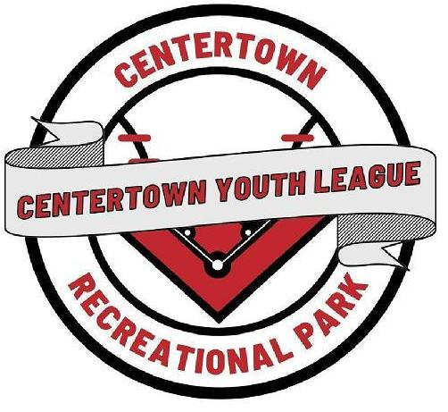

Logo Created By Emily Scott

CENTERTOWN YOUTH LEAGUE
TRAINING DIVISION GAME RULES

2026 EDITION
Any other rule added or needs to be clarified later if necessary; coaches will be informed

TABLE OF CONTENTS

RULE | TITLE | PAGE(S) | RULE | TITLE | PAGE(S)
1: GAME  Section 1  Section 2  Section 3  Section 4  Section 5  Section 6  Section 7  Section 8  Section 9  Section 10 | Game Schedule  Home/Visitors  Regulation Game  Game Time Limit  Forfeited Games  Suspended Game  Protested Game  Equipment  Apparel  League Bat Use | 3  3  3  4  4  4  4  4-5  5  5 | 7. FIELDING  Section 1 | Players on Field | 10
2. COACHES  Section 1 | Allowed on Field | 6 | 8. GAME TIME OUT  Section 1 | Players/Umpires | 10
3. PLAYERS  Section 1  Section 2  Section 3 | Registration  Ages  Playing/Substitute | 6  6  6 | 9.APPEAL PLAY  Section 1 | Procedures | 10
4. BALL IN PLAY  Section 1  Section 2  Section 3 | Put in play  Ball live in play  Ball dead not play | 6  7  7 | 10. SPORTS MANSHIP  Section 1 | Procedures | 11
5. BATTING  Section 1  Section 2  Section 3 | Batting Order  Batting Out Order  Batting | 7  7  8 | 11. SAFETY OF GAME  Section 1 | Procedures  Games/Practices | 11
6. BASERUNNING  Section 1  Section 2  Section 3  Section 4  Section 5  Section 6  Section 7  Section 8  Section 9 | Batter-Runner  Bat-Runner Out  Base runner safe  Base runner out  Missing Base  Touch same base  Base run Interference  Hit by batted ball  Courtesy runner | 8  9  9  9  9  9  9  10  10 | 12.ILLEGAL  BATS  PLAYING  FIELD  FIELDERS  POSITION  COACHES | Not to be use  Layout  Layout  Code of Conduct  Correction Action | 12  13  14  15  16

RULE 1: GAME

SECTI0N 1: GAME SCHEDULE

1.1.1: Game Schedules and Time are scheduled by the Scheduling Coordinator (30 minutes schedules)
NOTE ON RULE (1.1.1) From the Guidelines and Regulations Games Schedule Section 19.1

1.1.2: There is no game time grace period for any games scheduled at their time

1.1.3: Coaches and players should be at their designated playing field 15 minutes prior to game time.
NOTE ON RULE (1.1.3) From the Guidelines and Regulations Game Schedule Section 19.2

SECTION 2: THE CHOICE OF VISITOR AND HOME TEAM

1.2.1: Team listed first on the season schedule will be the visitor team and be assign to third base dugout.
NOTE ON RULE (1.21): Team listed second on the season schedule will be the home team and assigned to first base dugout.

1.2.2: During Tournament Play; home team will be determined by team flip of a coin.

SECTION 3: REGULATION GAME
1.3.1:
DIVISION | INNINGS PLAY | TIME LIMIT | GAME CALL DUE TO WEATHER
Training | 2  Complete | No Time Limit | Has not reached one (1) complete innings

1.3.2: A game called during season play due to weather during the game, will be subject to reschedule and start from the top of the first inning as a new game, (umpire, or umpire- in-chief, or youth league director are NOTE ON RULE 1.3.2): (a) Umpire Coordinator, or Building and Grounds Coordinator or Youth League Director are empowered to make the call,(b) Rain delay will be determined by the umpire coordinator or buildings and grounds coordinator or youth director.

1.3.3: A game called during tournament play due to weather, which cannot be resumed within 30 minutes, will be subject to reschedule and start from the top of the first inning as a new game, (umpire coordinator, or building and grounds coordinator, and/or youth league director are empowered to make the call),

1.3.4: If a season game has to be rescheduled toward the end of the season, then it’s up to the scheduling coordinator and/or youth league director to play the game or not.

1.3.5: The home plate umpire, or umpire coordinator, or buildings and grounds coordinator or youth league director are empowered to call a game any time because of rain, darkness, or for any of cause which puts the umpire, coaches, players or the patrons in peril.

SECTION 4: GAME TIME LIMIT

1.4.1: No Time Limit

SECTION 5: GAME PLAYERS NEEDED OR BECOMES A FORFIETED GAME

5.1.1: If both teams doesn’t have enough registered roster players. Since no win and losses count, no penalty, the game will not be rescheduled.

1.5.2: The two teams present can divide up the two teams C.Y.L. registered roster players to play the game or pick up players from another C.Y.L. training division team or play with what they have present.

SECTION 6: A SUSPENDED GAME FROM GAME STOPPAGE

1.6.1: A suspended game is halted before it can be completed, and the game is meant to be finished at a later time or date. Such as;
[] Weather Conditions
[] Field Conditions
[] No power
[] Facilities issues
[] Other interruption that makes it impossible to continue the game safely.

1.6.2: If game has to be make-up, it will start as a new game.

SECTION 7: PROTESTED GAME

1.7.1: There are no protests in this division.

SECTION 8: EQUIPMENT
1.8.1:
BALL | BAT | BATTING HELMET | GLOVE | BATTING TEE
RIF 1 or Level 1 9” Safe T Ball or compatible approved by youth league director. | Baseball/Tee Ball  Fast Pitch  No Wooden Bats  No Titanium Bats  No Senior Slow Pitch Bats | Meets NOCSAE standards or above (must have both ear flaps). Face masks are optional (not required). | Baseball or softball | Provided by the Youth League During Games.

1.8.2: Bat; No bat should be 26” in length and no more than 16 oz. See Rule 12 Banned/Altered Bats; page 13
1.8.3: Batting Helmet; Helmets must be worn in practices and games at bat and running the bases. (No penalty if fall off during times)

1.8.4: Fielder’s Glove; is highly encouraged, but if the fielder decides not to wear completely during the game, there is no penalty.
NOTE ON RULE: If player decides not to wear completely, the player should play behind the infielders whom have a glove on.

1.8.5: Pitcher Mask is an option (not required).

1.8.6: Catcher Mask/Helmet: No player assigned to catcher, so not needed.

1.8.7: Fielders Mask is an option (not required).

1.8.8: Batting Tee;

SECTION 9: PLAYERS AND COACHES APPAREL

1.9.1: Shirts: during practice and games must be worn. No shirts shall be worn at park that has any alcohol, drug, offences of any kind, or other illegal name on it. Encourage parents and players to wear team sponsor shirt to all games.

1.9.2: Pants/Shorts: no pants or shorts that are loose dropping down the waist line during practice and game.

1.9.3: Shoes: during practice and games must be worn (no steel cleats and/or wrap around steel cleats)
1.9.4: Caps/Hats: optional-not required. No caps/hats shall be worn at park that has any alcohol, drug, offences of any kind, or other illegal name on it

SECTION 10: LEAGUE BAT USE RULE

1.10.1: Whatever bat is brought to the game of play, must be align along the fence row near home plate area on their side of field.

1.45 Either team player has the right to use that bat during the game, no matter if it’s the visitor or home team or who brought the bat on the playing field.
- If a player, coach and/or parent, etc. doesn’t want another player to use the bat, they shouldn’t bring it to the game.
- For the protection of the bat owner, the player shall be told by the bat owner and coach if the bat is misuse such as throwing the bat against the fence or slamming to the ground, causing any damage, etc. that player will not be allowed to use that bat again and may be subject at their expense of replacing that bat to the owner.

RULE 2: COACHES

SECTION 1: COACHES ALLOWED ON FIELD

2.1.1: As many coaches you want, during batting, base running and fielding. We encourage the team to try to get all parents to participate with their child and the players.

2.2.2: Team Head Coach shall be the team representative and abide by all playing rules and regulations.

RULE 3: PLAYERS

SECTION 1: PLAYERS REGISTRATION

3.1.1: Player must be official registered in the Centertown Youth League to practice and/or played ball in the youth league.

3.1.2: There is a fee set by the Youth League to pay.

SECTION 2: AGES

3.2.1
- Girls: ages 3
- Boys: ages 3
- Age Cut off is May 1st (Whatever age is by than of the season year will determined Divisional Play)
- Age (3) must be by July 1st
- A Player can always play up one division if they are within one (1) year of the age in Division.

SECTION 3: PLAYING AND SUBSTITUTES

3.3.1: All players that show up play in the game on offense and defense.

3.3.2: Can pick up players from the other C.Y.L. registered training division teams,

3.3.3: The two teams present can divide up the two teams C.Y.L. registered roster players to play the game.

3.3.4: Free substitution throughout the game, player can come on and off the field anytime with no penalty,

RULE 4: BALL IN PLAY AND DEAD BALL

SECTION 1: THE BALL IS LEGALLY PUT IN PLAY BY THE UMPIRE

4.1.1: Start of the game, each inning and every batter the umpire places the ball on the batting tee and signals “play or batter up”
SECTION 2: THE BALL IS LIVE AND IN PLAY

4.2.1: Once the batted ball off the tee goes beyond the fair play arc.

4.2.2: A fair batted or thrown live ball accidentally strikes the coach or umpire.

4.2.3: Any thrown ball goes into foul territory and is not blocked or been obstructed.

4.2.4: A live ball strikes a photographer or others when they are assigned to the field as part of the game.

SECTION 3: THE BALL IS DEAD AND NOT IN PLAY

4.3.1: After each bat swing that doesn’t go beyond the fair play arc..

4.3.2: A batter is hit by their, own batted ball, either fair or foul.

4.3.3: Offensive team member or their equipment causes a blocked ball.

4.3.4:. Offensive team member cause interference.

4.3.5: A blocked ball occurs.

4.3.6: A over thrown ball goes over or under a fence

4.3.7: When time is called for any reason by the umpire.

RULE 5: BATTING

SECTION 1: BATTING ORDER

5.1.1: Girl or Boy may bat in any order of the line-up.

5.1.2: Batting order must be turned into the scorekeeper before the game starts.

5.1.3: If a player shows up late, they will be added to the bottom of the line-up.

5.1.4: If a player leaves the game early, there will be no penalty.

SECTION 2: BATTING OUT OF ORDER

5.2.1: There is no penalty for batting out of order, just make sure all batters present bat in that inning.
NOTE ON RULE: Please have someone assigned to keep the batters in order as much as possible.

SECTION 3: BATTING

5.2.1: Each team will bat all the players that show up for the game each inning.

5.2.2: All players bat each inning.

5.2.3: If a player in line-up refuses to bat, there is no penalty.

5.2.4: The ball placed on the team by the umpire
NOTE ON RULE: Make sure all defensive and base-runners are aware of play

5.2.5: The batter is allowed up to five (5) full swings to hit the ball in fair play.

5.2.6: Fair play is considered any batted ball off the tee in fair territory.
NOTE ON RULE: Fair territory is beyond the 12 foot arc. Home Umpire has the judgment call to allow the batter to run on last swing if the ball is contacted in fair play before reaching the 12 foot arc.

5.2.7: If the batter does not hit the ball in fair play after the five (5) full swings, the batter will be awarded first base. [Any other advance runner(s) get their awarded base].

5.2.8: If a player is struggling to hit the ball in play, the coach has the right to help the batter swing the bat by holding the player’s hands.

5.2.9: If the batter swings the bat in fair territory or foul territory, then the play becomes dead and the coach is required to hold the player’s hands to bat again. A bat swing is counted.
NOTE ON RULE: A bat swing count is added.

5.2.10: There are no outs counted and no player can be called out.

5.2.11: On deck batter must be inside the exit area of the dugout. Shouldn’t be on the playing field

5.2.12: If a pop, fly or line drive batted ball is caught, the batter will still advance to the base.
NOTE ON RULE: If caught, ball becomes dead and batter is awarded first base.

5.2.13: Last batter of the inning will be announced by the scorekeeper and umpire.

5.2.14: Last batter and all base runners will run all bases after the ball is put in fair play to home plate and the fielder brings the ball in and touches home plate.
NOTE ON RULE: If the batter doesn’t put the ball in play after five (5) full swings, then the batter and all runners should still run all the bases.

5.2.15: During last batter, all fielders should stay in the defensive playing field until all runners, including the batter runner touches home plate.

RULE 6: BASE-RUNNING

SECTION 1: BATTER BECOMES A BASE RUNNER

6.1.1: Batter becomes a base runner after putting the ball in fair play.

6.1.2: Batter becomes a base runner, if fail to put the ball in fair play after 5 full swings.

SECTION 2: BATTER-RUNNER IS NEVER CALLED OUT

6.2.1: Batter base runner refuses to not run the bases, there is no penalty.

SECTION 3: BASE RUNNER ALWAYS CALLED SAFE

6.3.1: All players will be able to run the bases in each inning. No one is called out, Everyone is safe..
NOTE ON RULE: If a player refuses to run a base there is no penalty, there are no courtesy runners.

6.3.2: Any coach can help the runner to a base by holding their hand or running alongside of them.

6.3.3: No runners should be tagged out or be forced out by a fielder.

6.3.4: If a pop, fly or line drive batted ball is caught, the batter and runners will still advance to the base.
NOTE ON RULE: If caught, ball becomes dead and runners are awarded base entitled to.

6.3.6:If a runner gets hit by a batted ball or runs into a ball in play, a dead ball is called by the umpire and all runners in play advance to that base after passing the halfway base path marker
NOTE ON RULE: If last batter of the inning, play continues on, until the fielder has brought the ball to home plate and touches.
- Unless play has stop due to an injured player or umpire judgment call to stop play for other reasons. The inning is completed.

SECTION 4: BASE RUNNER NEVER CALLED OUT

SECTION 5: MISSING A BASE (NO PENALTY)

6.5.1: Player’s must try touch each base advancing to. If a runner is out of base path or skipping a base there is no penalty. Play will stop by umpire.

SECTION 6: BASE RUNNERS TOUCHING SAME BASE (NO PENALTY)

6.6.1: The lead runner gets the base, the other returns to previous base

SECTION 7: BASE RUNNER INTERFERENCE

6.7.1 If a runner gets runs into a ball in play or a fielder, a dead ball is called by the umpire and all runners in play advance to that base after passing the halfway base path marker
NOTE ON RULE: If last batter of the inning, play continues on, until the fielder has brought the ball to home plate and touches.
- Unless play has stop due to an injured player or umpire judgment call to stop play for other reasons. The inning is completed.

SECTION 8: BASE RUNNER HIT BY BATTED BALL:

6.8.1: If a runner gets hit by a batted ball or runs into a ball in play, a dead ball is called by the umpire and all runners in play advance to that base after passing the halfway base path marker
NOTE ON RULE): If last batter of the inning, play continues on, until the fielder has brought the ball to home plate and touches.
- Unless play has stop due to an injured player or umpire judgment call to stop play for other reasons. The inning is completed.

SECTION 9: COURTESY RUNNER (ARE ALWAYS ALLOWED ON ANY RUNNER ON BASE)

RULE 7: FIELDING

SECTION 1: PLAYERS ON THE FIELD

7.1.1: All players’ play the field; if a player refuses to play the field there will be no penalty.

7.1.2: Players playing the infield must be in the infield positions (such as third base, shortstop, second base, first base inside the marked infield box and pitcher in the marked pitcher circle.

7.1.3: All other players besides the pitcher and infielders must be located anywhere behind the base running marked box.

7.1.4: Try to keep the players in the positions until the batted ball is hit off the tee. No penalty if players move outside the marked lines.

7.1.5: No player will be assigned to catcher position.

7.1.6: Last batter of the inning will be announced by the scorekeeper and umpire. The batted ball in fair play, the fielder who has the ball at the time will run to home plate and touch it.
NOTE ON RULE Unless play has stop due to an injured player or umpire judgment call to stop play for other reasons. The inning is completed.

7.1.7: During last batter, all fielders should stay in the defensive playing field until all runners, including the batter runner touches home plate.

RULE 8: GAME TIME OUT

SECTION 1: UMPIRE CALL

8.1.1: Time is called by the umpire not the players.
NOTE ON RULE: The coach has the right to teach the player to call time out from the tee ball rule, but it is still official when the umpire declares time.

8.1.2: The ball must be in control by the defense player brought inside the pitcher circle

RULE 9: APPEAL PLAY
There are no appeal plays

RULE 10: UNSPORTSMANSHIP

SECTION 1: GAMES AND PRACTICES
Centertown Youth League emphasizes; maintaining a family friendly environment and ensuring respect for officials, coaches, players and spectators along with preventing escalation between teams and players. Applies; to all practices and games.

10.1.1: There shall be no taunting and/or any other bad behavior toward the players, coaches, umpires and officials by anyone.

10.1.2: Demeaning comments toward umpires, opponents, or spectators.

10.1.3: Any behavior that disrupts the game or creates hostility

10.1.4: Profanity or abusive language

10.1.5: Verbal threats

Note: See also Rule 2: Section 4 Coaches about ejections and warnings; Rule 3:Section 4 Players about ejections and warnings.

Centertown Youth League has a section about Parents and Spectators behavior.
Centertown Youth League Guidelines and Regulations Section 7: Code of Conduct

RULE 11: SAFETY OF THE GAME

11.1.1 Keep all players that are not playing on the field in dugouts with the exception of base runner(s) and batter.

11.1.2: Do not climb on fences (including dugouts)

11.1.3: Do not stand on dugout benches

11.1.4 Do not throw any objects (including dirt, sand and rocks) on the field and in the dugouts.

11.1.5: Only game ball should be thrown around at the appropriate time.

11.1.6: Do not sling bats around.

RULE 12: ILLEGAL BATS NOT TO BE USE IN PRACTICES/PLAY

SECTION 1: DAMAGED BATS
As one that shows cracks, dents, rattles, loose end caps, loose knobs, or structural failure. These bats are considered unsafe and cannot be used in practices/play.

SECTION 2: ALTERED BAT

12.2.1 An altered bat is any bat that has been changed from its original factory condition. This includes, but is not limited to: shaving, rolling, end-loading, re-capping, painting or repainting, heating, sanding, drilling, or modifying internal or external components. Any bat that fails compression testing and shows signs of tampering shall be considered altered. Any bat with removed, modified, or obscured certification markings is also considered altered.

SECTION 3: OTHER BATS

12.3.1 Not to be used:
[] All Senior Slow pitch Softball
[] All Titanium bats
[] Wood bats

SECTION 4: ILLEGAL BATS
CYL has a list if regular softball bats; that are illegal and banned to use, mostly in the upper divisions.

Training Division Playing Field Layout

A
D
A

B

E

C

D

F

E
A

C
A

D

- Bases 45’ apart
- Batted Ball Fair Play Arc- 12 feet from home plate
- Base Path- 6 feet wide
- Time Out Base path marker- 27 ½ feet
- Defensive infielder Player Box- 3 feet wide
- Pitcher Circle 40’ to bottom of circle (45’ to center) 50’ to top of circle.
Circle is 10 feet wide

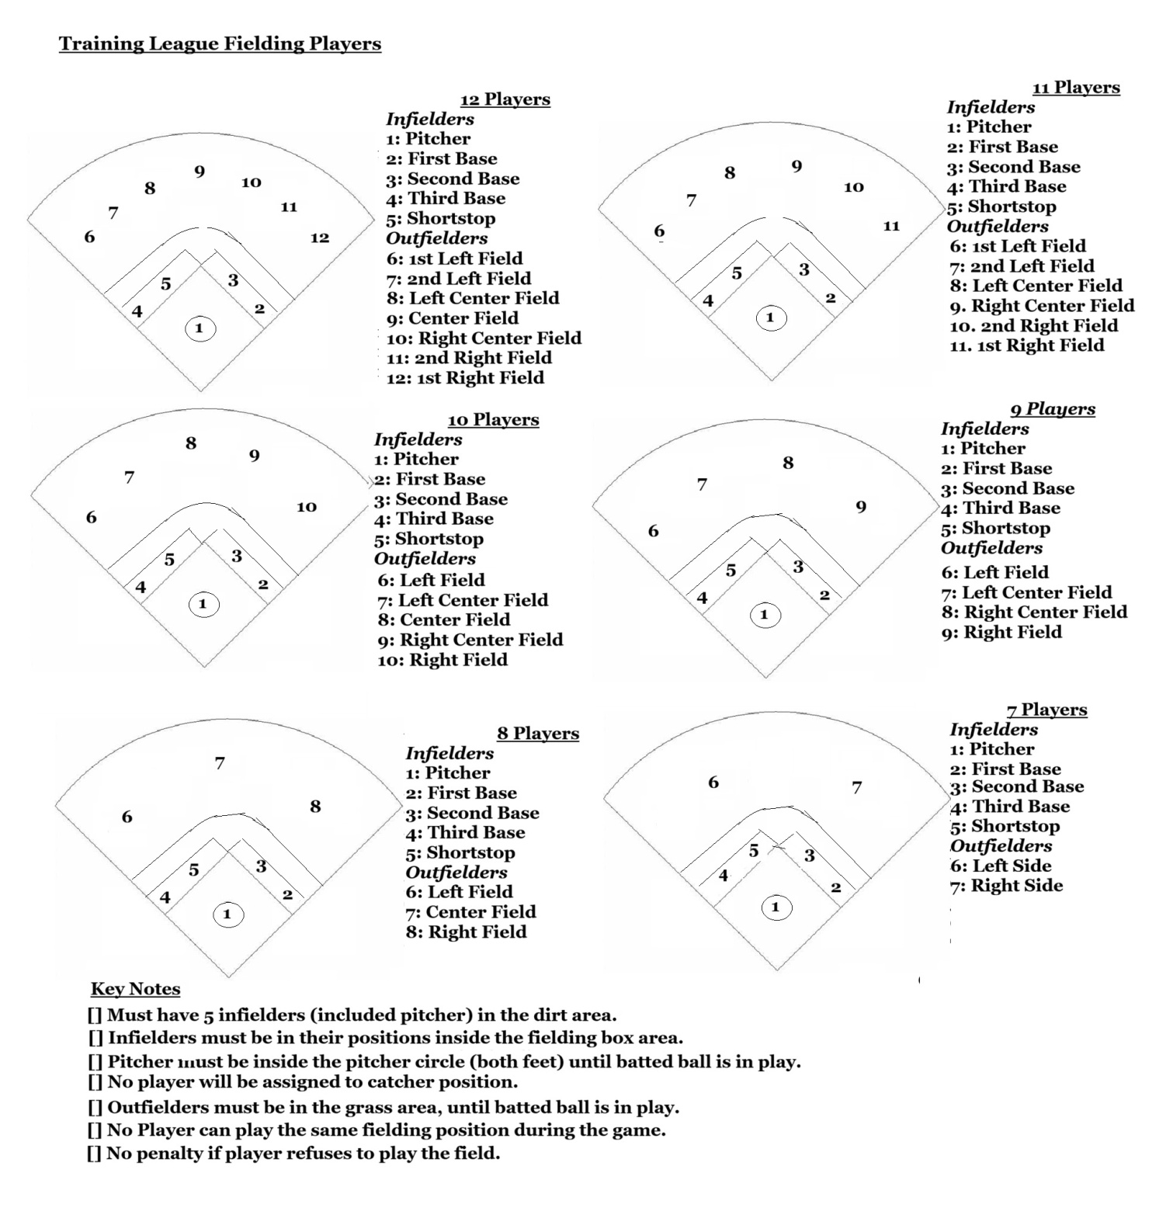

Section 9: Coaches Code of Character and Conduct | Coaches

From the Centertown Youth League Guidelines and Regulation Manual
CORE COMMITMENT
I will coach-always prioritizing safety, respect and integrity of the game and rules.

RESPECT AND SPORTSMANSHIP
[] Treat all players with fairness, patience, and dignity.
[] Model positive behavior toward umpires, opponents, spectators and league officials.
[] Never use profanity, ridicule, or humiliation.

PLAYER DEVELOPMENT
[] Focus on teaching fundamentals, teamwork, and confidence.
[] Provide equal opportunities for learning and improvement.
[] Never pressure a player to play through injury.

COMMUNICATION
[] Communicate clearly and respectfully with players and parents.
[] Address concerns privately and constructively.
[] Maintain appropriate boundaries with players.

INTEGRITY AND ACCOUNTABILITY
[] Follow league rules and guidelines.
[] Admit mistakes and model responsibility.
[] Avoid favoritism, conflicts of interest, or unethical behavior.

POSTIVE TEAM CULTURE
[] Encourage teamwork, effort, and resilience.
[] Celebrate improvement, not just outcomes.
[] Create an environment where every player feels valued.

Section 10: Coaches Corrective Action | Coaches

From the Centertown Youth League Guidelines and Regulation Manual
This policy ensures coaches uphold the Code of Conduct and provides a fair, consistent process for addressing concerns.

LEVEL1: MINOR CONCERNS
Examples: occasional frustration, unclear communication, inconsistent expectations.

Actions
[] Verbal reminder from league director or league official.
[] Review of the relevant Code of Conduct section.
[] Coach reflects on behavior and adjusts approach.

Goal
Early correction before issues escalate.

LEVEL 2: MODERATE CONCERNS
Examples: repeated negative tone, favoritism, arguing with umpires, poor sideline behavior.

Actions
[] Formal conversation with league leadership
[] Written summary of concern and expectations
[] Provide corrective steps (eg.; sportsmanship training, mentorship with league official)
[] Follow-up evaluation within 1-2 weeks.

Goal
Support the coach in improving behavior and maintaining standards.

LEVEL3: SERIOUS VIOLATIONS
Examples: yelling at players, disrespecting parents, unsafe practice methods, ignoring injury concerns.

Actions
[] Written or verbal warning
[] Temporary suspension from practices or games and park grounds.
[] Meeting with league board and parents if needed.

Goal
Protect players and restore trust.

LEVEL 4: SEVERE OR REPEATED VIOLATIONS
Examples; bullying, harassment, physical aggression, retaliation, boundary violations, repeated misconduct despite warnings.

Actions
[] Immediate suspension pending review
[] Investigation by league board
[] Possible removal from coaching positions
[] Possible banned from the park grounds.

Goal
Ensure player safety and league officials and uphold league integrity.

COMMUNICATION AND DOCUMENTATION
[] All concerns are handled privately and respectfully.
[] Coaches are given the opportunity to share their perspective
[] Parents are informed when issues affect player safety or team environment
[] All Level 2-4 actions are documented for future references.

Section 7: Parents/Spectators Code of Conduct | Parents/Spectators

From the Centertown Youth League Guidelines and Regulation Manual

CORE EXPECTATION
Spectators will model respect, positivity, and sportsmanship at all times to support a safe and enjoyable environment for all players.

RESPECT FOR PLAYERS
[] Cheer positively for all players
[] Never criticize or yell at any child
[] Avoid coaching from the sidelinews and bleachers.
[] Allow players to learn through mistakes

RESPECT FOR COACHES AND OFFICIALS
[] Allow coaches to coach, they are volunteering their time and energy to help with the league and your child.
[] Allow umpires to officiate without interference
[] Refrain from arguing calls or showing negative reactions.
[] Address concerns privately and calmly, never during games.

RESPECT FOR THE TEAM ENVIRONMENT
[] Support all players, not just your own.
[] Avoid gossip, drama, or negative sideline conversations
[] Keep language and behavior family-friendly.
[] Follow all facility rules and league policies/

POSITIVE COMMUNICATION
[] Use encouraging, uplifting language
[] Avoid yelling instructions or criticism
[] Keep emotions under control, even in tense moments.

ZERO TOLEREANCE BEHAVIORS
The following behaviors are strictly prohibited:
- Harassment or intimidation of players, coaches, officials or other spectators.
- Profanity or aggressive behavior
- Confrontations with coaches or officials during games.
- Entering the field of play without permission.
- Any behavior that compromises safety or sportsmanship.
- Any use of alcohol or illegal drug.

Section 8: Parent/Spectators  Corrective Action | Parents/Spectators

From the Centertown Youth League Guidelines and Regulation Manual

This policy ensures that spectator behavior is addressed consistently, fairly, and with the goal of protecting the players experience.

LEVEL 1: FIRST CONCERN-VERBAL REMINDER
Examples; mild complaining, negative comments, sideline or bleachers coaching.

Actions:
[] Coach or league representative gives a calm, respectful reminder.
[] Spectator is ask to adjust behavior
[] No formal documentation unless behavior repeats.

Goal
Redirect behavior early and maintain a positive environment

LEVEL 2: CONTINUED OR MODERATE ISSUES-FORMAL WARNING
Examples: repeated sideline coaching, arguing calls, disrespectful comments.

Actions
[] Spectator receives a formal warning from league official
[] Spectator may be asked to step away from the field for the remainder of the game.
[] Follow-up communication after the game.

Goal
Make expectations clear and prevent escalation.

LEVEL 3: SERIOUS MISCONDUCT-REMOVAL
Examples: yelling at players, confronting coaches or officials, profanity, aggressive behavior.

Actions
[] Spectator is removed from the facility for the remainder of the game
[] Mandatory meeting with league leadership before returning

Goal
Protect players, coaches, and officials from harmful behavior.

LEVEL 4: SEVERE OR REPEATED VIOLATIONS-SUSPENDED OR BAN
Examples; threats, harassment, physical aggression, repeated violations despite warnings.

Action
[] Immediate removal and temporary suspension from future games.
[] Review by league board
[] Possible season-long or permanent ban.

Goal
Ensure safety and uphold league integrity.

COMMUNICATION AND ENFORCEMENT
- All actions are handled respectfully and privately
- Coaches are not responsible for discipline spectators during games, but must be aware it could go against their team under a forfeited game if spectator does not leave. (This is a league decision)
- League officials or designated staff handle enforcement
- Documentation is kept for Levels 2-4 to ensure fairness and future protection.

NOTICE
It is illegal for anyone to: Intentionally use abusive, indecent, profane, or vulgar language. Make an offensive gesture in a public place if it incites a breach of the peace. Make unreasonable noise in a public place or abuse or threaten someone in an obviously manner. This park, known as the Centertown Recreational Park is a public place.
2021 Tennessee Code Title 39-Criminal Offenses Chapter 17-Offenses Against Public Health, Safety and Welfare Part 3-Disorderly Conduct and Riots Section 39-17-305. Disorderly Conduct
- A person commits an offense who, in a public place and when intent to cause public annoyance or alarm:

1. Engages in fighting or in violent or threatening behavior;

2. Refuses to obey an official order to disperse issued to maintain public safety in dangerous proximity to a fire, hazard or other emergency;

or 3. Creates a hazardous or physically offensive condition by any act that serves no legitimate purpose.

b. A person also violates this section who makes unreasonable noise that prevents others from carrying on lawful activities. c. A violation of this section is a Class C misdemeanor.

Section 20: Coach-Parent Agreement | Coaches/Parents
From the Centertown Youth League Guidelines and Regulation Manual
PURPOSE
PURPOSE
Ensures that coaches and parents work together to create a safe, positive, and development-focused environment for every player on the team.

COACH RESPONSIBILTY | PARENT RESPONSIBILTY
Abide by league game rules and the recreational park rules. No Pets-and Smoking Areas  Prioritize Player Well-Being  [] Keep players physically and emotionally safe  [] Never pressure a player to play through pain or injury.  [] Promote hydration, proper warm-ups, and safe equipment use.  Model Respect and Sportsmanship  [] Treat all players, parents, umpires, and opponents with respect.  [] Demonstrate calm, positive behavior during games and practices.  [] Avoid yelling, humiliation, or negative coaching tactics.  Communicate Clearly  [] Provide schedules, expectations, and updates in a timely manner  [] Address concerns privately and respectfully  [] Maintain appropriate boundaries with players and families  Support Player Development  [] Teach fundamentals, teamwork, and confidence  [] Give constructive feedback and celebrate improvement/  [] Make playing-time decisions based on effort, attitude, and safety. | Abide all the recreational park rules. No Pets-and Smoking Areas  Support Your Child Positively  [] Encourage effort, resilience, and sportsmanship.  [] Avoid coaching from the sidelines or bleachers  [] Help my getting your child there on time for games and practices. If something comes up, please let the coach know about it.  Respect Coaches and Officials  [] Allow coaches to coach and umpires to officiate  [] Address concerns calmly and privately, never during games.  [] Avoid negative comments toward players, coaches, or officials.  Promote a Healthy Team Environment  [] Model good sportsmanship at all times  [] Support all players, not just your own.  [] Avoid gossip, drama, or behavior that harms the team culture and league integrity.  Communicate Responsibly  [] Share concerns respectfully and at appropriate times.  [] Inform coaches of injuries, absences, or emotional concerns.  Player practice and games participation  [] If players do not attend at least half of the schedules practices, coaches shall have the prerogative to not start that player during that game schedule.  [] If players’ missies more than half of games schedule, coaches shall have the prerogative to not start play or not play said player during that game schedule.  [] Players shall have the dedication to attend practices and/or games or the courtesy from the player and/or parent to say to that coach why they cannot.

