Sponsorship Program | 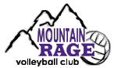

Participation in USA Volleyball is a rewarding, yet expensive activity. Gym time, tournament and USA Volleyball fees, equipment and uniforms contribute to a per player cost of nearly $500. Without sponsors, many girls would not have the opportunity to play. Mountain Rage Volleyball Club is a not-for-profit athletic organization that puts all funds back into improving the experience for our young players. Your assistance, regardless of what amount, is appreciated.

$100 to $199
Rotational shared banner advertisement at www.mountainrage.com
Listed on “Sponsor” page with link to your website
Club photo suitable for display at your business
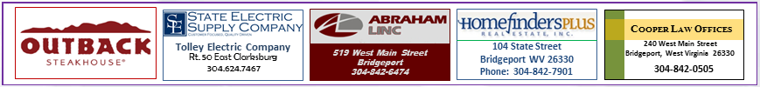

$200 to $399
Rotational personalized banner advertisement at www.mountainrage.com
Banner linked to your website!
Listed on “Sponsor” page with link to your website
Club photo suitable for display at your business


$400 or more
Same as $200 level plus you will receive a signed club volleyball for display
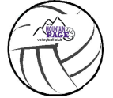

DONATIONS
Your gift of any amount is appreciated and will help our players represent North Central West Virginia throughout the Ohio Valley Region.
SPONSORSHIPS CAN BE SENT TO: Mountain Rage VbC – 21 Long Meadow Dr. – Bridgeport, WV 26330

Business Name: _______________________________________________________________________

Business Address: ______________________________________________________________________
Street City State/Zip
Web Address: _________________________________________ Email: _________________________

Business Contact Name: _________________________________ Phone: ________________________

Player Name: __________________________________________ Amount: $_____________________

