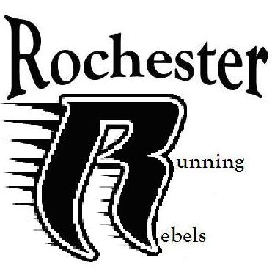

Rochester Running Rebels Track Club
Athlete Application

Name____________________________ Age______ Birthdate_____________________

Address_________________________Zip______ Email_________________________

Phone number__________________________ Cell Phone_________________________

Emergency Contact other than Parent_______________________Phone______________

Insurance Carrier__________________________ I.D.Number_____________________

Medical condition ________________________Allergies_________________________

Are you participating on the travel team? Yes No

If under 18 years of age, parental consent is required. Also there is an additional cost required for travel to the National Jr. Olympic in Wichita Kansas for example, hotels, meals and transportation cost.

PARENT SIGNATURE FOR TRAVEL _______________________________________

Please list any event that you wish to participate in competitive competition on the travel team.___________________________________________________________________
________________________________________________________________________
________________________________________________________________________
________________________________________________________________________

CODE OF CONDUCT:
All athletes and members representing Running Rebels Track Club shall conduct themselves in a professional manner both on and off the field. Athletes are required to show respect to all adults, competitors, coaches and officials. This club does not condone fighting or verbal confrontation at any time; if any such conduct is observed, the athlete will be removed from the team and not allowed to participate in any future events. (without refund)

I hereby agree to follow the code of conduct outlined above for the Running Rebels Track Club.

PARENT SIGNATURE ___________________________________________________

ATHLETES SIGNATURE _________________________________________________

