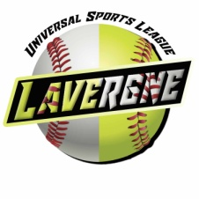
USL LaVergne Baseball Softball Association
Universal Sports League LaVergne Baseball Softball Association (USL LBSA) is looking for your support for our Spring and Fall Seasons.
USL LBSA strives to provide a foundation of integrity, self-confidence, discipline, sportsmanship, and competitive fun through involvement in organized sports in the community
Universal Sports League LaVergne Baseball Softball Association strives to build community involvement and to provide exposure for local businesses. We will promote our website to induce more traffic to view sponsor banners and add more value for you.
Your sponsorship will allow us to keep registration costs down and also allow us to purchase the necessary equipment to keep the league successful.
USL LBSA will gladly and gratefully accept any donation of any size. The sponsorship levels described below are designed to offer convenient, no-hassle options for donations.
If you would like to take advantage of this opportunity to support your community, please complete the attached form and submit it to:
Universal Sports League LaVergne Baseball Softball Association
Or USL LBSA
PO Box 223
La Vergne, TN 37068

If you have any questions, please feel free to contact

Julia Vestal at 615-305-5890
Email: usl.lbsa@gmail.com

Rick Autery at 615-545-9925
Email: rick.autery@gmail.com

Visit our website at universalsportsleague.org

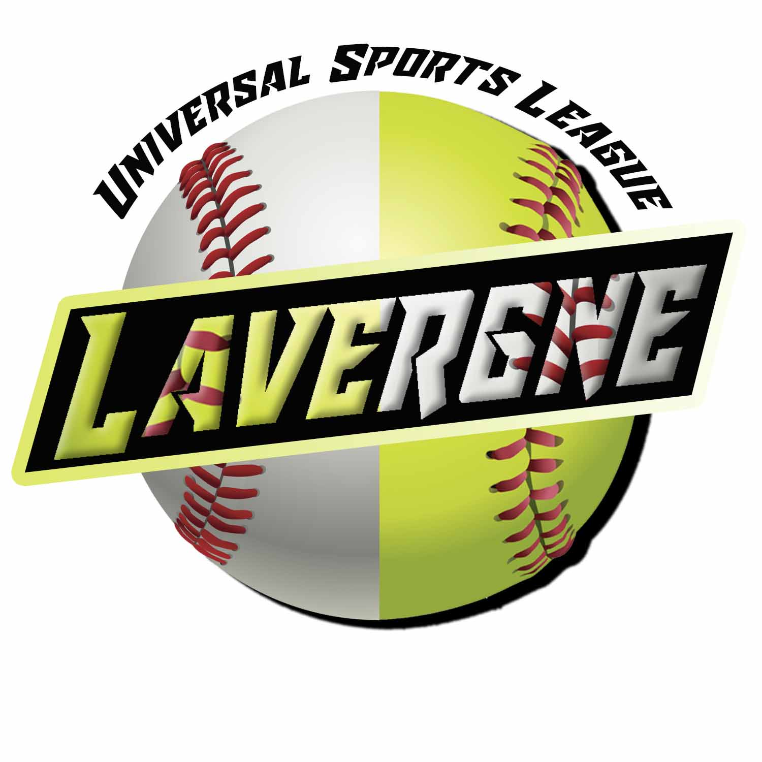
Universal Sports League LaVergne Baseball Softball Association
Sponsorship Form

Company Name: _____________________________________________________
Street Address:_______________________________________________________
City _____________________ Zip Code _______________________________
Contact Person ______________________ Telephone_________________________
Web Address ______________________________
Email ____________________________________

Please check one of the sponsorship levels below. Send this form along with your logo in .jpeg, .jpg or .pdf and payment. Mail to:
USL LBSA
PO Box 223
La Vergne, TN 37086

We agree to sponsor Universal Sports League LaVergne Baseball Softball Association as a:

___Standard level ($150-349 Spring or Fall Season/$300-599 Spring & Fall Season) –
Company name will be placed on league banners to be displayed at the park.
Company name/logo will go on USL LBSA’s website to show sponsorship.

___Level 2 ($350-599 Spring Season/$600 Spring or Fall & Fall Season) –Standard level benefits plus your company name/logo will be placed on a 4x6 banner to be displayed on one of the fields.

___Level 3 level ($600-up Spring or Fall Season/$1200-up Spring & Fall Season) – Level 2 package benefits plus your company name/logo will be placed on uniforms of 1 team of the league’s choice unless requested by sponsor.

___Other Level 4- Specify Amount: _______________
Company name will be placed on league banners to be displayed at the park. Individual or anonymous donations will be kept private at your request.

*For amount greater than Level 3 the company name/logo will be placed on the uniform of an additional team of the league’s choice unless requested by sponsor.

Thank you for your support to USL La Vergne Baseball Softball Association.

Signature ___________________________ Date _______________________________

USL LBSA appreciates your generosity and support!

