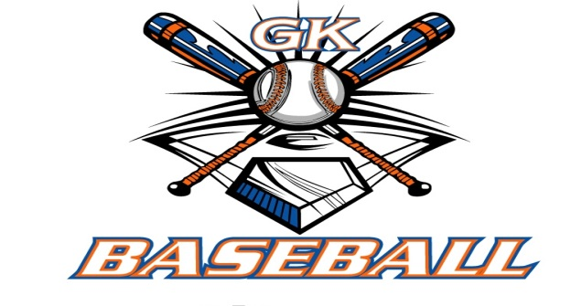
G-K BASEBALL MEETING NOTES
May 11, 2016
Call to Order
8:27 PM @ Genoa Veterans Home

Member Attendance Guest Attendance
- Ed Frye
- Larry Creadon
- Scott Franson
- Jerry Kline
- Chad Pacey
- Chris Welch
- Steve Younker
- Dave Grimm
- Troy Oates
- Steve Kleba

Approval of previous month minutes: December Meeting
Motion by: Steve Y
2nd : Dave G
Yes 9 No 0 Abstain Passed X

Treasurers Report (Closed Session)
Reg. Opening Bal: $ 34,448.65 (does not include opening day money) Concession Bal: $ 9,930.18
Income: $ Income: $
Expenses: $ Expenses: $
Notes: Ending $ Ending $ TOTAL $
Treasurers Report
Motion by: Steve Y.
2nd: Steve K.
Yes 9 No 0 Abstain Approved X

G-K BASEBALL Committee Reports

Old Business

New Business
- Scholarship recipient- Cole Blank
  - Mr. McPherson issuing at awards ceremony tonight.
- Review Opening Day-
  - Possibly come up w/ rain date next year
  - Suggest collect tickets and money prior to opening day
  - Suggest pushing picture day 1-2 weeks earlier and have that be ticket turn in
- Reminder on GES South parking at ACE Hardware; need to remind coaches that only two far east rows are to be used
- GES North home team responsible for banner placement and garbage empty
- Blue Badger Update-
  - 14U short one team
  - 12U may be short 1 team due to Elgin drop
  - no 8, 9, or 10U levels
  - Jerry getting barricades for throwing pit area
  - Ed reaching out to T-shirt printer and picture guy
  - Dave moving concession trailer from GMS to HS
  - Agreed on Trophies; approved $1,000

Field Report
Reminder to go out to coaches to re-work mounds, and fill in batters’ and catcher’s boxes after practices and games; last of lost equipment replaced- rakes at GES and Kiernan sheds.

Equipment Report
N/A

Sponsorship Report /Fundraising Report
N/A

Generals Report
N/A

Picture Report
N/A

Concessions Report
N/A

Spirit Wear Report
N/A

Website Report
N/A

OPEN FLOOR ITEMS (See Notes)
- Ed Frye: informed group about Janesville league volunteering requirements; concessions volunteering; each family required to give 2 hours of volunteer time.
- Larry Creadon
- Scott Franson
- Dan Awe
- Jerry Kline: Blue Badger Trophies
- Chad Pacey: Issuing first of umpire checks; mentioned Genoa Days parade; Cougars outing (7/17/16) needs to be paid in full by 6/5/16
- Steve Kleba: New Pony catcher’s gear delivered; teams appreciative; Do we allow 10U Generals to play in 11U division at Blue Badger?
- Chris Welch
- Troy Oates
- Matt Krueger
- Dave Grimm: Discussed new drag attachment for diamond demon; $1,200; Ed suggested finding out if Buck Bros will demo attachment prior to purchase.
- Steve Younker
- Chad Peterson
NOTES:
.
Motion to adjourn:
Motion by:
2nd:
Yes No 0 Abstain Approved
@ PM

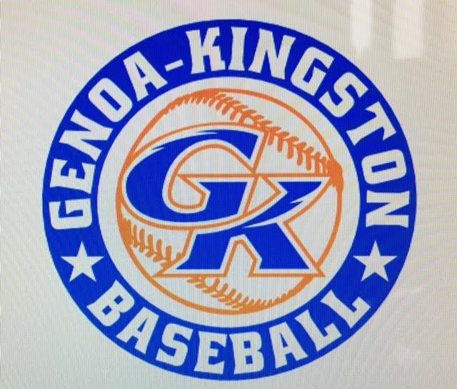

G-K BASEBALL MOTIONS

Motion to approve expenditure of $1,000 for Blue Badger 1st place trophies.
Motion by: Steve Y.
2nd : Jerry K.
Yea 9 Nay 0 Abstain 1 Approved X
************************************************************************************************************************************
Motion to
Motion by:
2nd :
Yea Nay Abstain Approved
************************************************************************************************************************************
Motion to
Motion by:
2nd :
Yea Nay Abstain Approved
************************************************************************************************************************************
Motion to approve
Motion by:
2nd :
Yea Nay Abstain Approved

G-K BASEBALL NEXT MONTH AGENDA ITEMS/ISSUE LIST FOR JUNE 8, 2016
The following items/issues will be part of following month meeting:
Item #1 Set Generals Try-Out Dates
Item #2 Genoa Days Parade Details
Item #3
Item #4
Item #5

ROLL CALL MOTION VOTE NOTES ON ITEMS MORE THAN $1,000: N/A
ROLL CALL VOTE (See Notes)
- Larry Creadon Yes No Abstain
- Jerry Kline Yes No Abstain
- Dan Awe Yes No Abstain
- Scott Franson Yes No Abstain
- Chris Welch Yes No Abstain
- Steve Kleba Yes No Abstain
- Troy Oates Yes No Abstain
- Chad Pacey Yes No Abstain
- Steve Younker yes No Abstain
- Dave Grimm yes No Abstain
- Matt Kreuger yes No Abstain
- Chad Peterson Yes No Abstain
- Ed Frye Yes No Abstain (TIE BREAKER CAST VOTE ONLY)

ROLL CALL VOTE TOTAL
Yes No0 Abstain Motion Approved Motion Failed
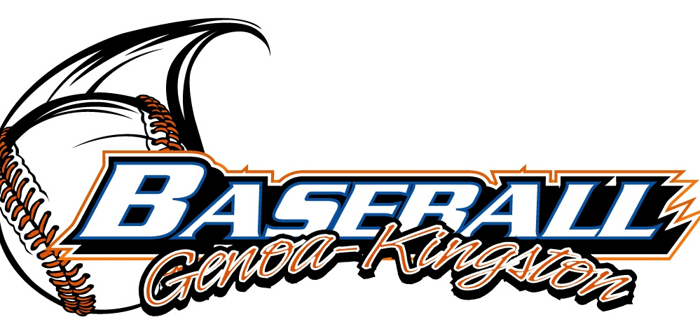

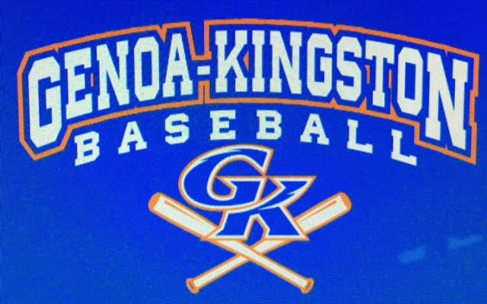

MISC.

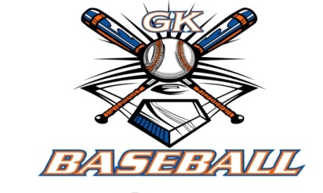
2015-2016 Attendance Attended Not Attended
- Ed Frye 8 0
- Larry Creadon 8 0
- Dan Awe 3 5
- Scott Franson 8 0
- Jerry Kline 7 1
- Chris Welch 8 0
- Chad Pacey 8 0
- Troy Oates 7 1
- Steve Kleba 6 2
- Matt Krueger 7 1
- Dave Grimm 5 3
- Steve Younker 7 1
- Chad Peterson 5 3

