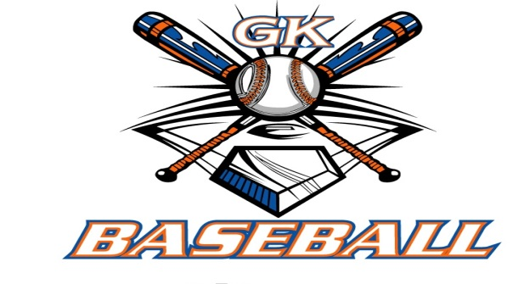
G-K BASEBALL MEETING NOTES
January 11, 2017
Call to Order
8:19 PM @ Genoa Veterans Home

Member Attendance Guest Attendance
- Ed Frye Roger Butler
- Larry Creadon
- Scott Franson
- Chad Pacey
- Steve Younker
- Dave Grimm
- Steve Kleba
- Matt Krueger
- Chad Peterson
- Chris Welch
- Dan Awe

Approval of previous month minutes: November Meeting
Motion by: Dave G.
2nd : Seve K.
Yes 10 No 0 Abstain Passed X

Treasurers Report (Closed Session)
Reg. Opening Bal: $ 20,035.30 Concession Bal: $ 10,250.99
Income: $ Income: $
Expenses: $ Expenses: $
Notes: Ending $ Ending $ TOTAL $
Treasurers Report
Motion by: Steve K.
2nd: Dave G.
Yes 10 No 0 Abstain Approved X

G-K BASEBALL Committee Reports

Old Business

New Business
- Registration Day Saturday Jan 14 (9:00-12:00) and Wednesday Jan 18 (6:00-9:00) @ VFW
  - Available to help: Chris, Matt I., Matt K., Steve K. (sizing kit), Dave, Chad P.
- In-House Coaches needed to set up and supervise GKMS balcony time
  - Chad Pacey sending out message to coaches
  - Discussed middle school complaint of not taking care of wrestling mats
  - Should not allow parents in balcony
  - Take better care of mats
- Wakoh Wear Spirit Wear Update
  - Preparing flyer for spirit wear
- FREE Kane County Cougar Coaches Clinic – Saturday 1/28, 9:00 – 11:30 (RSVP needed)
- Blue Badger Update-
  - Right now, 2 teams @ 14U, 3 teams @ 13U, 2 teams @ 12U, and 1 team at 11U
- Revisited discussion on having evaluations for team establishment
  - Motion by Steve K to get rid of evaluations, but keep draft, second by Matt K.

Field Report

Equipment Report
N/A

Sponsorship Report /Fundraising Report
N/A

Generals Report
N/A

Picture Report
N/A

Concessions Report
N/A

Spirit Wear Report
N/A

Website Report
N/A

OPEN FLOOR ITEMS (See Notes)
- Ed Frye: Belvidere Youth Baseball; would we have more teams outside of Broncos that we’d want to add to BYB program; possibly minor division, but wait until after couple of registrations to see where numbers shake out.
- Larry Creadon
- Scott Franson: concern that coaches and kids aren’t attending the free camps; rumor that certain coach actually encouraged team to NOT attend camp.
- Dan Awe: asked about tees for balcony use; thought there were some tees up there already, if not, let Steve Y. know and can order from BSN
- Jerry Kline:
- Chad Pacey: Camp flyer had wrong dates; making sure website is correct.
- Steve Kleba:
- Chris Welch: Matt Ides could not make meeting, but is available Saturday for registration.
- Matt Ides
- Matt Krueger
- Dave Grimm:
- Steve Younker: Need to start thinking about replacing benches at Kingston West
- Chad Peterson: asked if equipment would be available in balcony for in-house teams.
- Roger Butler: So far, good numbers at open gyms- around 20; 60 present at information meeting; equipment will be available for camps at high school; spring-break trip leaves Thursday ahead off school being out.
NOTES:
.
Motion to adjourn:
Motion by: Steve K.
2nd: Chad Pacey
Yes 8 No 0 Abstain Approved
@ 9:33 PM

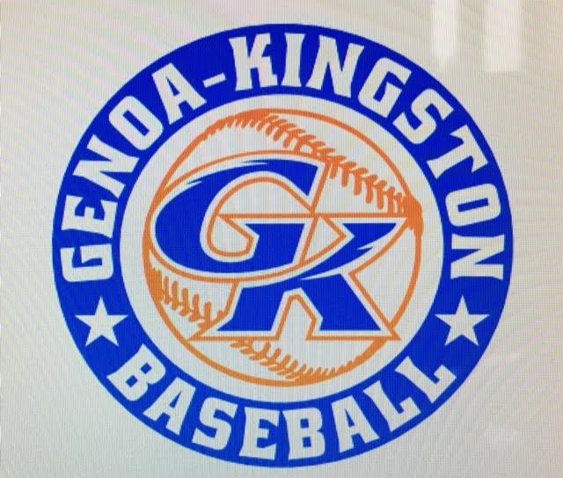

G-K BASEBALL MOTIONS

Motion to: Eliminate evaluations for draft and team determinations
Motion by: Steve K.
2nd : Matt K.
Yea 10 Nay 0 Abstain Approved
************************************************************************************************************************************
Motion to:
Motion by:
2nd :
Yea Nay Abstain Approved
************************************************************************************************************************************
Motion to
Motion by:
2nd :
Yea Nay Abstain Approved
************************************************************************************************************************************
Motion to approve
Motion by:
2nd :
Yea Nay Abstain Approved

G-K BASEBALL NEXT MONTH AGENDA ITEMS/ISSUE LIST FOR FEBRUARY 8, 2017
The following items/issues will be part of following month meeting:
Item #1
Item #2
Item #3
Item #4
Item #5

ROLL CALL MOTION VOTE NOTES ON ITEMS MORE THAN $1,000: N/A
ROLL CALL VOTE (See Notes)
- Larry Creadon Yes No Abstain
- Jerry Kline Yes No Abstain
- Dan Awe Yes No Abstain
- Scott Franson Yes No Abstain
- Chris Welch Yes No Abstain
- Steve Kleba Yes No Abstain
- Matt Ides Yes No Abstain
- Chad Pacey Yes No Abstain
- Steve Younker yes No Abstain
- Dave Grimm yes No Abstain
- Matt Kreuger yes No Abstain
- Chad Peterson Yes No Abstain
- Ed Frye Yes No Abstain (TIE BREAKER CAST VOTE ONLY)

ROLL CALL VOTE TOTAL
Yes No Abstain Motion Approved Motion Failed
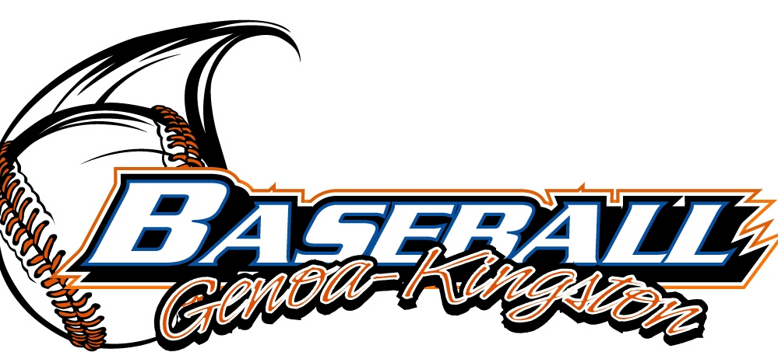

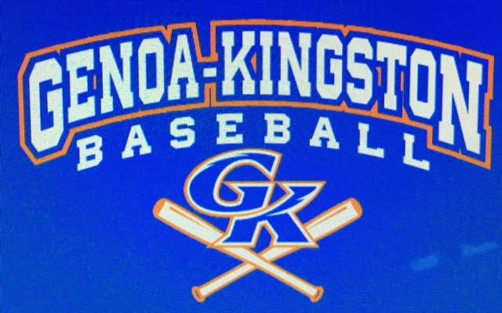

MISC.

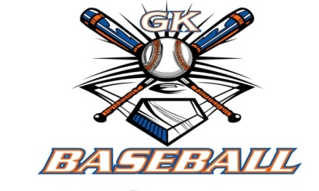
2016-2017 Attendance Attended Not Attended
- Ed Frye
- Larry Creadon
- Dan Awe
- Scott Franson
- Jerry Kline
- Chris Welch
- Matt Ides
- Chad Pacey
- Steve Kleba
- Matt Krueger
- Dave Grimm
- Steve Younker
- Chad Peterson

