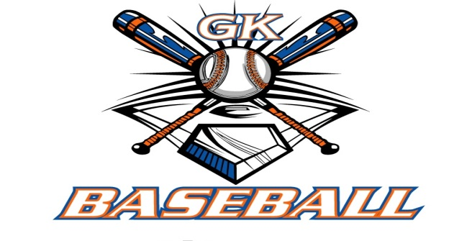
G-K BASEBALL MEETING NOTES
October 12, 2016
Call to Order
8:05 PM @ Genoa Veterans Home

Member Attendance Guest Attendance
- Ed Frye Roger Butler
- Scott Franson
- Jerry Kline
- Chad Pacey
- Steve Kleba
- Chris Welch
- Matt Krueger
- Chad Petersen
- Dave Grimm
- Steve Younkers
- Matt Ides

Approval of previous month minutes: September 2016 Meeting
Motion by: Jerry Kline
2nd : Dave Grimm
Yes 10 No 0 Abstain Passed X

Treasurers Report (Closed Session)
Reg. Opening Bal: $ 19,792.95 Concession Bal: $ 11,066.47
Income: $ Income: $
Expenses: $ Expenses: $
Notes: Ending $ 19,792.95 Ending $11,687.64 TOTAL $30,859.42
Treasurers Report
Motion by: Dave G
2nd: Chris W
Yes 10 No 0 Abstain Approved N/A

G-K BASEBALL Committee Reports

Old Business
Chad Pacey to discuss grant writing with Genoa Park District

New Business
GK Baseball Camps 2017 6-10 yrs old 12-2:00 and 11-14 yrs old 2:30-4:00
January 22nd .29th
February 12th, 19th

Registration Dates 2017
January 14th 9-Noon VFW
January 18th 6-9:00 PM VFW
January 22nd at Camp
January 29tbh at Camp

Field Report
Dean Awe sprayed Kingston East & west for weeds
Fall Work Dates October 16th & 23rd
GES completed by Ed & Steve Y September 24th & October 9th

Equipment Report
N/A.

Sponsorship Report
N/A

Generals Report
N/A

Picture Report
N/A

Fundraising Report
N/A

Concessions Report
N/A

Spirit Wear Report
N/A

Website Report
N/A

OPEN FLOOR ITEMS (See Notes)
- Ed Frye indicated a minimum of $2000 available for GK Cogs Varsity Spring Trip
- Larry Creadon
- Scott Franson indicated in the process of transferring Treasurer items to Matt Krueger
- Dan Awe
- Jerry Kline will provide draft of camp & registration flyers for November meeting
- Chad Pacey
- Steve Kleba
- Chris Welch suggested a water tank at Kiernan for field prep
- Matt Ides
- Matt Krueger
- Dave Grimm still looking into a new drag for our fields
- Steve Younker proposed rain barrels for water collection at Kiernan
- Roger butler suggested a mandatory coaches clinic for all GK coaches and also indicated he’d like to see our Pony League consider 60/90 dimensions..

NOTES:

Motion to adjourn:
Motion by: Steve Y
2nd: Chris Welch
Yes 10 No 0 Abstain Approved X
@ 9:10 PM

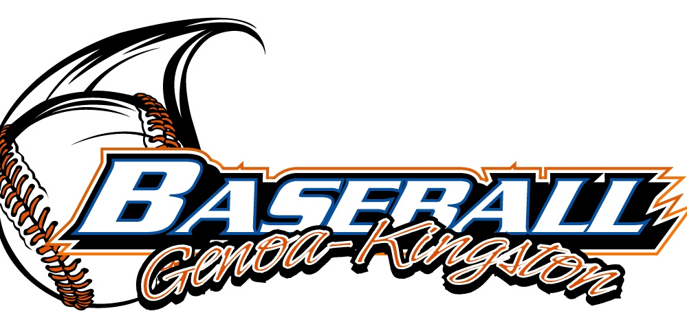

G-K BASEBALL MOTIONS

Motion to
Motion by:
2nd :
Yea Nay 0 Abstain Approved yes
************************************************************************************************************************************
Motion to
Motion by:
2nd :
Yea Nay Abstain Approved
************************************************************************************************************************************
Motion to
Motion by:
2nd :
Yea Nay Abstain Approved
************************************************************************************************************************************
Motion to approve
Motion by:
2nd :
Yea Nay Abstain Approved

ROLL CALL MOTION VOTE FOR: :
Motion by:
2nd :

ROLL CALL VOTE (See Notes)
- Larry Creadon Yes
- Jerry Kline Yes
- Dan Awe Yes
- Scott Franson Yes
- Chad Petersen Yes
- Chris Welch Yes
- Steve Kleba Yes
- Chad Pacey Yes
- Matt Ides Yes
- Steve Younker Yes
- Dave Grimm Yes
- Matt Kreuger Yes
- Ed Frye Abstain (TIE BREAKER CAST VOTE ONLY)

ROLL CALL VOTE TOTAL
Yes No Abstain Motion Approved Motion Failed

G-K BASEBALL NEXT MONTH AGENDA ITEMS/ISSUE LIST
The following items/issues will be part of following month meeting:
Item #1 Approval of Flyers
Item #2 2017 BBBB Rules & Items
Item #3 2017 Raffle Calendars
Item #4
Item #5

MISC.



