
G-K BASEBALL MEETING NOTES
May 9, 2018
Call to Order
8:16 PM @ Genoa Veterans Home

Member Attendance Guest Attendance
- Chad Pacey
- Steve Yonkers
- Matt Krueger
- Chris Welch
- Chad Peterson
- Robert Bohne
- Dan Awe
- Dave Grimm
- Matt Ides

Approval of previous month minutes: Dember Meeting
Motion by: Dave Grimm.
2nd : Rob B.
Yes 8 No Abstain Passed

Treasurers Report (Closed Session)
Reg. Opening Bal: $ 20477.34 Concession Bal: $ 12128.83
ncome: $ Income: $
Expenses: $ Expenses: $
Notes: Ending $ Ending $ TOTAL $
Treasurers Report
Motion by: Dave Grimm
2nd: Dan Awe
Yes 8 No 0 Abstain Approved

G-K BASEBALL Committee Reports

Old Business
- April Minutes

New Business
- Field days, update
- Equipment Report: Instructional, uniforms
- Calender turn in is 4-21
- Inhouse owes BYB 1125 Pony games at BYB
- Pictures 4-28 at GMS
- Grill Needs Maninentance

Field Report
- Issues with GES North and foul balls, Gravel

Equipment Report

Sponsorship Report /Fundraising Report

Generals Report
BBB 10u dropped

Picture Report
Las call spirit wear 5-6.

Concessions Report
Picinic tables

Spirit Wear Report

Website Report
Chad needs helps with website.

OPEN FLOOR ITEMS (See Notes)
- Dave Grimm-Fields are not being taken care of by coaches, must fill in holes after their game.

NOTES:
.
Motion to adjourn:
Motion by: Matt K.
2nd: Chris W.
Yes No Abstain Approved
@ 9:45 PM

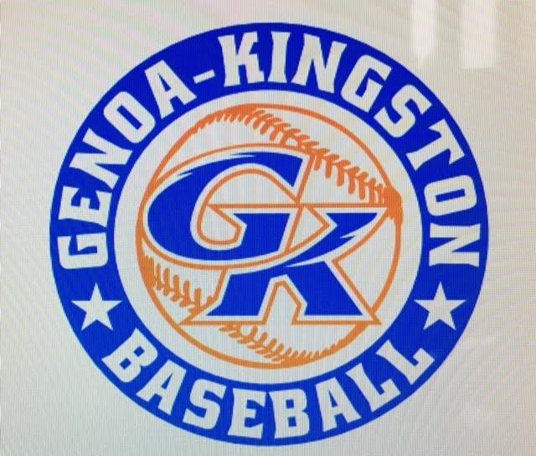

G-K BASEBALL MOTIONS

Motion to: 5 dollar raise for Bob Proebst per field for prep work.
Motion by: Steve Y.
2nd : Dave G.
Yea 8 Nay Abstain Approved
************************************************************************************************************************************
Motion to:
Motion by:
2nd :
Yea Nay Abstain Approved
************************************************************************************************************************************
Motion to
Motion by:
2nd :
Yea Nay Abstain Approved
************************************************************************************************************************************
Motion to approve
Motion by:
2nd :
Yea Nay Abstain Approved

G-K BASEBALL NEXT MONTH AGENDA ITEMS/ISSUE LIST FOR March 14, 2018
The following items/issues will be part of following month meeting:
Item #1 Draft night, Practice/Game Schedules
Item #2
Item #3
Item #4
Item #5

ROLL CALL MOTION VOTE NOTES ON ITEMS MORE THAN $1,000: N/A
ROLL CALL VOTE (See Notes)
- Steve Younker Yes No Abstain
- Dan Awe Yes No Abstain
- Chris Welch Yes No Abstain
- Steve Kleba Yes No Abstain
- Matt Ides Yes No Abstain
- Dave Grimm Yes No Abstain
- Matt Krueger Yes No Abstain
- Scott Franson Yes No Abstain
- Chad Peterson Yes No Abstain
- Robert Bohne Yes No Abstain
- Robby Montgomery Yes No Abstain
- Roger Butler Yes No Abstain
- Chad Pacey Yes No Abstain (TIE BREAKER CAST VOTE ONLY)

ROLL CALL VOTE TOTAL
Yes No Abstain Motion Approved Motion Failed
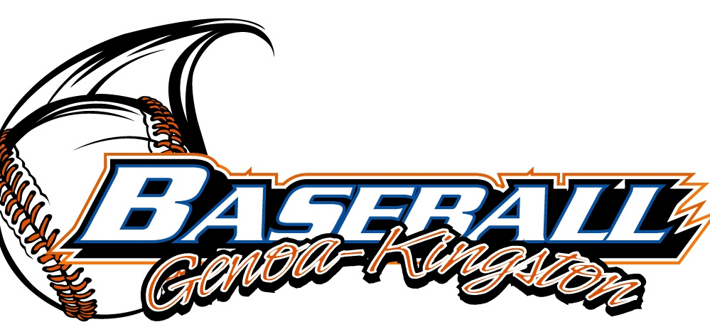



MISC.


2017-2018 Attendance Attended Not Attended
- Chad Pacey 7 0
- Steve Younker 6 1
- Dan Awe 3 4
- Chris Welch 7 0
- Matt Ides 2 5
- Steve Kleba 3 4
- Matt Krueger 7 0
- Scott Franson 5 2
- Dave Grimm 6 1
- Chad Peterson 4 3
- Robert Bohne 7 0
- Robby Montgomery 6 1
- Roger Butler 3 4

