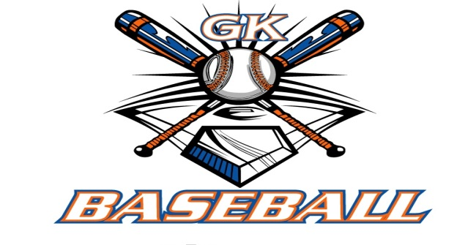
G-K BASEBALL MEETING NOTES
June 13, 2018
Call to Order
8:16 PM @ Genoa Veterans Home

Member Attendance Guest Attendance
- Chad Pacey Sycamore Youth Baseball
- Steve Kleba Ed Frye
- Matt Krueger
- Chris Welch
- Roger Butler
- Robert Bohne
- Dan Awe
- Robert Mongomery
- Steve Younkers
- Chad Peterson

Approval of previous month minutes: May Meeting
Motion by: Steve K.
2nd : Rob B.
Yes 9 No Abstain Passed

Treasurers Report (Closed Session)
Reg. Opening Bal: $ 28074.34 Concession Bal: $ 8902.17
Income: $ Income: $
Expenses: $ Expenses: $
Notes: Ending $ Ending $ TOTAL $
Treasurers Report
Motion by:
2nd:
Yes No Abstain Approved

G-K BASEBALL Committee Reports

Old Business
- NONE

New Bussiness
- Sycamore Youth Baseball will be host a fall ball legue. They will have teams at every level and is inviting Genoa to play in there league.

Field Report
- Kingston East Fould ball issues, GES Fencing for backstops would be 4800 dollars.

Equipment Report

Clean Sheds before fall.

Sponsorship Report /Fundraising Report
Make adjustments to the sponsorship amounts

Generals Report
August 12, 19 for tryouts. Refund Renegades 14 BBB money.

Picture Report
N/A

Concessions Report

Spirit Wear Report

Website Report

OPEN FLOOR ITEMS (See Notes)
- Chad Pacey: Board approves 300 dollar sponsorship to GK Athletics
- Dave Grimm:
- Dan Awe:
- Robert Bohne:

NOTES:
Roger Butler discussed being envolved with the possibility of the High School and GKYB partner in the calendar fundraiser in the future, since GK softball is doing a different fundraiser.
Motion to adjourn:
Motion by: Robert B.
2nd: Chad Peterson.
Yes No Abstain Approved
@ 9:52 PM

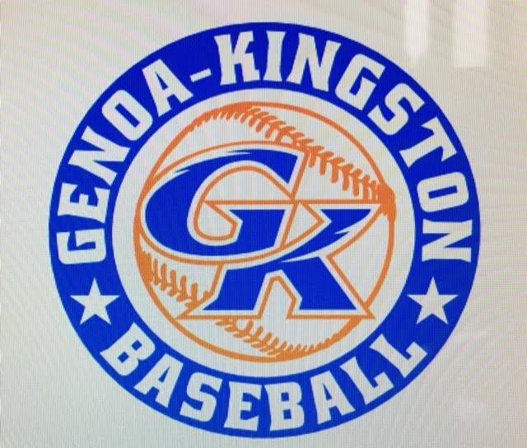

G-K BASEBALL MOTIONS

- Motion to: Board approves 300 dollar sponsorship to GK Athletics

Motion by: Steve Y.
2nd : Dave G.
Yea 8 Nay Abstain 1 Roger Butler Approved
************************************************************************************************************************************
Motion to:
Motion by:
2nd :
Yea Nay Abstain Approved
************************************************************************************************************************************
Motion to
Motion by:
2nd :
Yea Nay Abstain Approved
************************************************************************************************************************************
Motion to approve
Motion by:
2nd :
Yea Nay Abstain Approved

G-K BASEBALL NEXT MONTH AGENDA ITEMS/ISSUE LIST FOR August, 2018
The following items/issues will be part of following month meeting:
Item #1
Item #2
Item #3
Item #4
Item #5

ROLL CALL MOTION VOTE NOTES ON ITEMS MORE THAN $1,000: N/A
ROLL CALL VOTE (See Notes)
- Steve Younker Yes No Abstain
- Dan Awe Yes No Abstain
- Chris Welch Yes No Abstain
- Steve Kleba Yes No Abstain
- Matt Ides Yes No Abstain
- Dave Grimm Yes No Abstain
- Matt Krueger Yes No Abstain
- Scott Franson Yes No Abstain
- Chad Peterson Yes No Abstain
- Robert Bohne Yes No Abstain
- Robby Montgomery Yes No Abstain
- Roger Butler Yes No Abstain
- Chad Pacey Yes No Abstain (TIE BREAKER CAST VOTE ONLY)

ROLL CALL VOTE TOTAL
Yes No Abstain Motion Approved Motion Failed
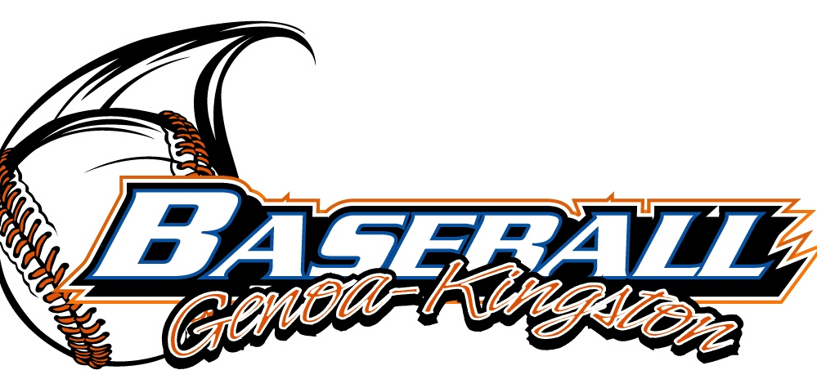

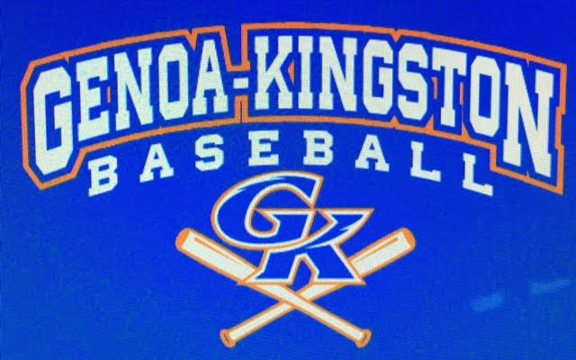

MISC.

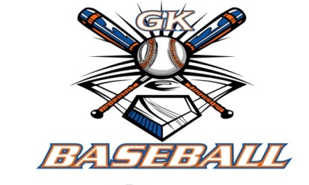
2017-2018 Attendance Attended Not Attended
- Chad Pacey 6 0
- Steve Younker 5 1
- Dan Awe 2 4
- Chris Welch 6 0
- Matt Ides 1 5
- Steve Kleba 3 3
- Matt Krueger 6 0
- Scott Franson 5 1
- Dave Grimm 5 1
- Chad Peterson 4 2
- Robert Bohne 6 0
- Robby Montgomery 5 1
- Roger Butler 3 3

