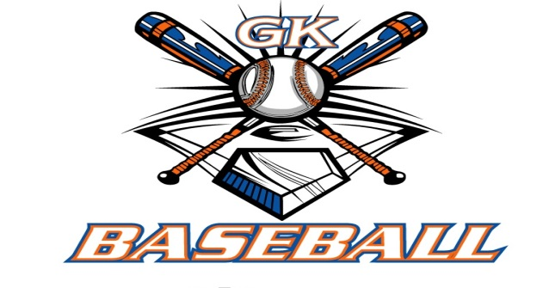
G-K BASEBALL MEETING NOTES
February 21, 2018
Call to Order
8:15 PM @ Genoa Veterans Home

Member Attendance Guest Attendance
- Chad Pacey
- Steve Younker
- Matt Krueger
- Scott Franson
- Chris Welch
- Chad Peterson
- Robert Bohne
- Roger Butler
- Dan Awe
- Dave Grimm

Approval of previous month minutes: Dember Meeting
Motion by: Matt K.
2nd : Rob B.
Yes 9 No Abstain Passed

Treasurers Report (Closed Session) ****TABLED**** (Matt forgot his homework)
Reg. Opening Bal: $ ? Concession Bal: $ ?
Income: $ Income: $
Expenses: $ Expenses: $
Notes: Ending $ Ending $ TOTAL $
Treasurers Report
Motion by:
2nd:
Yes No Abstain Approved

G-K BASEBALL Committee Reports

Old Business
- NONE

New Business
- In-House Update- Registrations and Camps
  - Instructional- 53 players
  - Minor- 30 players
  - Bronco- 17 players
  - Pony- 9 players
  - Generals- 33 players
  - Only 2 “scholarship” players registered this year
  - Camps
    - Had some challenges w/ camps
    - 142 signed up; had 70 through first two camps
    - For “snow-out” camp, decided to give “ticket” to 4/21 home baseball game, then
do dinner w/ HS players consisting of hot dogs, chips, water, etc.
    - Next year, consider leaving first two camp dates as is
    - For other two dates, do a camp day on Friday of Blue Badger and pick a
double-header “game day” recognition and luncheon
  - In-House Coaches:
    - Pony: Eddie Ibarra, Eric Rich (help), Jason Vogelbond
    - Bronco: Phil Swider & Eric Rich
    - Minor: Chad Cravatta, Eric Schmit, & Chad Pacey
    - Instructional: Matt Ides, Chad Peterson, Rob Kennedy, Adam Robinette, and
Brett Amen
  - Evaluations: March 11; First evaluation (Minors) at 11:00 through ~3:00
  - Draft night will be 3/14 @ 7:00 pm ahead of board meeting
  - Background checks will be using same company from couple years past
- Dean Awe w/ Kingston Park District passed away
  - Approved $200 donation from GK Baseball to whatever memorial mentioned in obituary
    - Steve moved, Dave G. seconded to approve $200
  - Board members to give consideration to ideas for Dean Awe memorial at Kingston Park
for discussion at March meeting
- Umpire training- Chad brought up idea to get several of the high-schoolers that have been umping
for us for some years together with a patched umpire or two to do some training and possibly
encourage them to pursue getting patched themselves

Field Report
- Spring Work Days: 3/17, 3/31, and 4/14; 4/21 & 4/28 as back-up dates
- Dave and Steve to walk fields in coming weeks to put list together of needs
- Scott to order porta-johns for 4/1
- Question asked if we’ve ever asked porta-johns for sponsorship- Scott to ask when he calls
- Demon trailer completed overhaul (Dave G.); Demon service in process

Equipment Report
N/A

Sponsorship Report /Fundraising Report
- Sponsors planned to be lined up by end of first week of March
- Calendar agreement with Softball turned into kind of a mess
  - Thought we had discussed as a board, and that we agreed to divide by percentage of money brought in,
but no notes or recollection of that
  - Tried to go back to the $5/calendar arrangement from last year, but Softball did not want that
  - Decided to honor split based on percentage money brought in, but understanding is that we may not include
them in this fundraiser next year and they may have to come up with their own fundraiser
  - Chad was assured by his contact that any fundraiser they come up with would NOT be a calendar raffle or
similar fundraiser
  - 4/28 was laid out as due date so that we can get all tickets into drawing and get the money split calculated
as timely as possible

Generals Report
- Jerry Kline has decided to resign from board and Chairman of Leagues position
- Chairman of Leagues position is Executive Board position that should not remain open for long
- A couple of ideas for potential candidates were floated and individuals are to give the position some consideration for
next month’s meeting
- Blue Badger Update:
  - 10U- 3 teams; 11U- 4 teams; 12U- 5 teams; 13U- 6 teams; 14U- 6 teams; 16U- Algonquin, Jerry, and
another team to commit after end of month

Picture Report
N/A

Concessions Report
- No concessions per se, but Chad to contact Jen about financial aid players and hot dogs/buns for 4/21 cookout w/
Varsity baseball team

Spirit Wear Report
- Spirit wear orders due mid-April to coaches

Website Report
N/A

OPEN FLOOR ITEMS (See Notes)
- Chad Pacey: Schedule coach meeting before spring break to hand out equipment, gear, schedules, and do some training w/ Roger on alignment of Instructional through HS
- Chris Welch: Chad Cravatta to possibly coach 10U tourney team
- Matt Krueger: Reconsidering coaching Instructional team because he’ll have two boys on one team
- Steve Younker: Fence cap previously discussed should be ordered this month
- Chad Peterson
- Dan Awe: Might need to reach out (Chad Pacey) to football regarding use of concession trailer during Blue Badger, in light of recent issues
- Robert Bohne:
- Scott Franson:
- Roger Butler: Requested funds from Blue Badger for HS boys’ spring trip ($3,500)
- Dave Grimm: Demon needs air filter cleaning

NOTES:
.
Motion to adjourn:
Motion by: Matt K.
2nd: Chris W.
Yes No Abstain Approved
@ 9:45 PM

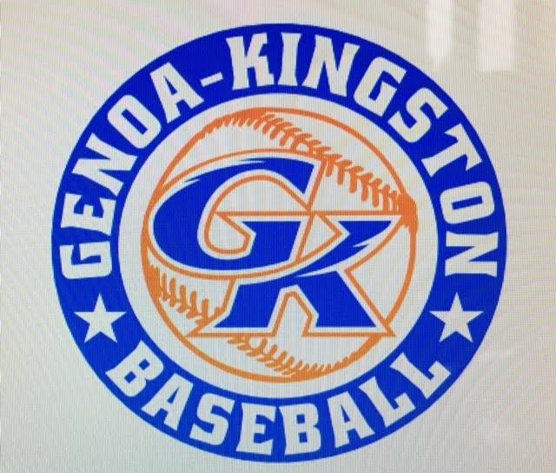

G-K BASEBALL MOTIONS

Motion to: Make $200 donation in name of Dean Awe to whatever organization is mentioned in his obituary
Motion by: Steve Y.
2nd : Dave G.
Yea 9 Nay Abstain Approved
************************************************************************************************************************************
Motion to:
Motion by:
2nd :
Yea Nay Abstain Approved
************************************************************************************************************************************
Motion to
Motion by:
2nd :
Yea Nay Abstain Approved
************************************************************************************************************************************
Motion to approve
Motion by:
2nd :
Yea Nay Abstain Approved

G-K BASEBALL NEXT MONTH AGENDA ITEMS/ISSUE LIST FOR March 14, 2018
The following items/issues will be part of following month meeting:
Item #1 Draft night, Practice/Game Schedules
Item #2
Item #3
Item #4
Item #5

ROLL CALL MOTION VOTE NOTES ON ITEMS MORE THAN $1,000: N/A
ROLL CALL VOTE (See Notes)
- Steve Younker Yes No Abstain
- Dan Awe Yes No Abstain
- Chris Welch Yes No Abstain
- Steve Kleba Yes No Abstain
- Matt Ides Yes No Abstain
- Dave Grimm Yes No Abstain
- Matt Krueger Yes No Abstain
- Scott Franson Yes No Abstain
- Chad Peterson Yes No Abstain
- Robert Bohne Yes No Abstain
- Robby Montgomery Yes No Abstain
- Roger Butler Yes No Abstain
- Chad Pacey Yes No Abstain (TIE BREAKER CAST VOTE ONLY)

ROLL CALL VOTE TOTAL
Yes No Abstain Motion Approved Motion Failed
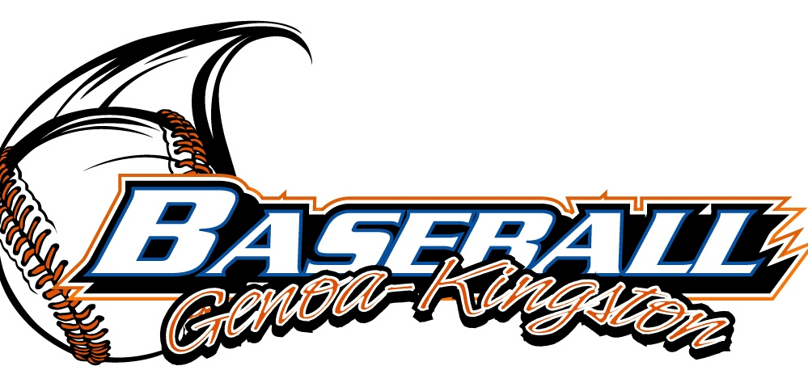

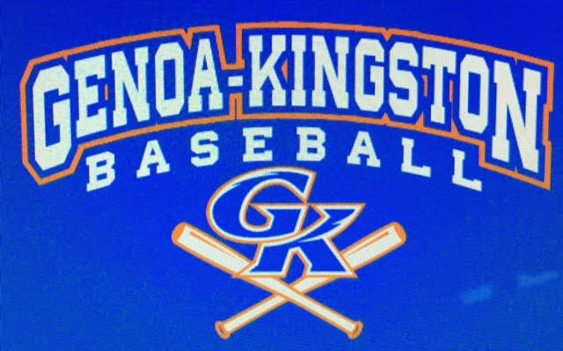

MISC.


2017-2018 Attendance Attended Not Attended
- Chad Pacey 6 0
- Steve Younker 5 1
- Dan Awe 2 4
- Chris Welch 6 0
- Matt Ides 1 5
- Steve Kleba 3 3
- Matt Krueger 6 0
- Scott Franson 5 1
- Dave Grimm 5 1
- Chad Peterson 4 2
- Robert Bohne 6 0
- Robby Montgomery 5 1
- Roger Butler 3 3

