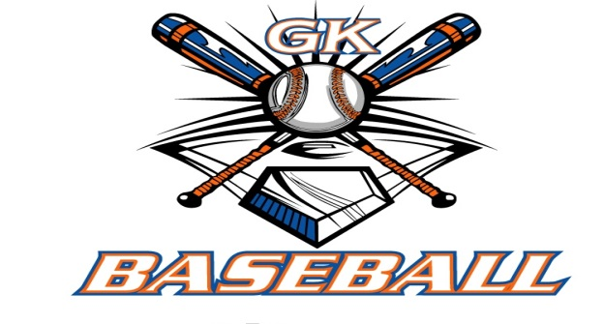
G-K BASEBALL MEETING NOTES
March 8, 2017
Call to Order
815 PM @ Genoa Veterans Home

Member Attendance Guest Attendance
- Ed Frye present x
- Larry Creadon present x
- Scott Franson present x
- Dan Awe present x
- Jerry Kline present x
- Chad Pacey present x

- Steve Kleba present x
- Chris Welch present x
- Steve Younkers x
10)Matt Krueger present x

- Dave Grimm present X
- Chad Peterson X
- Matt Ides x

Approval of previous month minutes: Will be tabled to April Meeting
Motion by:
2nd :
Yes 0 No 0 Abstain Passed X

Treasurers Report (Closed Session)
Reg. Opening Bal: $ 39583.82 Concession Bal: $ 10252.25
Income: $ Income: $
Expenses: $ Expenses: $
Notes: Ending $ Ending $ TOTAL $
Treasurers Report
Motion by: Chris W
2nd: Jerry K.
Yes 12 No 0 Abstain Approved x

G-K BASEBALL Committee Reports

Old Business
Had 233 attendees at the GK Baseball Camp hosted by the High School.

New Business
Registration updates at 166 down from 178 last season.
Practice schedule and games schedules are being worked on.
Field work days are April 8,9,15,22,23.
Jerry gave BBB update

Field Report

Equipment Report

Sponsorship Report

Generals Report

Picture Report

Fundraising Report

Concessions Report

Spirit Wear Report

Website Report

OPEN FLOOR ITEMS (See Notes)
- Ed Frye looking at cost for minors for byb or sycamore.
- Larry Creadon
- Scott Franson
- Dan Awe
- Jerry Kline
- Chad Pacey

- Steve Kleba
- Chris Welch
- Paul Perry
- Matt Krueger
- Dave Grimm
- Steve Younker
- Chad Peterson

NOTES:
.
Motion to adjourn:
Motion by: Jerry Kline.
2nd: Larry Creadon.
Yes 11 No 0 Abstain Approved X
@ 948 PM

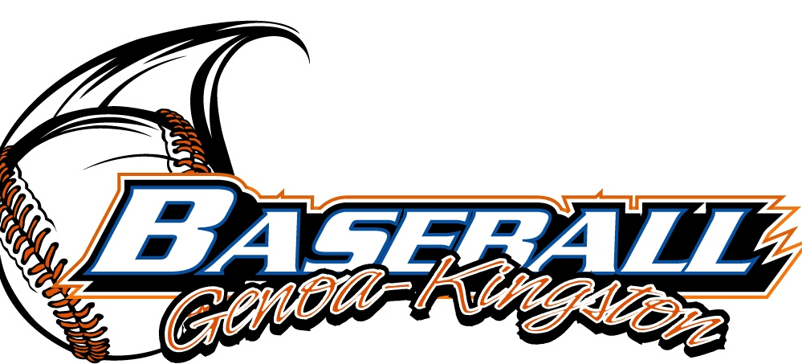
G-K BASEBALL MOTIONS

Motion to
Motion by: .
2nd : .
Yea Nay 0 Abstain Approved yes x
************************************************************************************************************************************
Motion to
Motion by:
2nd :
Yea Nay Abstain Approved
************************************************************************************************************************************
Motion to
Motion by:
2nd :
Yea Nay Abstain Approved
************************************************************************************************************************************
Motion to approve
Motion by:
2nd :
Yea Nay Abstain Approved

G-K BASEBALL NEXT MONTH AGENDA ITEMS/ISSUE LIST
The following items/issues will be part of following month meeting:
Item #1
Item #2
Item #3
Item #4
Item #5

ROLL CALL MOTION VOTE NOTES ON ITEMS MORE THAN $1,000: :
Motion by:
2nd :

ROLL CALL VOTE (See Notes)
- Larry Creadon Yes No Abstain
- Jerry Kline Yes No Abstain
- Dan Awe Yes No Abstain
- Scott Franson Yes No Abstain
- Chad Peterson Yes No Abstain
- Chris Welch Yes No Abstain
- Steve Kleba Yes No Abstain
- Matt Ides Yes No Abstain
- Chad Pacey Yes No Abstain
- Steve Younker yes no Abstain
- Dave Grimm yes no Abstain
- Matt Kreuger yes no Abstain
- Ed Frye Yes No Abstain
(TIE BREAKER CAST VOTE ONLY)

ROLL CALL VOTE TOTAL
Yes No0 Abstain Motion Approved Motion Failed

MISC.

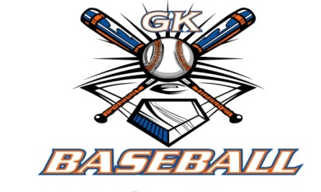

2015-2016 Attendance Attended Not Attended
- Ed Frye
- Larry Creadon
- Dan Awe
- Scott Franson
- Jerry Kline
- Chris Welch
Chad Pacey
- Steve Kleba
- Matt Krueger
- Dave Grimm
- Steve Younker
- Chad Peterson
- Matt Ides

