
G-K BASEBALL MEETING NOTES
December 13, 2017
Call to Order
805 PM @ Genoa Veterans Home

Member Attendance Guest Attendance
- Chad Pacey present X
- Roger Butler present x
- Scott Franson present x Ed Frye
- Dan Awe present x
- Jerry Kline present x
- Rob Montgomery present x

- Steve Kleba present
- Chris Welch present x
- Steve Younkers
- Matt Krueger present x

- Dave Grimm present x
- Chad Peterson present x
- Matt Ides
- Robert Bohne x

Approval of previous month minutes:
Motion by: Dave Grimm.
2nd : Jerry Kline
Yes 9 No 0 Abstain Passed X

Treasurers Report (Closed Session)
Reg. Opening Bal: $ 20045.37 Concession Bal: $ 12.884.37
Income: $ Income: $
Expenses: $ Expenses: $
Notes: Ending $ Ending $ TOTAL $
Treasurers Report
Motion by: Dave G.
2nd: Jerry Kline
Yes 9 No 0 Abstain Approved x

G-K BASEBALL Committee Reports

Old Business

New Business
Opening day ideas, bring them to next months meeting.
Camp Dates 1/14,1/21,2/11,2/18 6-10 12 to 1 pm. 11-14 130-300pm.
Opening date is May 5.

Field Report

Na

Equipment Report

Keirnan Shed update. Demon update, helmet /bat update when Steve will be at next months meeting

Sponsorship Report

Raffle calendars need to be ready for our signup.

Generals Report
BBB as teams signup they will be put on the Facebook Page.

Picture Report

Fundraising Report

Concessions Report

200 dollars approved for wall material, 1000 dollars approved for cabinets, Jerry motioned Chris second. Approved

Spirit Wear Report

Website Report

OPEN FLOOR ITEMS (See Notes)

NOTES:
.
Roger Butler talked about the concert and those ticket sales goes to the sport the child plays. GK baseball will again donate 1500 dollars to the High School camp.
Scott Franson AED is missing. Board decided to use Fox Valley Blues for Blue Badger umpire service.

Rob Montogmery suggested first aid training for coaches. Dan Awe talked about a divider screen for the cages upstair at gms.
Motion to adjourn:
Motion by: Dave G
2nd: Steve K.
Yes 10 No 0 Abstain Approved X
@ 827 PM

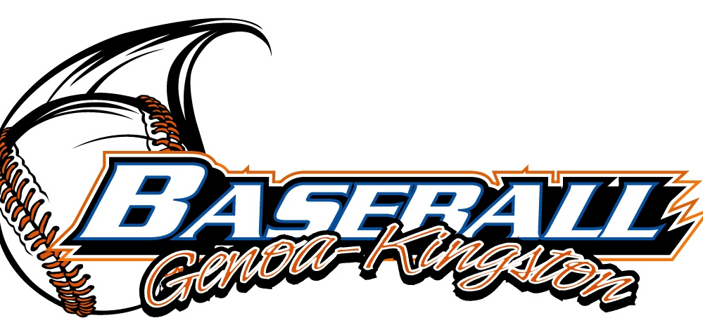
G-K BASEBALL MOTIONS

Motion to 200 dollars for wall material, 1000 dollars for cabinets
Motion by: Jerry Kline .
2nd : Chris Welch .
Yea 10 Nay 0 Abstain Approved yes x
************************************************************************************************************************************
Motion to
Motion by:
2nd :
Yea Nay Abstain Approved
************************************************************************************************************************************
Motion to
Motion by:
2nd :
Yea Nay Abstain Approved
************************************************************************************************************************************
Motion to approve
Motion by:
2nd :
Yea Nay Abstain Approved

G-K BASEBALL NEXT MONTH AGENDA ITEMS/ISSUE LIST
The following items/issues will be part of following month meeting:
Item #1
Item #2
Item #3
Item #4
Item #5

ROLL CALL MOTION VOTE NOTES ON ITEMS MORE THAN $1,000: :
Motion by:
2nd :

(TIE BREAKER CAST VOTE ONLY)

ROLL CALL VOTE TOTAL
Yes No0 Abstain Motion Approved Motion Failed

MISC.



2018 Attendance Attended Not Attended

