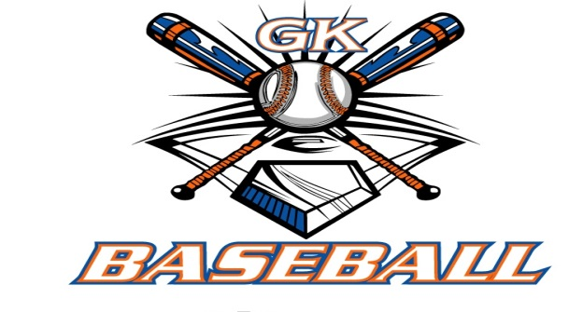
G-K BASEBALL MEETING NOTES
Sept 14,2016
Call to Order
815 PM @ Genoa Veterans Home

Member Attendance Guest Attendance
- Ed Frye present x
- Larry Creadon present x
- Scott Franson present x
- Dan Awe present x
- Jerry Kline present x
- Chad Pacey present x

- Steve Kleba present x
- Chris Welch present x
- Steve Younkers x
10)Matt Krueger present x

- Dave Grimm present x
- Chad Peterson

Approval of previous month minutes: November Meeting
Motion by: Steve Younkers
2nd : Jerry Kline
Yes 10 No 0 Abstain Passed X

Treasurers Report (Closed Session)
Reg. Opening Bal: $ 21232.09 Concession Bal: $ 11045.52
Income: $ Income: $
Expenses: $ Expenses: $
Notes: Ending $ Ending $ TOTAL $
Treasurers Report
Motion by: Steve Y.
2nd: Matt K.
Yes 10 No 0 Abstain Approved x

G-K BASEBALL Committee Reports

Old Business

New Business
Fall work dates: August 28.
Nomiations for 2017 Board:
Dan Awe Sec., Treasurer Matt Krueger, Fundraising Chair Larry Creadon, Sponsor Chair Steve Kleba.
Matt Ides as General Board Member

Grant proposal…..cost and what we would get back.. 4900 and 8900 for 5 years.

Field Report

Weed control, 10-2,16,23 work days

Equipment Report

Sponsorship Report

Generals Report

Picture Report

Fundraising Report

Concessions Report

Spirit Wear Report

Website Report

OPEN FLOOR ITEMS (See Notes)
- Ed Frye
- Larry Creadon
- Scott Franson
- Dan Awe will conatact Jeff Payton from Burlington to see there diamond demon.
- Jerry Kline
- Chad Pacey

- Steve Kleba
- Chris Welch
- Paul Perry
- Matt Krueger Talked about the fellowship of Chrisitan Athletes.
- Dave Grimm
- Steve Younker
- Chad Peterson

NOTES:
.
Motion to adjourn:
Motion by: Jerry Kline.
2nd: Larry Creadon.
Yes 11 No 0 Abstain Approved X
@ 948 PM

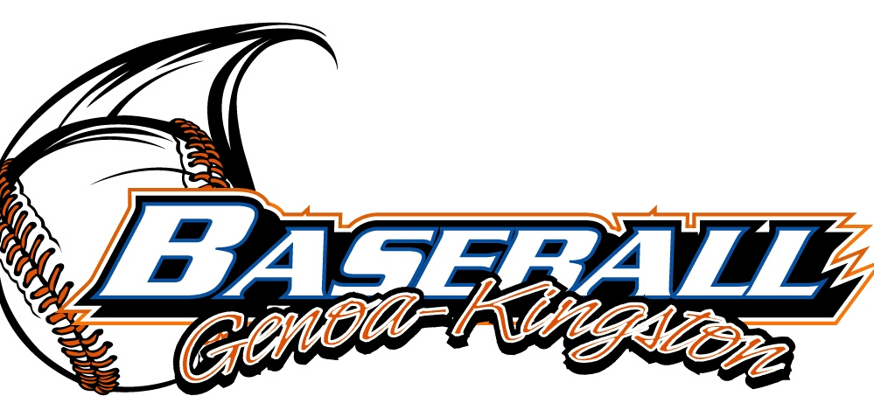
G-K BASEBALL MOTIONS

Motion to
Motion by: .
2nd : .
Yea Nay 0 Abstain Approved yes x
************************************************************************************************************************************
Motion to
Motion by:
2nd :
Yea Nay Abstain Approved
************************************************************************************************************************************
Motion to
Motion by:
2nd :
Yea Nay Abstain Approved
************************************************************************************************************************************
Motion to approve
Motion by:
2nd :
Yea Nay Abstain Approved

G-K BASEBALL NEXT MONTH AGENDA ITEMS/ISSUE LIST
The following items/issues will be part of following month meeting:
Item #1
Item #2
Item #3
Item #4
Item #5

ROLL CALL MOTION VOTE NOTES ON ITEMS MORE THAN $1,000: :
Motion by:
2nd :

ROLL CALL VOTE (See Notes)
- Larry Creadon Yes No Abstain
- Jerry Kline Yes No Abstain
- Dan Awe Yes No Abstain
- Scott Franson Yes No Abstain
- Paul Perry Yes No Abstain
- Chris Welch Yes No Abstain
- Eric Golembiewski Yes No Abstain
- Steve Kleba Yes No Abstain
- Troy Oates Yes No Abstain
- Chad Pacey Yes No Abstain
- Steve Younker yes no Abstain
- Dave Grimm yes no Abstain
- Matt Kreuger yes no Abstain
- Ed Frye Yes No Abstain
- Chad Peterson yes no Abstain (TIE BREAKER CAST VOTE ONLY)

ROLL CALL VOTE TOTAL
Yes No0 Abstain Motion Approved Motion Failed

MISC.

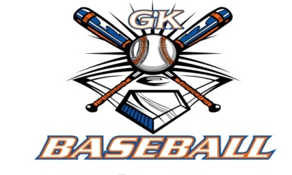

2015-2016 Attendance Attended Not Attended
- Ed Frye 11 0
- Larry Creadon 11 0
- Dan Awe 6 5
- Scott Franson 11 0
- Jerry Kline 10 1
- Chris Welch 11 0
Chad Pacey 11 0
- Steve Kleba 9 2
- Matt Krueger 9 2
- Dave Grimm 7 4
- Steve Younker 10 1
- Chad Peterson 6 5

