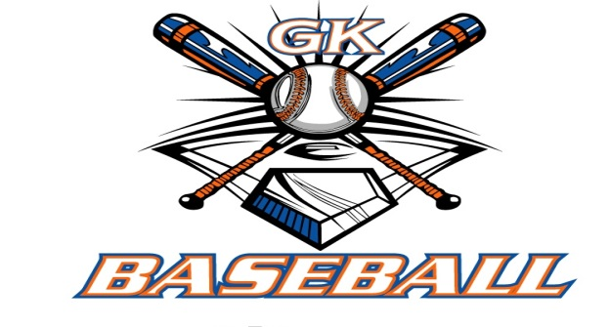
G-K BASEBALL MEETING NOTES
JANUARY 13, 2016
Call to Order
8:34 PM @ Genoa Veterans Home

Member Attendance Guest Attendance
- Ed Frye Roger Butler
- Larry Creadon
- Scott Franson
- Jerry Kline
- Paul Perry
- Chad Pacey
- Chris Welch
- Matt Krueger
- Steve Younker
- Dave Grimm
- Chad Peterson

Approval of previous month minutes: December Meeting
Motion by: Jerry K
2nd : Steve Y
Yes 9 No 0 Abstain Passed X

Treasurers Report (Closed Session)
Reg. Opening Bal: $ 26,775.31 Concession Bal: $ 10,002.42
Income: $ Income: $
Expenses: $ Expenses: $
Notes: Ending $ Ending $ TOTAL $
Treasurers Report
Motion by: Dave G
2nd: Paul P
Yes 9 No 0 Abstain Approved X

G-K BASEBALL Committee Reports

Old Business
Rules Committee must finalize and present updated version for 2016 at the February Meeting

New Business
- Registration Saturday 1/16/16 4-6 members needed with cooking burgers afterward. Set up 8:30 AM
- Registration Wednesday 1/20/16 4-6 members needed . Set up 8:30 PM
- In House Cages available 9:00-1:30 on Saturdays. Zach Stanis, Matt Krueger and Steve Younkers are interested in providing leadership for this. Times to be worked out for the age levels amongst them
- Kane County Cougars coaching clinic 1/30/16 9-11:30 AM in Geneva
- Kane County Cougars Outing will be 7/17/16 to coincide with the 14U Generals game. Ticket will be offered by the 14U Generals with food & drink at $35.00 each and GK Baseball will provide general seating tickets for $9.00 each Information will be passed out by the coaches once the season starts with the final sign up date being June 17th

Field Report
.N/A

Equipment Report
.N/A

Sponsorship Report /Fundraising Report
.N/A

Generals Report
.Uniforms are on order along with tournament fees being issued.
Registration Installments to be collected January, February and March

Picture Report
.N/A

Concessions Report
.N/A

Spirit Wear Report
. Wahkoo wear is updating the GK Baseball spirit wear logos and will provide a better quality shirt at no additional expense

Website Report
.

OPEN FLOOR ITEMS (See Notes)
- Ed Frye
- Larry Creadon
- Scott Franson provided newspaper advertising of Sycamore Baseball to compare with ours
- Dan Awe
- Jerry Kline
- Chad Pacey : Suggested we check that Brett’s Run does not conflict with the BBBB
- Steve Kleba
- Chris Welch
- Paul Perry Suggested that Roger Butler G-K Cogs provide a standard warm up routine that G-K Baseball could implement
- Troy Oates
- Matt Krueger
- Dave Grimm
- Steve Younker
- Chad Peterson Suggested a pitching tutorial be provided at the baseball camp. Roger Butler agreed to provide.
NOTES:
.
Motion to adjourn:
Motion by: Dave G .
2nd: Paul P
Yes 9 No 0 Abstain Approved X
@ 9:57 PM

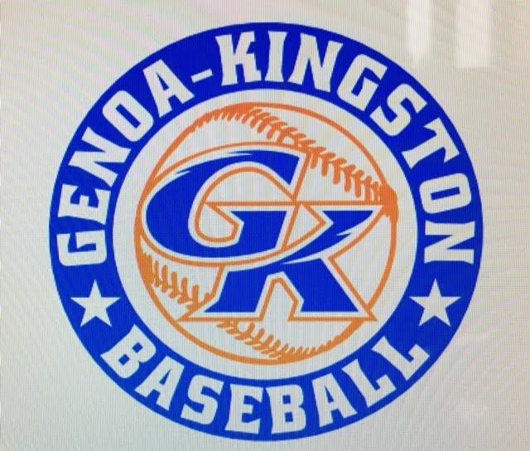

G-K BASEBALL MOTIONS

Motion to amend the December Board Vote and to follow the KCBL ruling to allow the 10U Generals Broidy Engel status eligibility for the 2016 season only.
Motion by: Jerry K .
2nd : Dave G
Yea 8 Nay 1 Abstain 1 Approved X
************************************************************************************************************************************
Motion to
Motion by:
2nd :
Yea Nay Abstain Approved
************************************************************************************************************************************
Motion to
Motion by:
2nd :
Yea Nay Abstain Approved
************************************************************************************************************************************
Motion to approve
Motion by:
2nd :
Yea Nay Abstain Approved

G-K BASEBALL NEXT MONTH AGENDA ITEMS/ISSUE LIST FOR FEBRUARY 10, 2016
The following items/issues will be part of following month meeting:
Item #1 Rules Updated & Discussed
Item #2 BBBB Update & Genoa Days conflicts discussed
Item #3 Insurance Renewal & Bid List
Item #4 Final Registration & Evaluations staffing
Item #5

ROLL CALL MOTION VOTE NOTES ON ITEMS MORE THAN $1,000: N/A
ROLL CALL VOTE (See Notes)
- Larry Creadon Yes No Abstain
- Jerry Kline Yes No Abstain
- Dan Awe Yes No Abstain
- Scott Franson Yes No Abstain
- Paul Perry Yes No Abstain
- Chris Welch Yes No Abstain
- Steve Kleba Yes No Abstain
- Troy Oates Yes No Abstain
- Chad Pacey Yes No Abstain
- Steve Younker yes No Abstain
- Dave Grimm yes No Abstain
- Matt Kreuger yes No Abstain
- Chad Peterson Yes No Abstain
- Ed Frye Yes No Abstain (TIE BREAKER CAST VOTE ONLY)

ROLL CALL VOTE TOTAL
Yes No0 Abstain Motion Approved Motion Failed
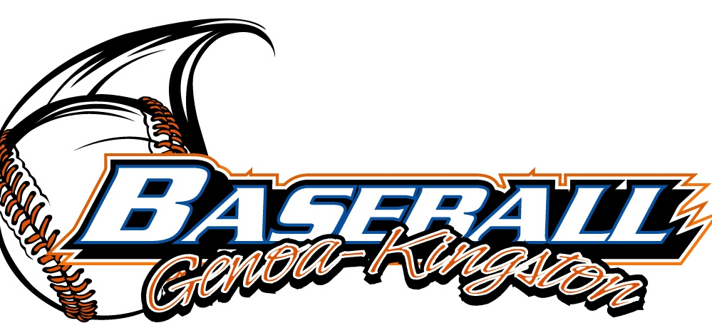

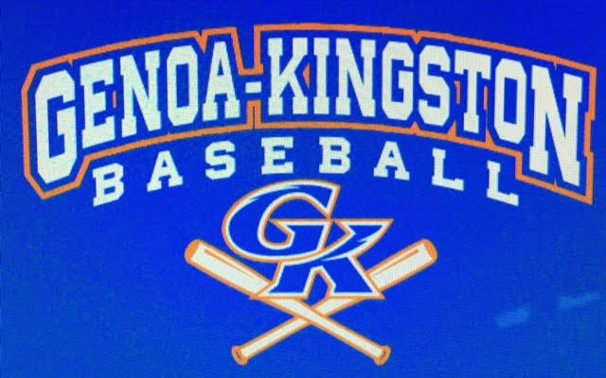

MISC.
BBBB Report of 13U Level full and possible addition of another 13U level to be played at Kingston West. Conflicts with the 8U-9U level played at GES wit hthe Genoa Day Parade conflicts. Further discussion needed in future meetings.

Roger Butler provided information of the Camp Schedule including specific stations and time at each drill Ed Frye reviewed the facts of the 10U Generals Engle issue including the KCBL approval with stipulations. This case will be reviewed in season by the KCBL and is only for the 2016 season. This case will be reviewed on a yearly. GK baseball will require Brian Lavender to provide written documentation to all tournaments he is interested in attending and must obtain written approval from said tournaments allowing Engle eligibility prior to any registration fees being issued.

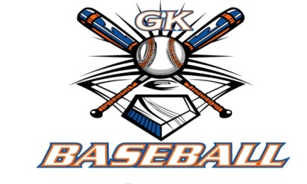
2015-2016 Attendance Attended Not Attended
- Ed Frye 4 0
- Larry Creadon 4 0
- Dan Awe 2 2
- Scott Franson 4 0
- Jerry Kline 3 1
- Paul Perry 2 2
- Chris Welch 4 0
- Chad Pacey 4 0
- Troy Oates 3 1
- Steve Kleba 2 2
- Matt Krueger 4 0
- Dave Grimm 3 1
- Steve Younker 3 1
- Chad Peterson 4 0

