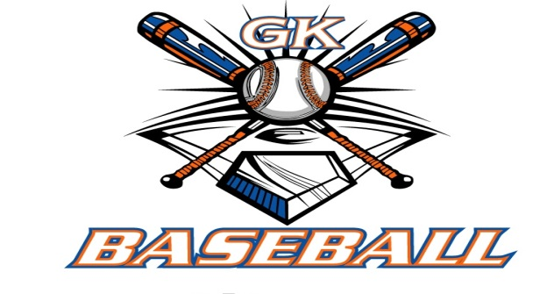
G-K BASEBALL MEETING NOTES
December 9, 2015
Call to Order
823 PM @ Genoa Veterans Home

Member Attendance Guest Attendance
- Ed Frye present x Roger Butler
- Larry Creadon present x Matt Tryaznka
- Scott Franson present x
- Dan Awe present x
- Jerry Kline present x
- Paul Perry present
- Chad Pacey present x
- Eric Golembiewski present

- Steve Kleba present
- Chris Welch present x
- Troy Oates present x

- Matt Krueger present x
- Steve Younker present
- Dave Grimm present x
- Chad Peterson x

Approval of previous month minutes: November Meeting
Motion by: Dave Grimm
2nd : Chris Welch
Yes 11 No 0 Abstain Passed X

Treasurers Report (Closed Session)
Reg. Opening Bal: $ 26,349.72 Concession Bal: $ 10001.35
Income: $ Income: $
Expenses: $ Expenses: $
Notes: Ending $ Ending $ TOTAL $
Treasurers Report
Motion by: Jerry Kline
2nd: Larry Creadon
Yes 11 No 0 Abstain Approved X

G-K BASEBALL Committee Reports

Old Business

New Business
Rules Review-catchers and when the kid can steal needs to be looked at.
Blue Bagder Bash needs to be flooded to the KCBL.

Field Report

Equipment Report

Sponsorship Report

Generals Report

Picture Report

Fundraising Report

Concessions Report

Spirit Wear Report

Website Report

OPEN FLOOR ITEMS (See Notes)
- Ed Frye Brian Lavender was suppose to get Ed documentation for Broday Engle to play on the 10 u team this year. This has not transpired. The board voted 10 to 0 with Chris Welch abstaining, not to allow Brody Engle to play on the 10 u. He will be offered a roster spot on 11u.
- Larry Creadon
- Scott Franson
- Dan Awe
- Jerry Kline
- Chad Pacey
- Eric Golembiewski
- Steve Kleba
- Chris Welch
- Paul Perry
- Troy Oates
- Matt Krueger
- Dave Grimm
- Steve Younker
- Chad Peterson

NOTES:
.
Motion to adjourn:
Motion by: Jerry Kline.
2nd: Larry Creadon.
Yes 11 No 0 Abstain Approved X
@ 937 PM

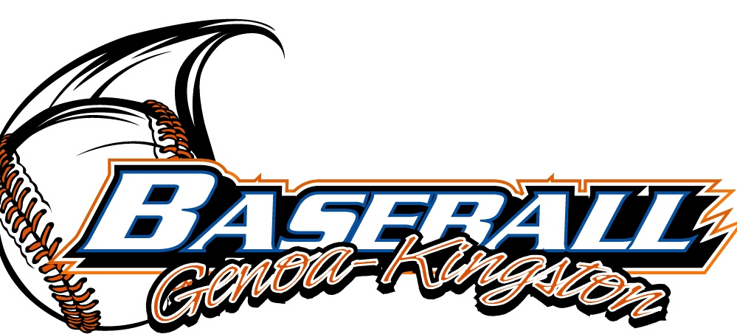
G-K BASEBALL MOTIONS

Motion to
Motion by: .
2nd : .
Yea Nay 0 Abstain Approved yes x
************************************************************************************************************************************
Motion to
Motion by:
2nd :
Yea Nay Abstain Approved
************************************************************************************************************************************
Motion to
Motion by:
2nd :
Yea Nay Abstain Approved
************************************************************************************************************************************
Motion to approve
Motion by:
2nd :
Yea Nay Abstain Approved

G-K BASEBALL NEXT MONTH AGENDA ITEMS/ISSUE LIST
The following items/issues will be part of following month meeting:
Item #1
Item #2
Item #3
Item #4
Item #5

ROLL CALL MOTION VOTE NOTES ON ITEMS MORE THAN $1,000: :
Motion by:
2nd :

ROLL CALL VOTE (See Notes)
- Larry Creadon Yes No Abstain
- Jerry Kline Yes No Abstain
- Dan Awe Yes No Abstain
- Scott Franson Yes No Abstain
- Paul Perry Yes No Abstain
- Chris Welch Yes No Abstain
- Eric Golembiewski Yes No Abstain
- Steve Kleba Yes No Abstain
- Troy Oates Yes No Abstain
- Chad Pacey Yes No Abstain
- Steve Younker yes no Abstain
- Dave Grimm yes no Abstain
- Matt Kreuger yes no Abstain
- Ed Frye Yes No Abstain
- Chad Peterson yes no Abstain (TIE BREAKER CAST VOTE ONLY)

ROLL CALL VOTE TOTAL
Yes No0 Abstain Motion Approved Motion Failed

MISC.

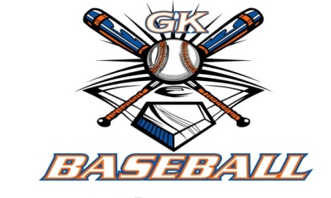

2015-2016 Attendance Attended Not Attended
- Ed Frye 3 0
- Larry Creadon 3 0
- Dan Awe 2 1
- Scott Franson 3 0
- Jerry Kline 2 1
- Paul Perry 1 2
- Chris Welch 3 0
Chad Pacey 3 0
- Troy Oates 3 0
- Steve Kleba 2 1
- Eric Golembiewski 2 1
- Matt Krueger 3 0
- Dave Grimm 2 1
- Steve Younker 2 1
- Chad Peterson 3 0

