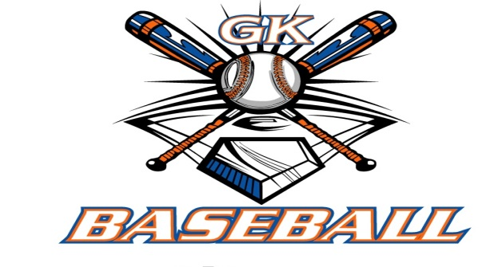
G-K BASEBALL MEETING NOTES
July 9, 2015
Call to Order
820 PM @ Genoa Veterans Home

Member Attendance Guest Attendance
- Ed Frye present x Roger Butler
- Larry Creadon present x Eric Rich
- Scott Franson present x
- Dan Awe present x
- Jerry Kline present x
- Paul Perry present x
- Chad Pacey present x
- Eric Golembiewski present x

- Steve Kleba present x
- Chris Welch present x
- Troy Oates present

- Matt Krueger present x
- Steve Younker present x
- Dave Grimm present

Approval of previous month minutes: June Meeting
Motion by: Steve Younker
2nd : Jerry Kline
Yes 11 No 0 Abstain Passed X

Treasurers Report (Closed Session)
Reg. Opening Bal: $ 39552.65 Concession Bal: $ 10829.62
Income: $ Income: $
Expenses: $ Expenses: $
Notes: Ending $ Ending $ TOTAL $
Treasurers Report
Motion by: Chris Welch
2nd: Steve Kleba
Yes 11 No 0 Abstain Approved X

G-K BASEBALL Committee Reports

Old Business

New Business

Battle of the Bats for 8 u is 7-25 and 7-26 drop dead date is 7-18 for the teams to commit.
Generals Tryout dates Aug. 9, 16 9 am. Kingston West 14u will be at Kingston East.
The Generals coaches Dan Awe 14u, Jerry Kline 13u,Larry Creadon 12u, Chris Welch 11u, Brian Lavender 10 u.
Minor League Rules will be discussed by the rules committee and bring to the board at next meeting.
Fall Ball in Belvidere will not be happening due to low turnout in the league.
Fall field workdates are Aug 12 and 13.
GKHS Baseball Funding will be tabled until next month to discuss.

Field Report

Equipment Report

Sponsorship Report

Generals Report

Picture Report

Fundraising Report

Concessions Report

Spirit Wear Report

Website Report

OPEN FLOOR ITEMS (See Notes)
- Ed Frye
- Larry Creadon
- Scott Franson
- Dan Awe
- Jerry Kline
- Chad Pacey
- Eric Golembiewski
- Matt Trzynka
- Steve Kleba Thoughts on a A and B team at Bronco level. Will discuss next month.
- Chris Welch
- Paul Perry
- Troy Oates
- Brian Lavender
- Matt Krueger
- Dave Grimm
- Steve Younker

NOTES:
.
Motion to adjourn:
Motion by: Steve y.
2nd: Steve K..
Yes 11 No 0 Abstain Approved X
@ 955 PM

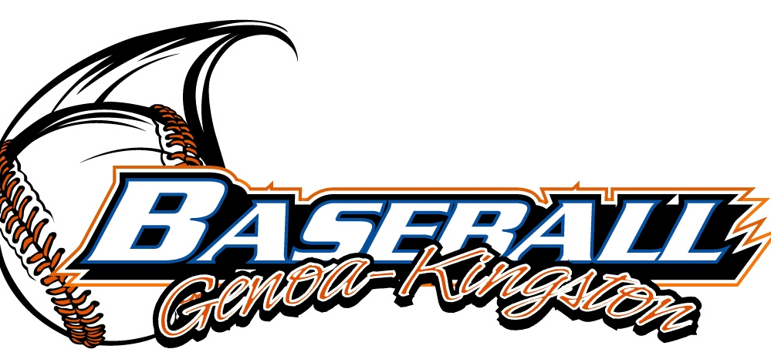
G-K BASEBALL MOTIONS

Motion to
Motion by: .
2nd : .
Yea Nay 0 Abstain Approved yes x
************************************************************************************************************************************
Motion to
Motion by:
2nd :
Yea Nay Abstain Approved
************************************************************************************************************************************
Motion to
Motion by:
2nd :
Yea Nay Abstain Approved
************************************************************************************************************************************
Motion to approve
Motion by:
2nd :
Yea Nay Abstain Approved

G-K BASEBALL NEXT MONTH AGENDA ITEMS/ISSUE LIST
The following items/issues will be part of following month meeting:
Item #1
Item #2
Item #3
Item #4
Item #5

ROLL CALL MOTION VOTE NOTES ON ITEMS MORE THAN $1,000: Motion 1500 for Trophies :
Motion by:
2nd :

ROLL CALL VOTE (See Notes)
- Larry Creadon Yes No Abstain
- Jerry Kline Yes No Abstain
- Dan Awe Yes No Abstain
- Scott Franson Yes No Abstain
- Paul Perry Yes No Abstain
- Chris Welch Yes No Abstain
- Eric Golembiewski Yes No Abstain
- Steve Kleba Yes No Abstain
- Troy Oates Yes No Abstain
- Chad Pacey Yes No Abstain
- Matt Trzynka Yes No Abstain
- Stev Younker yes no Abstain
- Brian Lavender yes no Abstain
- Dave Grimm yes no Abstain
- Matt Kreuger yes no Abstain
- Ed Frye Yes No Abstain (TIE BREAKER CAST VOTE ONLY)

ROLL CALL VOTE TOTAL
Yes No0 Abstain Motion Approved Motion Failed

MISC.

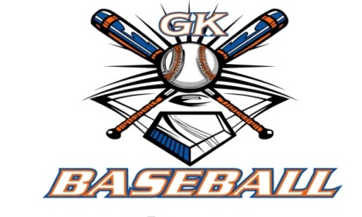

2014-15 Attendance Attended Not Attended
- Ed Frye 11 0
- Larry Creadon 10 1
- Dan Awe 9 2
- Scott Franson 11 0
- Jerry Kline 11 0
- Paul Perry 9 2
- Chris Welch 9 2
Chad Pacey 10 1
- Troy Oates 8 3
- Steve Kleba 10 1
- Eric Golembiewski 6 5
- Matt Krueger 9 2
- Dave Grimm 9 2
- Steve Younker 9 2

