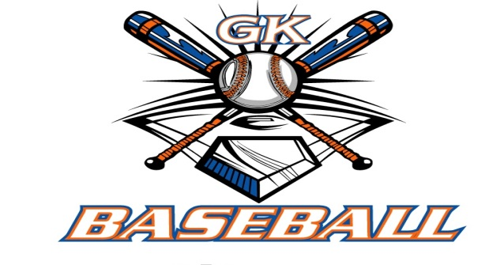
G-K BASEBALL MEETING NOTES
November 9, 2016
Call to Order
8:47 PM @ Genoa Veterans Home

Member Attendance Guest Attendance
- Ed Frye
- Dan Awe
- Chad Pacey
- Chris Welch
- Matt Krueger
- Steve Younker
- Larry Creadon

Approval of previous month minutes: September 2016 Meeting
Motion by: Steve Younkers
2nd : Larry Creaqdon
Yes 6 No 0 Abstain Passed X

Treasurers Report (Closed Session)
Reg. Opening Bal: $ Concession Bal: $
Income: $ Income: $
Expenses: $ Expenses: $
Notes: Ending $ 17645.43 Ending $13276.87 TOTAL $30922.30
Treasurers Report
Motion by: Steve y.
2nd: Chris W
Yes 6 No 0 Abstain Approved N/A

G-K BASEBALL Committee Reports

Old Business
Chad Pacey to discuss grant writing with Genoa Park District

New Business
GK Baseball Camps 2017 6-10 yrs old 1-2:00 and 11-14 yrs old 2:30-4:00
January 22nd .29th
February 12th, 19th

Registration Dates 2017
January 14th 9-Noon VFW
January 18th 6-9:00 PM VFW
January 22nd at Camp
January 29th at Camp
Evalutations March 19
Draft March 23
Opening Day April 29 rain April 30
Picture Day April 29 9 to 11.

Coaches collect raffle tickets April 12

Spirit wear by 1st Registraion

Field Report

Equipment Report
N/A.

Sponsorship Report
N/A

Generals Report
N/A

Picture Report
N/A

Fundraising Report
N/A

Concessions Report
N/A

Spirit Wear Report
N/A

Website Report
N/A

OPEN FLOOR ITEMS (See Notes)
- Ed Frye
- Larry Creadon
- Scott Franson
- Dan Awe
- Jerry Kline
- Chad Pacey
- Steve Kleba
- Chris Welch
- Matt Ides
- Matt Krueger
- Dave Grimm
- Steve Younker
- Roger Butler

NOTES:

Motion to adjourn:
Motion by: Steve Y
2nd: Chris Welch
Yes 6 No 0 Abstain Approved X
@ 9:27 PM

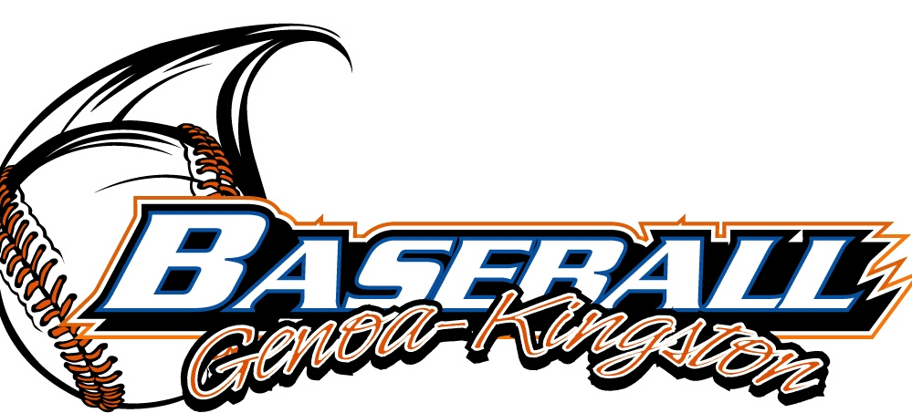

G-K BASEBALL MOTIONS

Motion to
Motion by:
2nd :
Yea Nay 0 Abstain Approved yes
************************************************************************************************************************************
Motion to
Motion by:
2nd :
Yea Nay Abstain Approved
************************************************************************************************************************************
Motion to
Motion by:
2nd :
Yea Nay Abstain Approved
************************************************************************************************************************************
Motion to approve
Motion by:
2nd :
Yea Nay Abstain Approved

ROLL CALL MOTION VOTE FOR: :
Motion by:
2nd :

ROLL CALL VOTE (See Notes)
- Larry Creadon Yes
- Jerry Kline Yes
- Dan Awe Yes
- Scott Franson Yes
- Chad Petersen Yes
- Chris Welch Yes
- Steve Kleba Yes
- Chad Pacey Yes
- Matt Ides Yes
- Steve Younker Yes
- Dave Grimm Yes
- Matt Kreuger Yes
- Ed Frye Abstain (TIE BREAKER CAST VOTE ONLY)

ROLL CALL VOTE TOTAL
Yes No Abstain Motion Approved Motion Failed

G-K BASEBALL NEXT MONTH AGENDA ITEMS/ISSUE LIST
The following items/issues will be part of following month meeting:
Item #1
Item #2
Item #3
Item #4
Item #5

MISC.



