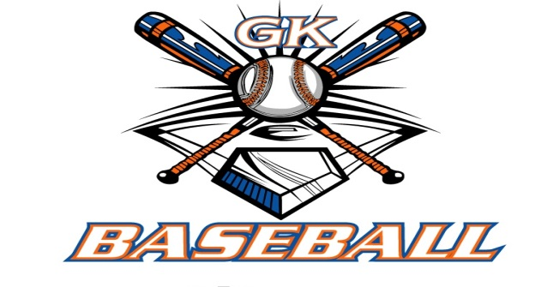
G-K BASEBALL MEETING NOTES
November 17, 2015
Call to Order
8:15 PM @ Genoa Veterans Home

Member Attendance Guest Attendance
- Ed Frye Roger Butler
- Larry Creadon Steve Theil
- Scott Franson Zach Bohne
- Jerry Kline
- Paul Perry
- Steve Kleba
- Chris Welch
- Troy Oates
- Steve Younker
- Dave Grimm

Approval of previous month minutes: October, 2015 Meeting
Motion by: Steve Younkers
2nd : Dave Grimm
Yes 10 No 0 Abstain Passed X

Treasurers Report (Closed Session)
Reg. Opening Bal: $ Concession Bal: $ 10,000.00
Income: $ Income: $ 0.94
Expenses: $ Expenses: $
Notes: Ending $ 27,466.07 Ending $10,000.94 TOTAL $37,467.01
Treasurers Report
Motion by: Paul Perry
2nd: Steve Kleba
Yes 10 No 0 Abstain Approved N/A

G-K BASEBALL Committee Reports

Old Business
BBBB projected net profit for 2016 is $6500 with the addition of 8U & 9U
2015 Net profit was $4750
2014 Net profit was $2100 with $1500 donated to the MJM Foundation

New Business

2016 Registration Dates:
January 16th 9-12 VFW
January 20th 6-9 VFW
January 24th 12-3 GKHS
January 31st 12-3 GKHS
February 14th 12-3 GKHS (Late Fee Applies)
February 21st 12-3 GKHS (Late Fee Applies)

2016 GK Cogs Baseball Camp
January 24th 1-2 PM 6-10 yrs. old 2:30-4 11-14 yrs old
January 31st 1-2 PM 6-10 yrs. old 2:30-4 11-14 yrs old
February 14th 1-2 PM 6-10 yrs. old 2:30-4 11-14 yrs old
February 21st 1-2 PM 6-10 yrs. old 2:30-4 11-14 yrs old

Evaluation at GKHS March 6th time TBD

Draft at VFW March 10th
Minor 6-7:00
Bronco 7-7:30
Pony 7:30-8:00

Opening Day & Picture Day April 30th
Pictures 9-11 AM
Opening Day Ceremony 12:00
Games 1:00 PM

Field Report
Minor work as able with winter progressing.
Wagner to deliver baseball mix to Kingston East & Chamberlain on 11/18/15 if weather allows.
Mesh backing to be removed at Kernian by Steve Younkers & Larry will have the infield sodded yet this year
Ed planted 2 trees as requested by the Park District

Equipment Report
Ordering Uniforms for In House by March 15th

Sponsorship Report
N/A

Generals Report
N/A

Picture Report
Scheduled for 9:00 AM April 30th GES

Fundraising Report
N/A

Concessions Report
N/A

Spirit Wear Report
N./A

Website Report
N/A

OPEN FLOOR ITEMS (See Notes)
- Ed Frye
- Larry Creadon
- Scott Franson
- Dan Awe
- Jerry Kline
- Chad Pacey
- Steve Kleba
- Chris Welch .
- Paul Perry
- Troy Oates
- Matt Krueger
- Dave Grimm
- Steve Younker

NOTES:
Steve Kleba will be out of town for the December Meeting .

Paul Perry will coordinate the scholarship letter with Ed Frye to present to the school district next month

Scott Franson indicated that BSN rep will give a discounted pricing to replace any items lost in the fire. Steve Younkers will create of list of items needed and get together with Scott.

Larry Creadon asked for clarification to Broidy Engel elgiblity to the 10U team. Stated that Brian Lavender has obtained a “waiver” from KCBL but has not produced to Ed Frye upon his request a few months ago. Larry will contact KCBL President Gary Tickle to confirm that this is allowed otherwise Broidy will have to play at the appropriate 11U level.

Roger Butler introduced his coaching staff and discussed his schedule and plans for the 2016 season.

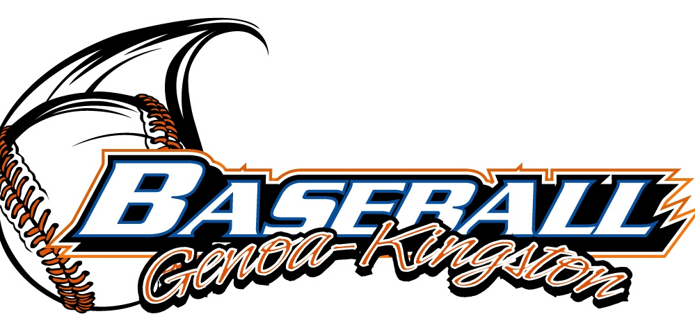

G-K BASEBALL MOTIONS

Motion to Approve $500.00 deposit for 14U to play at Kane County Cougars Stadium on 7/17/15 which will be refunded to the league.
Motion by: Jerry Kline .
2nd : Chris Welch .
Yea 10 Nay 0 Abstain Approved X
************************************************************************************************************************************
Motion to
Motion by:
2nd :
Yea Nay Abstain Approved
************************************************************************************************************************************

************************************************************************************************************************************
Motion to approve
Motion by:
2nd :
Yea Nay Abstain Approved

ROLL CALL MOTION VOTE FOR: $2100.00 to G-K Cogs Baseball to aid with lodging & meal expense for the March 2016 Jacksonville trip.
Motion by: Ed Frye
2nd : Jerry Kline

ROLL CALL VOTE (See Notes)
- Larry Creadon Yes
- Jerry Kline Yes
- Scott Franson Yes
- Paul Perry Yes
- Chris Welch Yes
- Steve Kleba Yes
- Troy Oates Yes
- Steve Younker Yes
- Dave Grimm Yes
- Ed Frye Abstain (TIE BREAKER CAST VOTE ONLY)

ROLL CALL VOTE TOTAL
Yes 9 No 0 Abstain Motion Approved X Motion Failed
G-K BASEBALL NEXT MONTH AGENDA ITEMS/ISSUE LIST
The following items/issues will be part of following month meeting:
Item #1
Item #2
Item #3
Item #4
Item #5

Motion to adjourn
Motion by: Steve Younkers
2nd: Dave Grimm
Yes 10 No 0 Abstain Approved X
@ 9:56 PM
MISC.

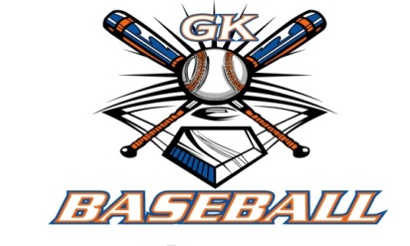
September 2015 – August 2016 Attended Not Attended
- Ed Frye 3 0
- Larry Creadon 3 0
- Dan Awe 2 1
- Scott Franson 3 0
- Jerry Kline 2 1
- Paul Perry 3 0
- Chris Welch 3 0
- Chad Pacey 2 1
- Troy Oates 3 0
- Steve Kleba 3 0
- Matt Krueger 2 1
- Dave Grimm 3 0
- Steve Younker 3 0

