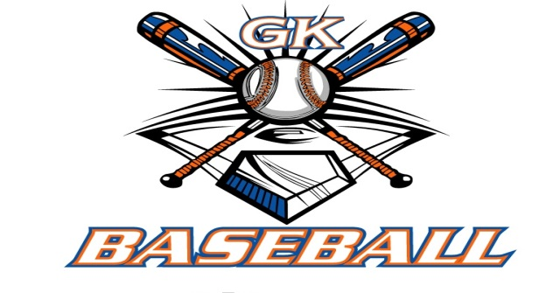
G-K BASEBALL MEETING NOTES
November 12, 2014
Call to Order
812 PM @ Genoa Veterans Home

Member Attendance Guest Attendance
- Ed Frye present x
- Larry Creadon present x
- Scott Franson present x
- Dan Awe present x
- Jerry Kline present x
- Paul Perry present x
- Chad Pacey present x
- Eric Golembiewski present x
- Matt Trzynka present x
- Steve Kleba present x
- Chris Welch present x
- Troy Oates present x
13)Brian Lavendar present x
- Matt Krueger present
- Steve Younker present x
- Dave Grimm present x

Approval of previous month minutes: October 9 2014 Meeting
Motion by: Dave Grimm
2nd : Larry Creadon
Yes 14 No 0 Abstain Passed X

Treasurers Report (Closed Session)
Reg. Opening Bal: $ 26602.12 Concession Bal: $ 11835.23
Income: $ Income: $
Expenses: $ Expenses: $
Notes: Ending $ Ending $ TOTAL $
Treasurers Report
Motion by: Jerry Kline
2nd: Dave Grimm
Yes 14 No 0 Abstain Approved X

G-K BASEBALL Committee Reports

Old Business
Dates will be set for Signups in January ( finalized at Decembers Meeting).

New Business

Ed Frye received an email from Chad Henry from the board. GK Baseball would like to thank Chad for his time and efforts on the board.
Blue Badger Bash will have a 10,11,12,13, and 14 $350 per team $375 for 14 u. Dates June 6 and 7.

Ed will contact school for Camps dates with Coach Ellis.

Field Report

Equipment Report

Sponsorship Report

Generals Report
Contact with Chiltons to get sizing kits.

Picture Report

Fundraising Report

Concessions Report

Spirit Wear Report

Website Report

OPEN FLOOR ITEMS (See Notes)
- Ed Frye— Ed thanked everyone on board for the gift card in his fathers honor, he is going to put up a tree at Kiernan in his honor.
- Larry Creadon
- Scott Franson
- Dan Awe
- Jerry Kline
- Chad Pacey
- Eric Golembiewski
- Matt Trzynka
- Steve Kleba
- Chris Welch
- Paul Perry
- Troy Oates
- Brian Lavender
- Matt Krueger
- Dave Grimm
- Steve Younker

NOTES:
.

Motion to adjourn:
Motion by: Scott Franson
2nd: Jerry Kline
Yes 14 No 0 Abstain Approved X
@ 934 PM

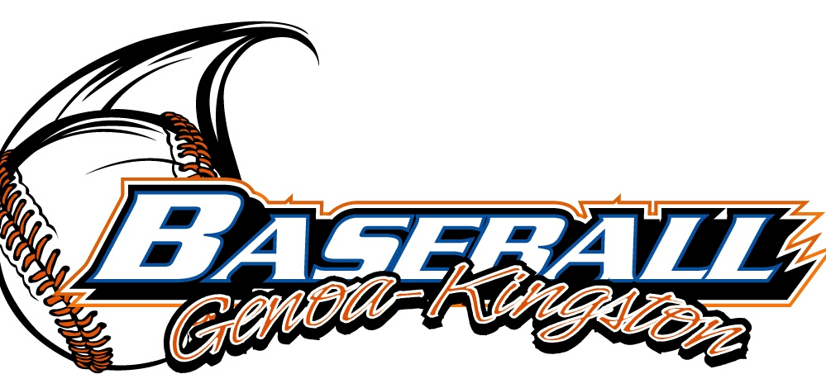
G-K BASEBALL MOTIONS

Motion to
Motion by: .
2nd : .
Yea Nay 0 Abstain Approved yes
************************************************************************************************************************************
Motion to
Motion by:
2nd :
Yea Nay Abstain Approved
************************************************************************************************************************************
Motion to
Motion by:
2nd :
Yea Nay Abstain Approved
************************************************************************************************************************************
Motion to approve
Motion by:
2nd :
Yea Nay Abstain Approved

G-K BASEBALL NEXT MONTH AGENDA ITEMS/ISSUE LIST
The following items/issues will be part of following month meeting:
Item #1
Item #2
Item #3
Item #4
Item #5

ROLL CALL MOTION VOTE NOTES ON ITEMS MORE THAN $1,000: :
Motion by:
2nd :

ROLL CALL VOTE (See Notes)
- Larry Creadon Yes No Abstain
- Jerry Kline Yes No Abstain
- Dan Awe Yes No Abstain
- Scott Franson Yes No Abstain
- Paul Perry Yes No Abstain
- Chris Welch Yes No Abstain
- Eric Golembiewski Yes No Abstain
- Steve Kleba Yes No Abstain
- Troy Oates Yes No Abstain
- Chad Pacey Yes No Abstain
- Matt Trzynka Yes No Abstain
- Stev Younker yes no Abstain
- Brian Lavender yes no Abstain
- Dave Grimm yes no Abstain
- Matt Kreuger yes no Abstain
- Ed Frye Yes No Abstain (TIE BREAKER CAST VOTE ONLY)

ROLL CALL VOTE TOTAL
Yes No Abstain Motion Approved x Motion Failed

November 2014 MISC.

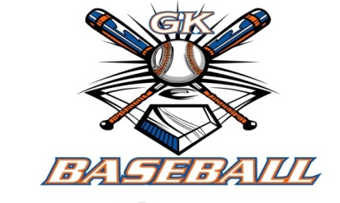

2014 Attendance Attended Not Attended
- Ed Frye 2 0
- Larry Creadon 2 0
- Dan Awe 2 0
- Scott Franson 2 0
- Jerry Kline 2 0
- Paul Perry 2 0
- Chris Welch 1 1
- Matt Trzynka 2 0
- Chad Pacey 2 0
- Troy Oates 2 0
- Steve Kleba 2 0
- Eric Golembiewski 2 0
- Matt Krueger 1 1
- Dave Grimm 2 0
- Steve Younker 2 0
- Brain Lavender 2 0

