
G-K BASEBALL MEETING NOTES
May 13, 2014
Call to Order
858 PM @ Genoa Veterans Home

Member Attendance Guest Attendance
- Ed Frye present x
- Larry Creadon present
- Scott Franson present x
- Dan Awe present
- Jerry Kline present x
- Paul Perry present
- Chad Pacey present x
- Eric Golembiewski present
- Matt Trzynka present
- Steve Kleba present x
- Chris Welch present x
- Troy Oates present
13)Brian Lavendar present
- Matt Krueger present x
- Steve Younker present x
- Dave Grimm present x

Approval of previous month minutes: April, 2015 Meeting
Motion by: Dave Grimm
2nd : Jerry Kline
Yes 8 No 0 Abstain Passed X

Treasurers Report (Closed Session)
Reg. Opening Bal: $ 42914.29 Concession Bal: $ 11686.23
Income: $ Income: $
Expenses: $ Expenses: $
Notes: Ending $ 42914.29 Ending $ 11686.23 TOTAL $
Treasurers Report
Motion by: Jerry Kline
2nd: Dave Grimm
Yes 8 No 0 Abstain Approved X

G-K BASEBALL Committee Reports

Old Business
Minor Pitch Count Clarified to be 60 pitches or finish the batter and no more than three innings
Varsity Field for BBB Clean up is May 30 7 am to 1 pm.
Jerry is to provide BBB grill schedule.
6/5 BBB set at HS at 5 pm
Larry generator
Paint bases
Chalk box from kiernen
Scott tractor to kiernen
Steve is making batter box frame.

New Business
GES home team responsible for cleanup and banners.
Ace Parking first two rows only.

Field Report

Equipment Report

Sponsorship Report

Generals Report

Picture Report

Fundraising Report

Concessions Report

Spirit Wear Report

Website Report

OPEN FLOOR ITEMS (See Notes)
- Ed Frye
- Larry Creadon p;point person for genoa days parade
- Scott Franson
- Dan Awe
- Jerry Kline
- Chad Pacey getting info on Kane county outing
- Eric Golembiewski
- Matt Trzynka
- Steve Kleba has cubs uniforms to Special fx that Scott will pick up, order in house trophies and minor allstar hats
- Chris Welch
- Paul Perry
- Troy Oates
- Brian Lavender
- Matt Krueger
- Dave Grimm
- Steve Younker

NOTES:
.
Motion to adjourn:
Motion by: Steve y.
2nd: Steve K..
Yes 8 No 0 Abstain Approved X
@ 10:14 PM

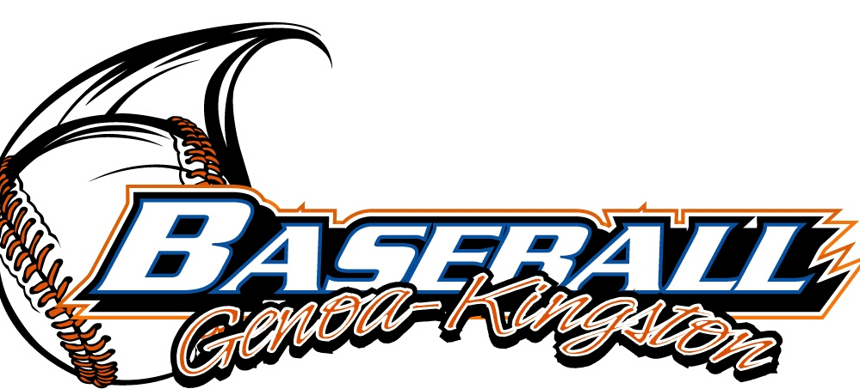
G-K BASEBALL MOTIONS

Motion to purchase new loots
Motion by: steve y. .
2nd : Dave g .
Yea 8 Nay 0 Abstain Approved yes x
************************************************************************************************************************************
Motion to
Motion by:
2nd :
Yea Nay Abstain Approved
************************************************************************************************************************************
Motion to
Motion by:
2nd :
Yea Nay Abstain Approved
************************************************************************************************************************************
Motion to approve
Motion by:
2nd :
Yea Nay Abstain Approved

G-K BASEBALL NEXT MONTH AGENDA ITEMS/ISSUE LIST
The following items/issues will be part of following month meeting:
Item #1
Item #2
Item #3
Item #4
Item #5

ROLL CALL MOTION VOTE NOTES ON ITEMS MORE THAN $1,000: Motion 1500 for Trophies :
Motion by: Jerry Kline
2nd : Dave Grimm

ROLL CALL VOTE (See Notes)
- Larry Creadon Yes No Abstain
- Jerry Kline Yes x No Abstain
- Dan Awe Yes No Abstain
- Scott Franson Yes x No Abstain
- Paul Perry Yes No Abstain
- Chris Welch Yes x No Abstain
- Eric Golembiewski Yes No Abstain
- Steve Kleba Yes x No Abstain
- Troy Oates Yes No Abstain
- Chad Pacey Yes No Abstain
- Matt Trzynka Yes No Abstain
- Stev Younker yes x no Abstain
- Brian Lavender yes no Abstain
- Dave Grimm yes x no Abstain
- Matt Kreuger yes x no Abstain
- Ed Frye Yes No Abstain (TIE BREAKER CAST VOTE ONLY)

ROLL CALL VOTE TOTAL
Yes 8 No0 Abstain Motion Approved x Motion Failed

MISC.



2014 Attendance Attended Not Attended
- Ed Frye 9 0
- Larry Creadon 8 1
- Dan Awe 7 2
- Scott Franson 9 0
- Jerry Kline 9 0
- Paul Perry 8 1
- Chris Welch 7 2
- Matt Trzynka 7 2
- Chad Pacey 9 0
- Troy Oates 7 2
- Steve Kleba 8 1
- Eric Golembiewski 4 5
- Matt Krueger 7 2
- Dave Grimm 7 2
- Steve Younker 7 2
- Brain Lavender 7 2

