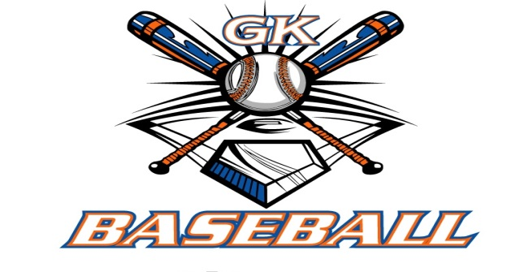
G-K BASEBALL MEETING NOTES
June 11, 2014
Call to Order
815 PM @ Genoa Veterans Home

Member Attendance Guest Attendance
- Ed Frye present x Dave Grimm
- Larry Creadon present x
- Scott Franson present x
- Dan Awe present x
- Jerry Kline present x
- Paul Perry presentx
- Chad Pacey present x
- Eric Golembiewski present x
- Matt Trzynka present absent
- Steve Kleba present x
- Chris Welch present x
- Troy Oates present x
- Chad Henry present x
- General Board Open Position
- General Board Open Position

Approval of previous month minutes: May 2014 Meeting
Motion by: Paul Perry
2nd :
Yes 11 No 0 Abstain Passed X

Treasurers Report (Closed Session)
Reg. Opening Bal: $ Concession Bal: $
Income: $ Income: $
Expenses: $ Expenses: $
Notes: Ending $ Ending $ TOTAL $
Treasurers Report
Motion by:
2nd :
Yes No 0 Abstain Approved X

G-K BASEBALL Committee Reports

Old Business
The aeds to be mounted at Kingston east and Kiernen. Will get mounted 0n 6-11.

New Business
Brain Lavendar has asked to host a 8u tourney on July 26 and 28.
July 19,20 remove hr fence at Kingston East.
Email out for parking at Tobinsons.
Trophies first place and metals for second.

Field Report

Equipment Report

Sponsorship Report

Generals Report
Season going well at all levels.

Picture Report
Pictures should be arriving at the homes of coaches.

Fundraising Report
.

Concessions Report

Spirit Wear Report
Avaiable from Wacko Wear

Website Report
Chad Pacey is helping out posting things to website.

OPEN FLOOR ITEMS (See Notes)
- Ed Frye—
- Larry Creadon
- Scott Franson
- Dan Awe
- Jerry Kline
- Chad Pacey minor 7 games haven’t been played yet,
- Eric Golembiewski
- Matt Trzynka
- Steve Kleba expressed concern with the Generals taking away kids from inhouse teams.
- Chris Welch
- Paul Perry
- Troy Oates
- Chad Henry

NOTES:
.10 teams in parade. Starts at 1 pm, be at castco 12 noon.

Motion to adjourn:
Motion by: Jerry K.
2nd : Steve Kleba
Yes 11 No 0 Abstain Approved X
@ 8:00 PM

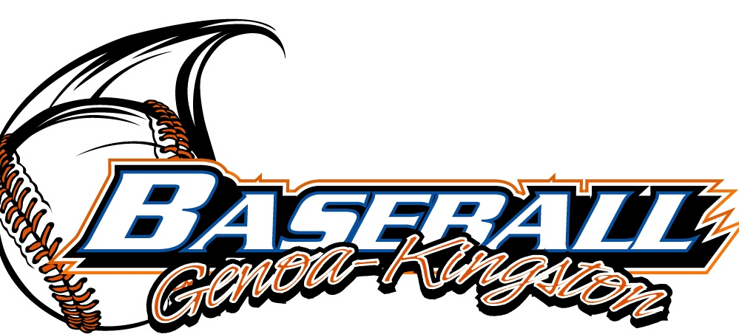
G-K BASEBALL MOTIONS

Motion to Dedicate 500 dollard to GK BASEBALL S cholorship for a graduating senior.
Motion by: Jerry Kline
2nd : Paul Perry
Yea 10 Nay 2 Abstain Approved yes
************************************************************************************************************************************
Motion to
Motion by:
2nd :
Yea Nay Abstain Approved
************************************************************************************************************************************
Motion to
Motion by:
2nd :
Yea Nay Abstain Approved
************************************************************************************************************************************
Motion to approve
Motion by:
2nd :
Yea Nay Abstain Approved

G-K BASEBALL NEXT MONTH AGENDA ITEMS/ISSUE LIST
The following items/issues will be part of following month meeting:
Item #1
Item #2
Item #3
Item #4
Item #5

ROLL CALL MOTION VOTE NOTES ON ITEMS MORE THAN $1,000: 1500 dollars to Mason Mcpherson Fund from tournament :
Motion by: Jerry Kline
2nd : Chris Welch

ROLL CALL VOTE (See Notes)
- Larry Creadon x Yes No Abstain
- Jerry Kline x Yes No Abstain
- Dan Awe x Yes No Abstain
- Scott Franson Yes x No Abstain
- Paul Perry x Yes No Abstain
- Chris Welch x Yes No Abstain
- Eric Golembiewskxi Yes No Abstain
- Chad Henry Yes x No Abstain
- Steve Kleba Yes x No Abstain
- Troy Oates Yes x No Abstain
- Chad Pacey x Yes No Abstain
- Matt Trzynka Yes No Abstain
- Ed Frye Yes No Abstain (TIE BREAKER CAST VOTE ONLY)

ROLL CALL VOTE TOTAL
Yes 7 No 4 Abstain Motion Approved x Motion Failed

May 2014 MISC.

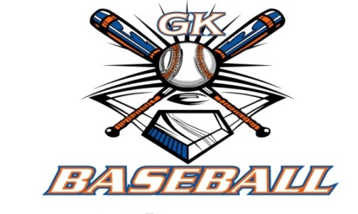
2014 Attendance Attended Not Attended
- Ed Frye 6 0
- Larry Creadon 6 0
- Dan Awe 5 1
- Scott Franson 6 0
- Jerry Kline 6 0
- Paul Perry 6 0
- Chris Welch 6 0
- Matt Trzynka 4 2
- Chad Pacey 6 0
- Troy Oates 5 1
- Chad Henry 4 2
- Steve Kleba 5 1
- Eric Golembiewski 6 0

