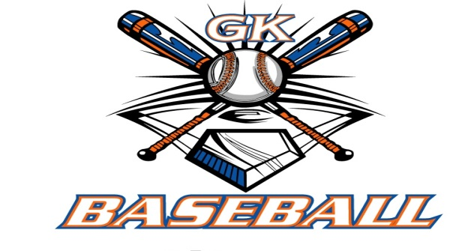
G-K BASEBALL MEETING NOTES
July 10, 2014
Call to Order
820 PM @ Genoa Veterans Home

Member Attendance Guest Attendance
- Ed Frye present x Dave Grimm
- Larry Creadon present x
- Scott Franson present x
- Dan Awe present x
- Jerry Kline present x
- Paul Perry presentx
- Chad Pacey present x
- Eric Golembiewski present x
- Matt Trzynka present
- Steve Kleba ABSENT
- Chris Welch present x
- Troy Oates ABSENT
- Chad Henry ANSENT
- General Board Open Position
- General Board Open Position

Approval of previous month minutes: May 2014 Meeting
Motion by: Jerry Kline
2nd : Paul Perry
Yes 10 No 0 Abstain Passed X

Treasurers Report (Closed Session)
Reg. Opening Bal: $ 32063.48 Concession Bal: $ 8636
Income: $ Income: $
Expenses: $ Expenses: $
Notes: Ending $ Ending $ TOTAL $
Treasurers Report
Motion by: Jerry Kline
2nd : Paul Perry
Yes 10 No 0 Abstain Approved X

G-K BASEBALL Committee Reports

Old Business

New Business
Dicks Sporting Goods has offered a sponsorship to go with online registration at 2.8% paypall is 3.2%. Ed was going to look into it to see if it worth investigating doing.

Field Report
Field work days planned for 9-7,9-21,10-5,10-19. 10 am start time.

Equipment Report

Sponsorship Report

Generals Report

Picture Report

Fundraising Report
.

Concessions Report

Spirit Wear Report

Website Report

OPEN FLOOR ITEMS (See Notes)
- Ed Frye— Generals tryout dates 8/17,8/24
- Larry Creadon
- Scott Franson
- Dan Awe
- Jerry Kline
- Chad Pacey –season ending pool party asked to be reimbursed 95 dollars. Fall ball in Belvidere
- Eric Golembiewski
- Matt Trzynka
- Steve Kleba
- Chris Welch
- Paul Perry
- Troy Oates
- Chad Henry

NOTES:
. Next Meeting 8/14 8pm

Motion to adjourn:
Motion by: Jerry Kline
2nd : Matt T.
Yes 10 No 0 Abstain Approved X
@ 9:40 PM

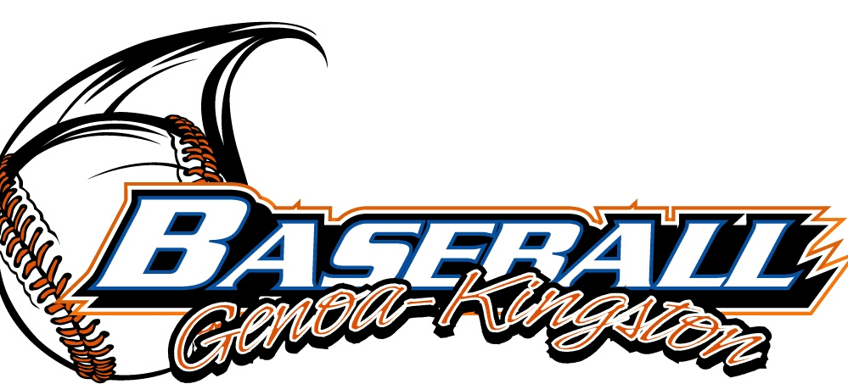
G-K BASEBALL MOTIONS

Motion to reimburse Chad Pacey 95 dollars for pool party
Motion by: Dan Awe
2nd : Paul Perry
Yea 10 Nay 0 Abstain Approved yes x
************************************************************************************************************************************
Motion to
Motion by:
2nd :
Yea Nay Abstain Approved
************************************************************************************************************************************
Motion to
Motion by:
2nd :
Yea Nay Abstain Approved
************************************************************************************************************************************
Motion to approve
Motion by:
2nd :
Yea Nay Abstain Approved

G-K BASEBALL NEXT MONTH AGENDA ITEMS/ISSUE LIST
The following items/issues will be part of following month meeting:
Item #1
Item #2
Item #3
Item #4
Item #5

ROLL CALL MOTION VOTE NOTES ON ITEMS MORE THAN $1,000: :
Motion by:
2nd :

ROLL CALL VOTE (See Notes)
- Larry Creadon Yes No Abstain
- Jerry Kline Yes No Abstain
- Dan Awe Yes No Abstain
- Scott Franson Yes No Abstain
- Paul Perry Yes No Abstain
- Chris Welch Yes No Abstain
- Eric Golembiewskxi Yes No Abstain
- Chad Henry Yes No Abstain
- Steve Kleba Yes No Abstain
- Troy Oates Yes No Abstain
- Chad Pacey Yes No Abstain
- Matt Trzynka Yes No Abstain
- Ed Frye Yes No Abstain (TIE BREAKER CAST VOTE ONLY)

ROLL CALL VOTE TOTAL
Yes No Abstain Motion Approved x Motion Failed

JULY 2014 MISC.

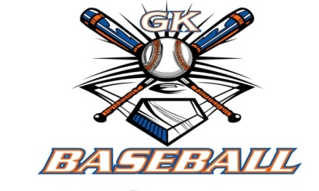
2014 Attendance Attended Not Attended
- Ed Frye 7 0
- Larry Creadon 7 0
- Dan Awe 6 1
- Scott Franson 7 0
- Jerry Kline 7 0
- Paul Perry 7 0
- Chris Welch 7 0
- Matt Trzynka 5 2
- Chad Pacey 7 0
- Troy Oates 5 2
- Chad Henry 4 3
- Steve Kleba 5 2
- Eric Golembiewski 7 0

