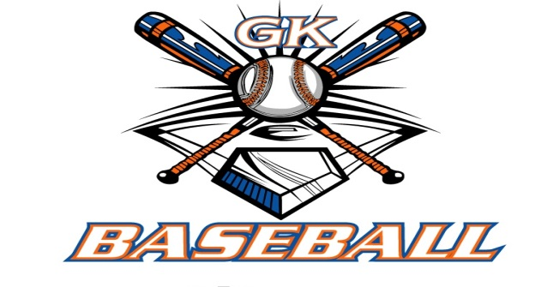
G-K BASEBALL MEETING NOTES
April15, 2014
Call to Order
825 PM @ Genoa Veterans Home

Member Attendance Guest Attendance
- Ed Frye present x
- Larry Creadon present x
- Scott Franson present x
- Dan Awe present x
- Jerry Kline present x
- Paul Perry present x
- Chad Pacey present x
- Eric Golembiewski present
- Matt Trzynka present x
- Steve Kleba present
- Chris Welch present x
- Troy Oates present x
13)Brian Lavendar present x
- Matt Krueger present
- Steve Younker present x
- Dave Grimm present x

Approval of previous month minutes: March , 2015 Meeting
Motion by: Paul Perry
2nd : Jerry Kline
Yes 13 No 0 Abstain Passed X

Treasurers Report (Closed Session)
Reg. Opening Bal: $ 28391.66 Concession Bal: $ 11686.71
Income: $ 15545.41 Income: $
Expenses: $ Expenses: $
Notes: Ending $ 43937.06 Ending $ 11687.64 TOTAL $
Treasurers Report
Motion by: Jerry Kline
2nd: Dan Awe
Yes 13 No 0 Abstain Approved X

G-K BASEBALL Committee Reports

Old Business
Field Day Aprill 11,12 final work day went well.

New Business
Opening day set up will meet about 9:30 am. All hands on deck for help

Insurance Renewal – up for vote in Roll call section

Field Report

Equipment Report

Sponsorship Report

Generals Report

Picture Report
Picture Day scheduled for May 10, 4 pm.

Fundraising Report

Concessions Report

Spirit Wear Report

Website Report

OPEN FLOOR ITEMS (See Notes)
- Ed Frye
- Larry Creadon
- Scott Franson
- Dan Awe
- Jerry Kline
- Chad Pacey
- Eric Golembiewski
- Matt Trzynka
- Steve Kleba
- Chris Welch
- Paul Perry
- Troy Oates
- Brian Lavender
- Matt Krueger
- Dave Grimm
- Steve Younker

NOTES:
.
Motion to adjourn:
Motion by: Chris
2nd: Paul P.
Yes 12 No 0 Abstain Approved X
@ 938 PM

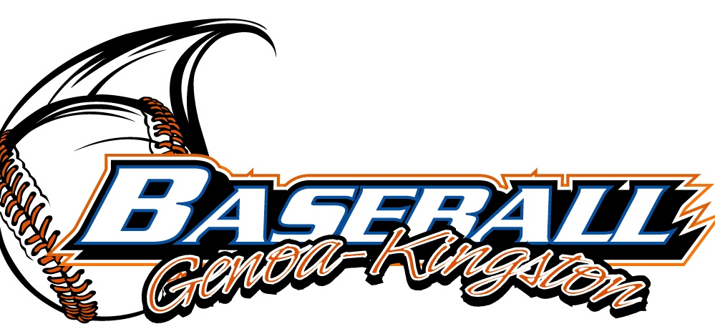
G-K BASEBALL MOTIONS

Motion to Motion to purchase a tent not to exceed 1600 dollars for opening day
Motion by: Paul Perry .
2nd : Dan Awe .
Yea 13 Nay 0 Abstain Approved yes x
************************************************************************************************************************************
Motion to
Motion by:
2nd :
Yea Nay Abstain Approved
************************************************************************************************************************************
Motion to
Motion by:
2nd :
Yea Nay Abstain Approved
************************************************************************************************************************************
Motion to approve
Motion by:
2nd :
Yea Nay Abstain Approved

G-K BASEBALL NEXT MONTH AGENDA ITEMS/ISSUE LIST
The following items/issues will be part of following month meeting:
Item #1
Item #2
Item #3
Item #4
Item #5

ROLL CALL MOTION VOTE NOTES ON ITEMS MORE THAN $1,000: Motion to pay insurance that is due. Motion not to exceed 1600 to purchase new tents for BBB. Both motions approved
:
Motion by: Jerry Kline
2nd : Larry Creadon

ROLL CALL VOTE (See Notes)
- Larry Creadon Yes x No Abstain
- Jerry Kline Yes x No Abstain
- Dan Awe Yes x No Abstain
- Scott Franson Yes x No Abstain
- Paul Perry Yes x No Abstain
- Chris Welch Yes x No Abstain
- Eric Golembiewski Yes No Abstain
- Steve Kleba Yes x No Abstain
- Troy Oates Yes x No Abstain
- Chad Pacey Yes x No Abstain
- Matt Trzynka Yes x No Abstain
- Stev Younker yes x no Abstain
- Brian Lavender yes x no Abstain
- Dave Grimm yes x no Abstain
- Matt Kreuger yes no Abstain
- Ed Frye Yes No Abstain (TIE BREAKER CAST VOTE ONLY)

ROLL CALL VOTE TOTAL
Yes 13 No Abstain Motion Approved x Motion Failed

MISC.



2014 Attendance Attended Not Attended
- Ed Frye 8 0
- Larry Creadon 8 0
- Dan Awe 7 1
- Scott Franson 8 0
- Jerry Kline 8 0
- Paul Perry 8 0
- Chris Welch 6 2
- Matt Trzynka 7 1
- Chad Pacey 8 0
- Troy Oates 7 1
- Steve Kleba 7 1
- Eric Golembiewski 4 4
- Matt Krueger 6 2
- Dave Grimm 6 2
- Steve Younker 6 2
- Brain Lavender 7 1

