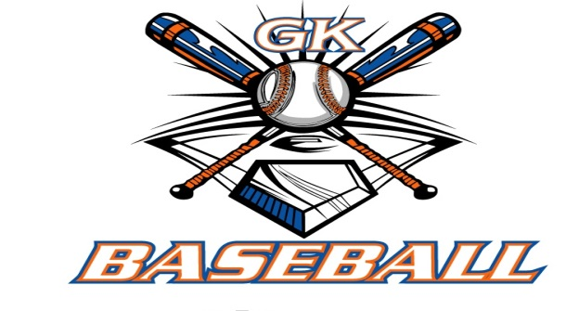
G-K BASEBALL MEETING NOTES
January 10, 2018
Call to Order
8:07 PM @ Genoa Veterans Home

Member Attendance Guest Attendance
- Chad Pacey
- Steve Younker
- Jerry Kline
- Matt Krueger
- Scott Franson
- Chris Welch
- Chad Peterson
- Robert Bohne
- Robby Montgomery
- Steve Kleba
- Roger Butler

Approval of previous month minutes: Dember Meeting
Motion by: Jerry K. (with changes)
2nd : Robby M.
Yes 10 No Abstain Passed

Treasurers Report (Closed Session)
Reg. Opening Bal: $ 22,145.46 Concession Bal: $ 12,884.88
Income: $ Income: $
Expenses: $ Expenses: $
Notes: Ending $ Ending $ TOTAL $
Treasurers Report
- Put together P&L statement for last year and this year
- 2016, total income- $77,475 against expenses- $84,039
- 2017, total income- $79,961 against expenses- $78,286
Motion by: Steve Y.
2nd: Rob M.
Yes 10 No 0 Abstain Approved X

G-K BASEBALL Committee Reports

Old Business
- NONE

New Business
- Field Report
  - Bob P. agreed to prep fields again this year
  - Steve has quote out for load of Field Mix for Kiernan, but no response yet
  - Home plate at GES North needs re-set
- Generals Update
  - Generals sizing- 11U & 13U on 1/11/18; 14U next week
  - Met with wrestling coach at GMS to go over management of mats
    - Went over procedures to peel up and reuse tape
    - No shoes on the mats
- Blue Badger Update-
  - 10U- 2 teams; 11U- 2 teams; 12U- 7 teams; 13U- 5 teams; 14U- 3 teams
  - Umpires quoted $55 per game; came down $5 per game from last year
- Update on GES/Kiernan Sheds
  - Blue shed (demon shed) is empty
  - Demon is ready to be hauled out for service (Dave G.)
- Equipment Update
  - Steve K. to order 7X7 screen for use in balcony; Steve Y get competitive quotes from BSN
  - Order helmets; Steve Y. get competitive quote from BSN and check on quantity breaks
- Scholarship/Fundraising Update
  - Calendars completed
  - Numbers 1 – 1500 will go to baseball; numbers 1501 – 3000 will go to softball
  - Chad will update sponsor form
- In-House Update- Registrations and Camps
  - Saturday help- Rob M., Steve, Chad Pe., Chad Pa., Rob B. (9-noon)
  - Sunday help- Jerry, Chad Pa., Scott (12-1 & 1-3)
  - Jerry bringing bag of equipment for older kids
  - Steve K. picking up bag for minor and bronco levels
  - Chad Pa. has all necessary paperwork for registration
  - Chad Pa. has uniform shirts for shizing as well
- Pictures / Sprit Wear Update
  - Plan is to have 200 picture forms
- Miscellaneous
  - Baseball received invoice for $225 from Football for recertification of AED and new pads
  - Jerry moved and Roger seconded to approve the payment of $225

Field Report
- (New business)

Equipment Report
N/A

Sponsorship Report /Fundraising Report
N/A

Generals Report
N/A

Picture Report
N/A

Concessions Report
N/A

Spirit Wear Report
N/A

Website Report
N/A

OPEN FLOOR ITEMS (See Notes)
- Chad Pacey: Went to coach clinic in Indianapolis hosted by ABCA; good information; should have access to videos.
- Chris Welch
- Matt Krueger
- Steve Younker
- Chad Peterson
- Jerry Kline: Got call from Aaron Meyer- football annoyed that they were removed from storage at KES; baseball sending contingent to their board meeting 3rd Thursday of the month.
- Robert Bohne:
- Rob Montgomery:
- Steve Kleba
- Scott Franson: Matt T. contacted him wanting to sponsor a scholarship for an in-house player
- Roger Butler: Concert for the COGS is 1/20/18, 4:00-7:00; have tickets available

NOTES:
.
Motion to adjourn:
Motion by: Steve Y.
2nd: Rob M.
Yes No Abstain Approved
@ 9:06 PM

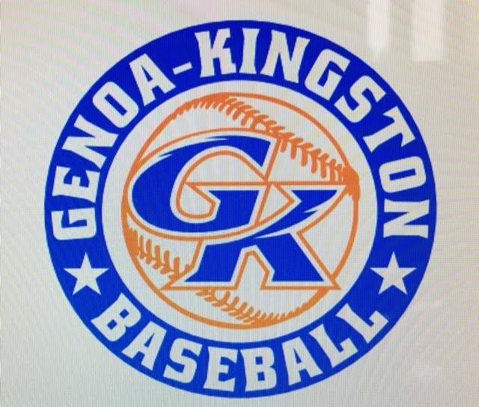

G-K BASEBALL MOTIONS

Motion to: Reimburse $225 bill for reconditioning and servicing AED
Motion by: Jerry K.
2nd : Roger B.
Yea 10 Nay Abstain Approved
************************************************************************************************************************************
Motion to:
Motion by:
2nd :
Yea Nay Abstain Approved
************************************************************************************************************************************
Motion to
Motion by:
2nd :
Yea Nay Abstain Approved
************************************************************************************************************************************
Motion to approve
Motion by:
2nd :
Yea Nay Abstain Approved

G-K BASEBALL NEXT MONTH AGENDA ITEMS/ISSUE LIST FOR February 21, 2018
The following items/issues will be part of following month meeting:
Item #1
Item #2
Item #3
Item #4
Item #5

ROLL CALL MOTION VOTE NOTES ON ITEMS MORE THAN $1,000: N/A
ROLL CALL VOTE (See Notes)
- Steve Younker Yes No Abstain
- Jerry Kline Yes No Abstain
- Dan Awe Yes No Abstain
- Chris Welch Yes No Abstain
- Steve Kleba Yes No Abstain
- Matt Ides Yes No Abstain
- Dave Grimm Yes No Abstain
- Matt Krueger Yes No Abstain
- Chad Peterson Yes No Abstain
- Robert Bohne Yes No Abstain
- Robby Montgomery Yes No Abstain
- Roger Butler Yes No Abstain
- Chad Pacey Yes No Abstain (TIE BREAKER CAST VOTE ONLY)

ROLL CALL VOTE TOTAL
Yes No Abstain Motion Approved Motion Failed
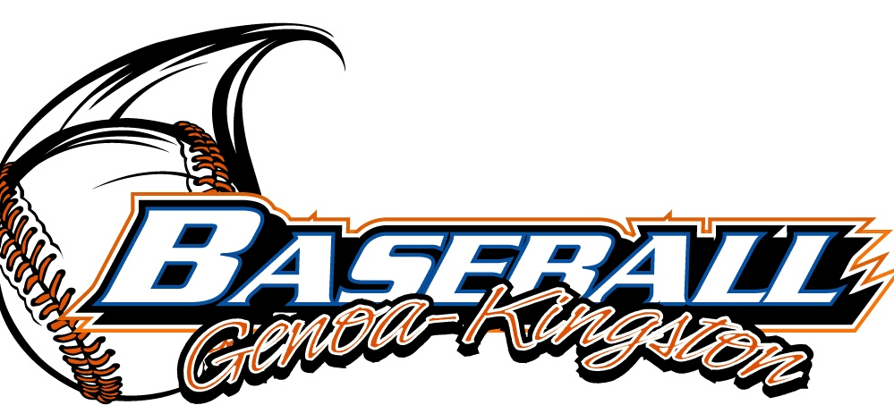

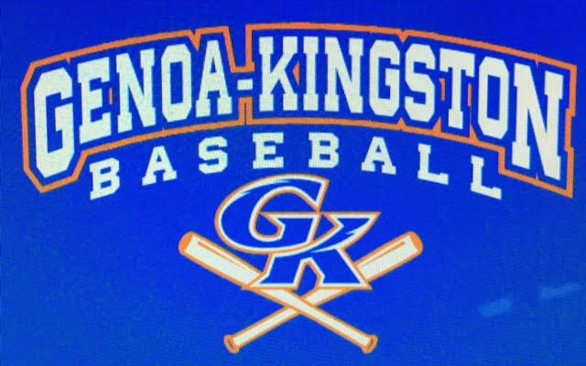

MISC.

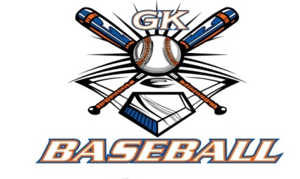
2017-2018 Attendance Attended Not Attended
- Chad Pacey
- Steve Younker
- Dan Awe
- Jerry Kline
- Chris Welch
- Matt Ides
- Steve Kleba
- Matt Krueger
- Dave Grimm
- Chad Peterson
- Robert Bohne
- Robby Montgomery
- Roger Butler

