
G-K BASEBALL MEETING NOTES
October 11, 2017
Call to Order
8:07 PM @ Genoa Veterans Home

Member Attendance Guest Attendance
- Chad Pacey
- Steve Younker
- Jerry Kline
- Matt Krueger
- Scott Franson
- Chris Welch
- Dave Grimm
- Chad Peterson
- Robert Bohne
- Robby Montgomery
- Matt Ides

Approval of previous month minutes: August Meeting & September Meeting
Motion by: Dave G. (August) Robby M. (September)
2nd : Robby M. Dave G.
Yes 10 No Abstain Passed

Treasurers Report (Closed Session)
Reg. Opening Bal: $ 20,770.03 Concession Bal: $ 12,873
Income: $ Income: $
Expenses: $ Expenses: $
Notes: Ending $ Ending $ TOTAL $
Treasurers Report
Motion by: Steve Y.
2nd: Dave G.
Yes 10 No 0 Abstain Approved X

G-K BASEBALL Committee Reports

Old Business
- NONE

New Business
- Fill open board positions
  - Robby Montgomery agreed to Picture Day Chair
  - Robert Bohne agreed to Fundraising Chair
- Fall Baseball Update
  - 2 games left; 7-3 record; going well
- Fall Field Work
  - Steve not available until November
  - Rework mounds and Chamberlain and Kiernan
  - Disrupt weeds at all fields; not a lot else needed
  - Jerry to contact Bob P. to drag/tine all fields
  - Do not need Ag Lime, but Steve has quote out for load of Field Mix for Kiernan
  - Home plate at GES North needs re-set
  - Kingston West has divots from circus
  - Discussed pallet racking available from Robby for out at Kiernan Shed
    - 16’ standards; agreed to cut to 8’ and have two sets
- Generals Update
  - 80% of $100 deposits received
  - New check needed for GMS balcony
  - Getting bags and helmets ordered for any new teams
- Blue Badger Update-
  - To do over next two months
    - Double check rules
    - Finalize Dates
    - Verify check deposit for use of HS
- Coaching Clinic Reimbursement
  - Not a lot of feedback yet
  - Thought is to set at $75 max reimbursement
  - Have to hold money talley on their own until registration time
  - Need to think of ways to make sure that if we reimburse that they coach at some level
  - Discussed offering discount on registration if coach, but decided to hold on that until after
we get through the registration process and see where we are
  - Push the Cougars clinic in January
- Update on GES/Kiernan Sheds
  - Blue shed (demon shed) will need to go at some point
  - Dave G. to talk to Dean Awe about possibly moving out to Kingston East
  - Discussed where to store demon during season and off-season
    - Maybe at GES during off-season, but Kiernan during season

Field Report
- (New business)

Equipment Report
N/A

Sponsorship Report /Fundraising Report
N/A

Generals Report
N/A

Picture Report
N/A

Concessions Report
N/A

Spirit Wear Report
N/A

Website Report
N/A

OPEN FLOOR ITEMS (See Notes)
- Chad Pacey: Brought up dugout finishing at Kiernan; found plan as reviewing stuff and need to finalize what we want to do and finish it.
- Chris Welch
- Matt Krueger
- Steve Younker: Park district called and fence cap at Chamberlain needs replaced; got quote for $253.99; Get quote to replace caps at GES and at Kingston West also.
- Chad Peterson
- Dave Grimm
- Jerry Kline: Concessions- proposed new cabinets; looking at $900-$1,000 and Jen Creadon would paint them; Dave G. to follow up on cabinet options; Chad to talk to Jen about concessions at Kiernan since plan is to have more games out there; Also need to look at HS Baseball Camp time shift because Varsity team will be attending hitting instruction in St. Charles on Sunday afternoons; Will supply 15 mil poly for field mix pile at Kiernan to keep weeds down.
- Robert Bohne:
- Robby Montgomery: really need to look at replacing helmets and other equipment; have Steve K. weed them out over off-season; next month, discuss budget for replacement of equipment.
- Matt Ides
- Scott Franson

NOTES:
.
Motion to adjourn:
Motion by: Dave G.
2nd: Steve Y.
Yes No Abstain Approved
@ 9:30 PM

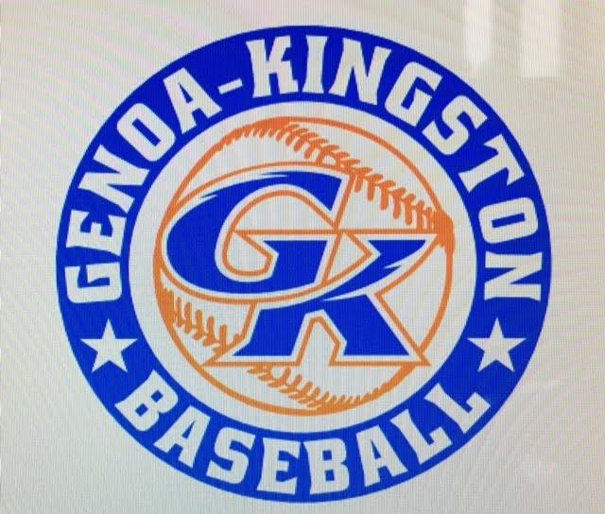

G-K BASEBALL MOTIONS

Motion to:
Motion by:
2nd :
Yea Nay Abstain Approved
************************************************************************************************************************************
Motion to:
Motion by:
2nd :
Yea Nay Abstain Approved
************************************************************************************************************************************
Motion to
Motion by:
2nd :
Yea Nay Abstain Approved
************************************************************************************************************************************
Motion to approve
Motion by:
2nd :
Yea Nay Abstain Approved

G-K BASEBALL NEXT MONTH AGENDA ITEMS/ISSUE LIST FOR November 8, 2017
The following items/issues will be part of following month meeting:
Item #1 Budget for equipment replacement
Item #2 Update on cabinet options for GES shed/concessions
Item #3
Item #4
Item #5

ROLL CALL MOTION VOTE NOTES ON ITEMS MORE THAN $1,000: N/A
ROLL CALL VOTE (See Notes)
- Steve Younker Yes No Abstain
- Jerry Kline Yes No Abstain
- Dan Awe Yes No Abstain
- Chris Welch Yes No Abstain
- Steve Kleba Yes No Abstain
- Matt Ides Yes No Abstain
- Dave Grimm Yes No Abstain
- Matt Krueger Yes No Abstain
- Chad Peterson Yes No Abstain
- Robert Bohne Yes No Abstain
- Robby Montgomery Yes No Abstain
- Roger Butler Yes No Abstain
- Chad Pacey Yes No Abstain (TIE BREAKER CAST VOTE ONLY)

ROLL CALL VOTE TOTAL
Yes No Abstain Motion Approved Motion Failed
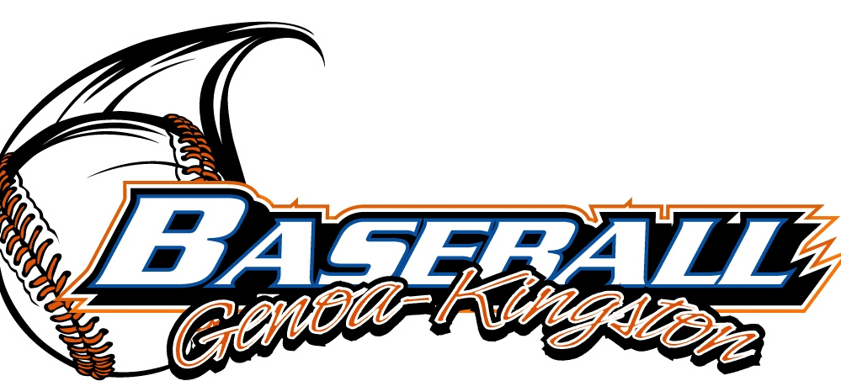

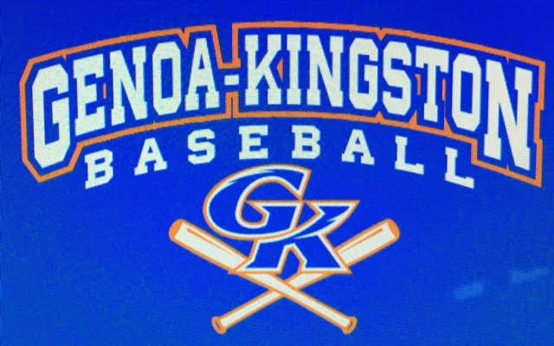

MISC.


2017-2018 Attendance Attended Not Attended
- Chad Pacey
- Steve Younker
- Dan Awe
- Jerry Kline
- Chris Welch
- Matt Ides
- Steve Kleba
- Matt Krueger
- Dave Grimm
- Chad Peterson
- Robert Bohne
- Robby Montgomery
- Roger Butler

