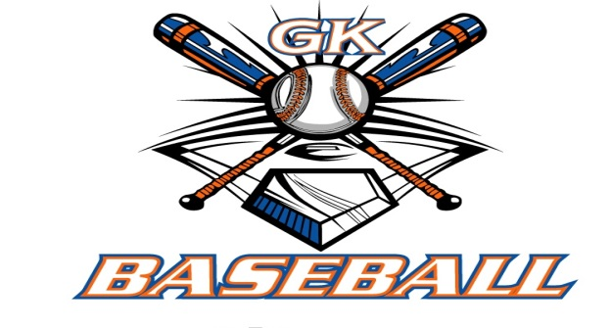
G-K BASEBALL MEETING NOTES
September 13, 2017
Call to Order
8:34 PM @ Genoa Veterans Home

Member Attendance Guest Attendance
- Ed Frye
- Chad Pacey
- Jerry Kline
- Steve Younker
- Matt Krueger
- Chris Welch
- Dave Grimm
- Steve Kleba
- Robert Bohne
- Robby Montgomery

Approval of previous month minutes: August Meeting
Motion by: ****TABLED- NONE AVAILABLE****
2nd :
Yes No Abstain Passed

Treasurers Report (Closed Session)
Reg. Opening Bal: $ 28,378.35 Concession Bal: $ 12,882.77
Income: $ Income: $
Expenses: $ Expenses: $
Notes: Ending $ Ending $ TOTAL $
Treasurers Report
Motion by: Steve Y.
2nd: Chris W.
Yes 9 No 0 Abstain Approved X

G-K BASEBALL Committee Reports

Old Business
- NONE

New Business
- Installation of New Officers and New Members
  - Robert Bohne and Robby Montgomery agreed to join board
  - Roger Butler agreed to join as general board member
  - Ed Frye resigned in order to spend more time with Caden in his final year of high school
prior to leaving for college.
  - Ed Frye nominated Chad Pacey for next president, Jerry Kline seconded; Chad agreed to
accept role of president
  - Ed nominated Steve Younker for Vice President, Jerry Kline seconded; Steve accepted
  - Voted back in Ruth Kleba as Concessions Manager, Matt Krueger as Treasurer, and Jerry
Kline as Chairman of Leagues.
- Fall Field Work
  - Sometime Late October / Early November
  - Suggested getting in Ag Lime for October and load of Field Mix for Kiernan
  - Discussed getting some pallet racking for out at Kiernan Shed
    - Robby Montgomery has a possible line on racking that he will check on
  - Steve Younker to put together list of field work items for October meeting.
- Belvidere Fall Ball Update
  - 14U team playing at 12U level
  - Playing in league with two in-house teams and two travel teams
  - Going well; playing 12 games
- Generals Update
  - No 10U team
  - 11U – 7 of 10 positions accepted
  - 12U – not enough players to form team; staying in-house and putting together a
tournament team to go play a couple of places.
  - 13U – 10 accepted, 2 pending
  - 14U – 11 accepted, 1 pending
  - Time slots and paperwork in-process for middle school balcony
  - Possibly use Kiernan Park for more in-house games with absence of 10U and 12U teams
- Blue Badger Update-
  - Planning to send out information around 11/1/17
  - Hope to have 10U team still and hope to have a 16U division hosted at Kingston East
    - Would bring us to 36 teams

Field Report
- None

Equipment Report
N/A

Sponsorship Report /Fundraising Report
N/A

Generals Report
N/A

Picture Report
N/A

Concessions Report
N/A

Spirit Wear Report
N/A

Website Report
N/A

OPEN FLOOR ITEMS (See Notes)
- Ed Frye:
- Chad Pacey: Updated our registration form; coach clinic in Peoria was phenomenal; encourage our coaches to got to future event in Milwaukee
- Chris Welch
- Matt Krueger: still owe GK Softball their half of calendar sales ($4,595.00)
- Steve Younker
- Steve Kleba: Any plans yet for storage space? Need ideas on how to make sure Generals keeps going.
- Dave Grimm
- Jerry Kline: Consider modeling Generals tryouts after Storm… make more concise and quick.
- Robert Bohne:
- Robby Montgomery:
NOTES:
.
Motion to adjourn:
Motion by: Dave G.
2nd: Steve K.
Yes No Abstain Approved
@ 9:47 PM

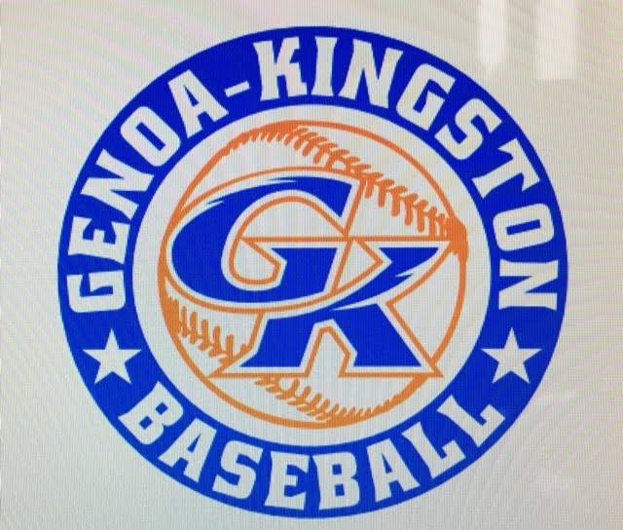

G-K BASEBALL MOTIONS

Motion to:
Motion by:
2nd :
Yea Nay Abstain Approved
************************************************************************************************************************************
Motion to:
Motion by:
2nd :
Yea Nay Abstain Approved
************************************************************************************************************************************
Motion to
Motion by:
2nd :
Yea Nay Abstain Approved
************************************************************************************************************************************
Motion to approve
Motion by:
2nd :
Yea Nay Abstain Approved

G-K BASEBALL NEXT MONTH AGENDA ITEMS/ISSUE LIST FOR October 11, 2017
The following items/issues will be part of following month meeting:
Item #1
Item #2
Item #3
Item #4
Item #5

ROLL CALL MOTION VOTE NOTES ON ITEMS MORE THAN $1,000: N/A
ROLL CALL VOTE (See Notes)
- Steve Younker Yes No Abstain
- Jerry Kline Yes No Abstain
- Dan Awe Yes No Abstain
- Chris Welch Yes No Abstain
- Steve Kleba Yes No Abstain
- Matt Ides Yes No Abstain
- Dave Grimm Yes No Abstain
- Matt Krueger Yes No Abstain
- Chad Peterson Yes No Abstain
- Robert Bohne Yes No Abstain
- Robby Montgomery Yes No Abstain
- Roger Butler Yes No Abstain
- Chad Pacey Yes No Abstain (TIE BREAKER CAST VOTE ONLY)

ROLL CALL VOTE TOTAL
Yes No Abstain Motion Approved Motion Failed
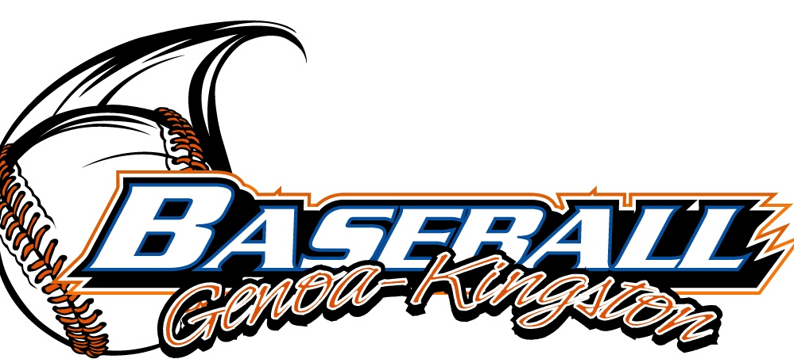

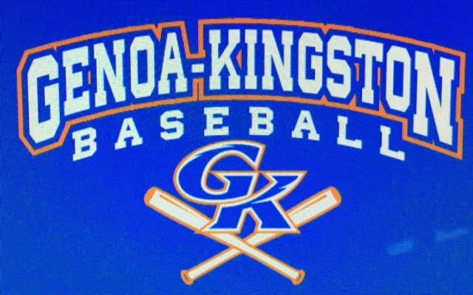

MISC.

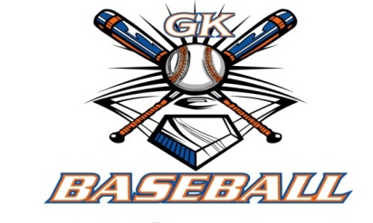
2017-2018 Attendance Attended Not Attended
- Chad Pacey
- Steve Younker
- Dan Awe
- Jerry Kline
- Chris Welch
- Matt Ides
- Steve Kleba
- Matt Krueger
- Dave Grimm
- Chad Peterson
- Robert Bohne
- Robby Montgomery
- Roger Butler

