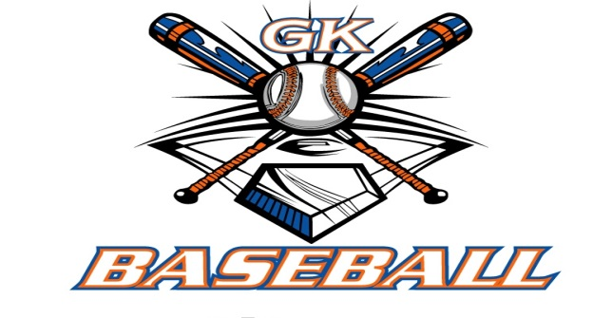
G-K BASEBALL MEETING NOTES
May 10, 2017
Call to Order
8:16 PM @ Genoa Veterans Home

Member Attendance Guest Attendance
- Ed Frye Roger Butler
- Larry Creadon
- Scott Franson
- Chad Pacey
- Steve Younker
- Steve Kleba
- Matt Krueger
- Chris Welch
- Jerry Kline
- Matt Ides

Approval of previous month minutes: April Meeting
Motion by: Larry C.
2nd : Steve K.
Yes 9 No 0 Abstain Passed X

Treasurers Report (Closed Session)
Reg. Opening Bal: $ 50,750.79 Concession Bal: $ 7,898.48
Income: $ Income: $
Expenses: $ Expenses: $
Notes: Ending $ Ending $ TOTAL $
Treasurers Report
Motion by: Jerry K.
2nd: Chris W.
Yes 9 No 0 Abstain Approved X

G-K BASEBALL Committee Reports

Old Business
- NONE

New Business
- 2017 GK Youth Baseball Senior Scholarship recipient is Zach Butler
  - Chad Pacey presenting at HS this eve (May 10)
- Review Opening Day Ceremonies
  - Picture Day WILL be separate date in future
  - Too much hassle for same day
- E-mail reminder to GES North teams; Home team responsible for banner placement, concessions,
and garbage removal; GES South teams need reminder to only use 2 far east rows for
parking at ACE
  - Chad Pacey will send message
- Should we have trophies for 1st and 2nd place Instructional Teams? Quickly decided “No”
- Blue Badger Update-
  - 10U: 4 teams; 11U: 5 teams; 12U: Full; 13 U: Full; 14U, 5 teams
  - Working on schedules this weekend
  - Decided no second place trophies
  - Roger was asked if he could move concession trailer from middle school to HS and he
responded to the affirmative
  - T-Shirts- Ed to communicate schedule

Field Report
- GES South- needs “gully” between 2nd and 3rd bases filled
  - Steve to get regrade completed this weekend
- GES shed evacuation date
  - Plan for Memorial Day weekend
  - Ed to contact Joe Ratliff on schedule
- Kingston East- need material moved away from home plate- too high in that area
- Kiernan- Still need to complete dugout work and install backstop screen
  - Dugout work includes some sort of opening cover for foul ball safety, concrete floor, and
cover, if desired

Equipment Report
N/A

Sponsorship Report /Fundraising Report
N/A

Generals Report
N/A

Picture Report
N/A

Concessions Report
N/A

Spirit Wear Report
N/A

Website Report
N/A

OPEN FLOOR ITEMS (See Notes)
- Ed Frye: More issues with Pony team; parental complaints of how practices are run, safety, language, etc. Ed still collecting data and sides of stories.
- Larry Creadon: consider ordering 3,000 fund-raiser tickets next year; ran very low this year; would be 500 more than this year
- Scott Franson: Have we heard anything of fall ball in Belvidere for this year? Response was that we don’t have any detail yet, but that BYB is wanting to revive that program.
- Jerry Kline: start thinking about officers for next cycle.
- Chad Pacey: GK Girls Softball kicked our butts on calendar ticket sales AND collection; need nails for temporary rubbers at GES, and peg cleaners (Steve Y. to take care of); would like to consider purchasing some new instructional bats.
- Steve Kleba: Minors moving to Belvidere has been good so far.
- Chris Welch
- Matt Ides
- Matt Krueger
- Steve Younker
- Roger Butler: extended sincere thanks for GK Baseball’s generosity towards Zach with scholarship.
NOTES:
.
Motion to adjourn:
Motion by: Steve Y.
2nd: Steve K.
Yes No Abstain Approved
@ 9:50 PM

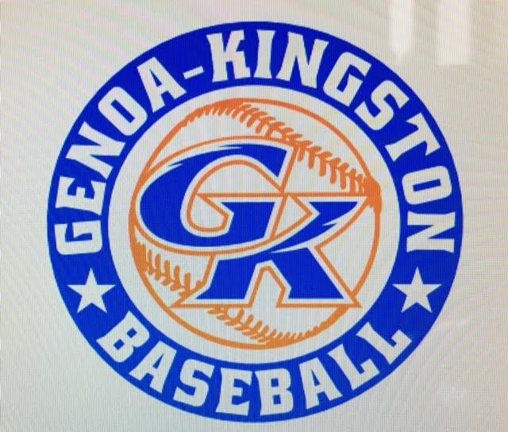

G-K BASEBALL MOTIONS

Motion to:
Motion by:
2nd :
Yea Nay Abstain Approved
************************************************************************************************************************************
Motion to:
Motion by:
2nd :
Yea Nay Abstain Approved
************************************************************************************************************************************
Motion to
Motion by:
2nd :
Yea Nay Abstain Approved
************************************************************************************************************************************
Motion to approve
Motion by:
2nd :
Yea Nay Abstain Approved

G-K BASEBALL NEXT MONTH AGENDA ITEMS/ISSUE LIST FOR JUNE 14, 2017
The following items/issues will be part of following month meeting:
Item #1
Item #2
Item #3
Item #4
Item #5

ROLL CALL MOTION VOTE NOTES ON ITEMS MORE THAN $1,000: N/A
ROLL CALL VOTE (See Notes)
- Larry Creadon Yes No Abstain
- Jerry Kline Yes No Abstain
- Dan Awe Yes No Abstain
- Scott Franson Yes No Abstain
- Chris Welch Yes No Abstain
- Steve Kleba Yes No Abstain
- Matt Ides Yes No Abstain
- Chad Pacey Yes No Abstain
- Steve Younker yes No Abstain
- Dave Grimm yes No Abstain
- Matt Krueger yes No Abstain
- Chad Peterson Yes No Abstain
- Ed Frye Yes No Abstain (TIE BREAKER CAST VOTE ONLY)

ROLL CALL VOTE TOTAL
Yes No Abstain Motion Approved Motion Failed
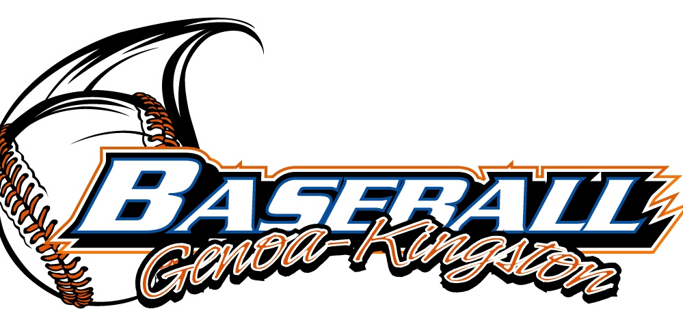

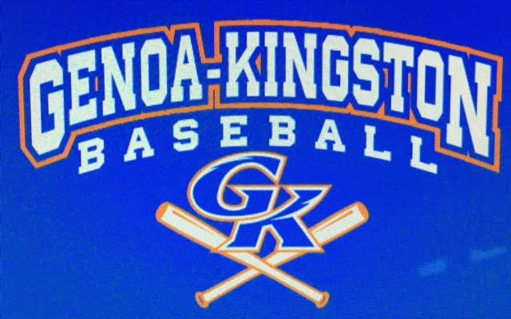

MISC.

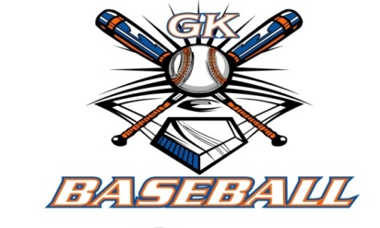
2016-2017 Attendance Attended Not Attended
- Ed Frye
- Larry Creadon
- Dan Awe
- Scott Franson
- Jerry Kline
- Chris Welch
- Matt Ides
- Chad Pacey
- Steve Kleba
- Matt Krueger
- Dave Grimm
- Steve Younker
- Chad Peterson

