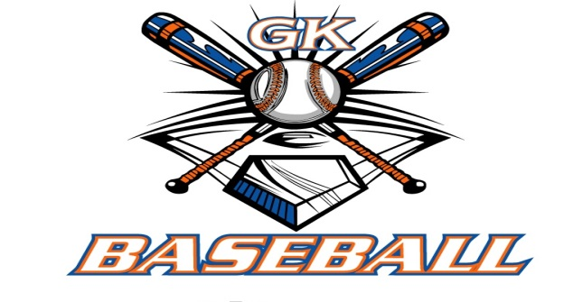
G-K BASEBALL MEETING NOTES
February 8, 2017
Call to Order
8:14 PM @ Genoa Veterans Home

Member Attendance Guest Attendance
- Ed Frye Roger Butler
- Larry Creadon
- Scott Franson
- Chad Pacey
- Steve Younker
- Steve Kleba
- Matt Krueger
- Chad Peterson
- Chris Welch
- Dan Awe
- Jerry Kline
- Matt Ides

Approval of previous month minutes: November Meeting
Motion by: Jerry K.
2nd : Chris W.
Yes 11 No 0 Abstain Passed X

Treasurers Report (Closed Session)
Reg. Opening Bal: $ 29,408.77 Concession Bal: $ 10,251.86
Income: $ Income: $
Expenses: $ Expenses: $
Notes: Ending $ Ending $ TOTAL $
Treasurers Report
Motion by: Jerry K.
2nd: Dan A.
Yes 11 No 0 Abstain Approved X

G-K BASEBALL Committee Reports

Old Business
- Kane County Cougars Coach Clinic- Well attended again; Steve Y. has video if anyone interested.

New Business
- Registration update: As of Sunday 2/5, Instructional: 42 (+1), Minor: 12 (+1), Bronco: 12 (+2),
Pony: 8 (+1)
- HS Baseball Camp: attendance was average of 25-30 boys in both groups past two weeks
  - Not bad for all JR Cogs Basketball levels being in Dells for tournament
- Wakoh Wear Spirit Wear Update: Order deadline 4/15; Orders completed by opening day
- In-House Coaches Selections
  - Instructional division is in good shape
  - Minor has none assigned yet
  - Bronco division: Eric Rich
  - Pony: Ed Lechelt & Robbie Montgomery
- Draft Day: March 8, 6:30 PM, VFW
- Kirkland & Belvidere Leagues Rebuilding Developments
  - Kirkland sending all their age divisions to Belvidere
  - Propose with only 1 or 2 minor teams that send that division to Belvidere’s program
    - Steve Y. moved to send Minor division to Belvidere, Jerry K. seconded motion
- GK Girls Softball
  - Ed approached by Oscar Garza regarding struggles that Softball is having
  - May not be able to fund next year
  - Asking questions about how we manage program
  - Wondered about possibility of combining programs
  - Group agreed to some level of sharing Calendar Fundraiser with Softball- Ed to follow up
with Oscar
- Blue Badger Update-
  - 10U: 3 teams; 12U: Full; 13 U: Full; 14U, 2 teams; 8U/9U just sent out

Field Report

Equipment Report
N/A

Sponsorship Report /Fundraising Report
N/A

Generals Report
N/A

Picture Report
N/A

Concessions Report
N/A

Spirit Wear Report
N/A

Website Report
N/A

OPEN FLOOR ITEMS (See Notes)
- Ed Frye: Sending formal letter out to Sponsors to invite them to come to opening day
- Larry Creadon
- Scott Franson: Spring trip to Jacksonville locked in
- Dan Awe: Generals teams need to get fees in
- Jerry Kline:
- Chad Pacey: has list of who played last year, but not signed up yet, Jerry said he’d send e-mails; coach meeting date set for 3/18 at noon
- Steve Kleba
- Chris Welch
- Matt Ides
- Matt Krueger
- Dave Grimm:
- Steve Younker
- Chad Peterson
- Roger Butler: sent HS kids from station to station for camps; lent some continuity to the groups of boys as to who was instructing; worked well
NOTES:
.
Motion to adjourn:
Motion by:
2nd:
Yes No Abstain Approved
@ 9:52 PM

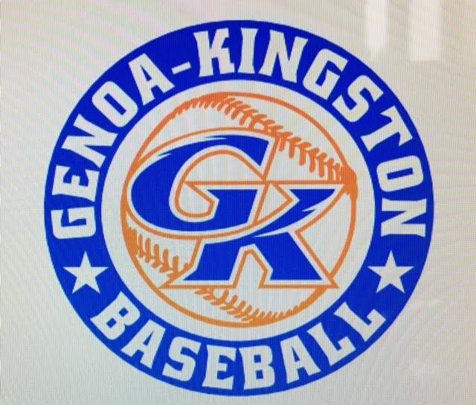

G-K BASEBALL MOTIONS

Motion to: Send Minor Division Team(s) to Belvidere League this year
Motion by: Steve Y.
2nd : Jerry K.
Yea 11 Nay 0 Abstain Approved
************************************************************************************************************************************
Motion to:
Motion by:
2nd :
Yea Nay Abstain Approved
************************************************************************************************************************************
Motion to
Motion by:
2nd :
Yea Nay Abstain Approved
************************************************************************************************************************************
Motion to approve
Motion by:
2nd :
Yea Nay Abstain Approved

G-K BASEBALL NEXT MONTH AGENDA ITEMS/ISSUE LIST FOR MARCH 8, 2017
The following items/issues will be part of following month meeting:
Item #1
Item #2
Item #3
Item #4
Item #5

ROLL CALL MOTION VOTE NOTES ON ITEMS MORE THAN $1,000: N/A
ROLL CALL VOTE (See Notes)
- Larry Creadon Yes No Abstain
- Jerry Kline Yes No Abstain
- Dan Awe Yes No Abstain
- Scott Franson Yes No Abstain
- Chris Welch Yes No Abstain
- Steve Kleba Yes No Abstain
- Matt Ides Yes No Abstain
- Chad Pacey Yes No Abstain
- Steve Younker yes No Abstain
- Dave Grimm yes No Abstain
- Matt Krueger yes No Abstain
- Chad Peterson Yes No Abstain
- Ed Frye Yes No Abstain (TIE BREAKER CAST VOTE ONLY)

ROLL CALL VOTE TOTAL
Yes No Abstain Motion Approved Motion Failed
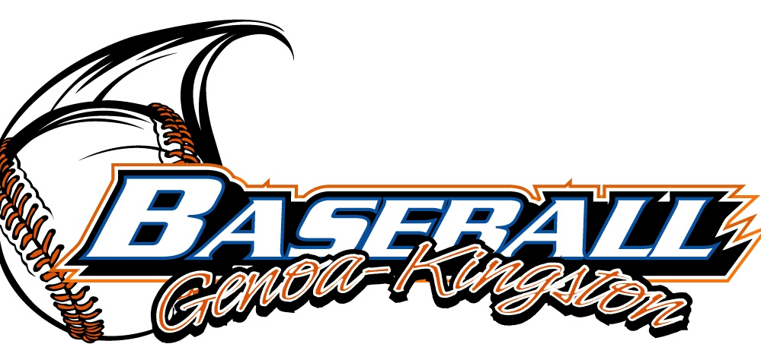

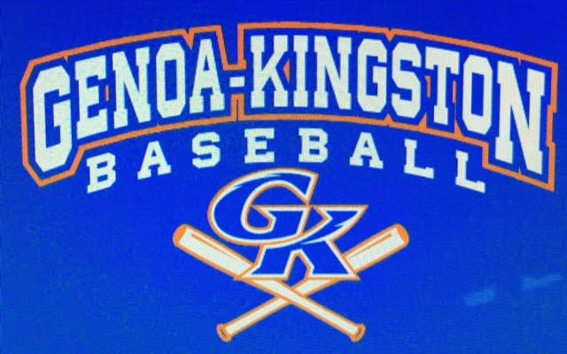

MISC.

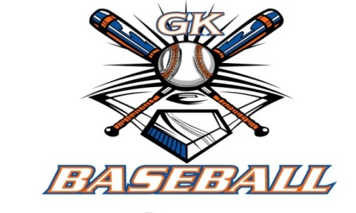
2016-2017 Attendance Attended Not Attended
- Ed Frye
- Larry Creadon
- Dan Awe
- Scott Franson
- Jerry Kline
- Chris Welch
- Matt Ides
- Chad Pacey
- Steve Kleba
- Matt Krueger
- Dave Grimm
- Steve Younker
- Chad Peterson

