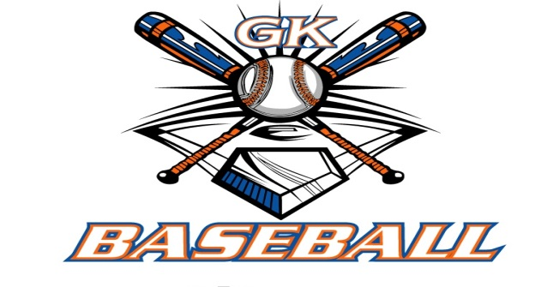
G-K BASEBALL MEETING NOTES
December 14, 2016
Call to Order
8:10 PM @ Genoa Veterans Home

Member Attendance Guest Attendance
- Ed Frye
- Larry Creadon
- Scott Franson
- Jerry Kline
- Chad Pacey
- Steve Younker
- Dave Grimm
- Steve Kleba
- Matt Krueger

Approval of previous month minutes: November Meeting
Motion by: Steve Y.
2nd : Seve K.
Yes 8 No 0 Abstain Passed X

Treasurers Report (Closed Session)
Reg. Opening Bal: $ 20,372.58 Concession Bal: $ 10,250.99
Income: $ Income: $
Expenses: $ Expenses: $
Notes: Ending $ Ending $ TOTAL $
Treasurers Report
Motion by: Dave
2nd: Steve K.
Yes 8 No 0 Abstain Approved X

G-K BASEBALL Committee Reports

Old Business

New Business
- GK Baseball Senior Scholarship available Jan 2nd in GKHS Athletic Office
  - Agreed to leave @ $500 w/ option to increase or split among qualified candidates
- Raffle Calendars
  - Larry meeting the guy this Friday; should have proof within week; should have printed by
January 11 meeting
- Registration an Camp Flyers to schools after Christmas Break
  - Registrations: 1/14, 9:00 – 12:00; 1/18, 6:00 – 9:00; Camps: 1/22, 1/29, 2/12, 2/19
  - Deliver flyers to school Tuesday after Christmas break
- Spirit Wear
  - Consider having some printed stuff to have on table by first registration
- FREE Kane County Cougar Coaches Clinic – Saturday 1/28, 9:00 – 11:30
- Blue Badger Update-
  - Umpire Fees: $400 13 U and down, $425 14U
  - Propose have only 1 Umpire/game on Saturday
- Debit / Credit Card w/ Resource Bank
  - Matt authorized to purchase Square card reader for use with registration fees

Field Report

Equipment Report
N/A

Sponsorship Report /Fundraising Report
N/A

Generals Report
N/A

Picture Report
N/A

Concessions Report
N/A

Spirit Wear Report
N/A

Website Report
N/A

OPEN FLOOR ITEMS (See Notes)
- Ed Frye: Belvidere President resigned; new president threw out some new stuff; possibly weeknight league for travel/tourney teams; wants to restart fall leagues.
- Larry Creadon
- Scott Franson
- Dan Awe:
- Jerry Kline: Cage time set for Generals teams; in-house teams will have Saturdays from 9:00 – 1:30
- Chad Pacey: Does rules committee need to meet? This is around the time they normally would.
  - Propose eliminating evaluations and performing them at the camps.
- Steve Kleba: request sponsorship information from Matt K.
- Chris Welch
- Matt Ides
- Matt Krueger
- Dave Grimm:
- Steve Younker:
- Chad Peterson
NOTES:
.
Motion to adjourn:
Motion by: Steve Y.
2nd: Dave G.
Yes 8 No 0 Abstain Approved
@ 9:33 PM

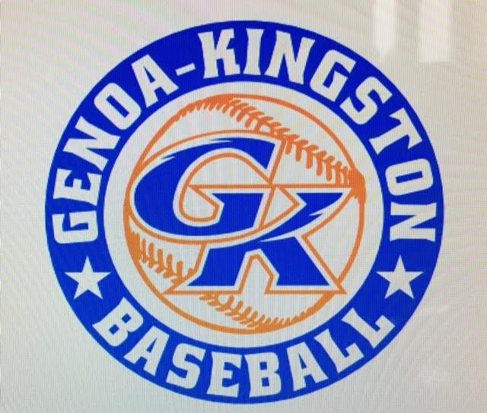

G-K BASEBALL MOTIONS

Motion to: approve Blue Badger Bash umpire fees @ $400 for 13-U and down, $425 for 14-U
Motion by: Steve Y.
2nd : Jerry K.
Yea 8 Nay 0 Abstain Approved
************************************************************************************************************************************
Motion to: propose using only one umpire at Saturday games for Blue Badger Bash
Motion by: Jerry K.
2nd : Dave G.
Yea 8 Nay 0 Abstain Approved
************************************************************************************************************************************
Motion to
Motion by:
2nd :
Yea Nay Abstain Approved
************************************************************************************************************************************
Motion to approve
Motion by:
2nd :
Yea Nay Abstain Approved

G-K BASEBALL NEXT MONTH AGENDA ITEMS/ISSUE LIST FOR JANUARY 11, 2017
The following items/issues will be part of following month meeting:
Item #1
Item #2
Item #3
Item #4
Item #5

ROLL CALL MOTION VOTE NOTES ON ITEMS MORE THAN $1,000: N/A
ROLL CALL VOTE (See Notes)
- Larry Creadon Yes No Abstain
- Jerry Kline Yes No Abstain
- Dan Awe Yes No Abstain
- Scott Franson Yes No Abstain
- Chris Welch Yes No Abstain
- Steve Kleba Yes No Abstain
- Matt Ides Yes No Abstain
- Chad Pacey Yes No Abstain
- Steve Younker yes No Abstain
- Dave Grimm yes No Abstain
- Matt Kreuger yes No Abstain
- Chad Peterson Yes No Abstain
- Ed Frye Yes No Abstain (TIE BREAKER CAST VOTE ONLY)

ROLL CALL VOTE TOTAL
Yes No Abstain Motion Approved Motion Failed
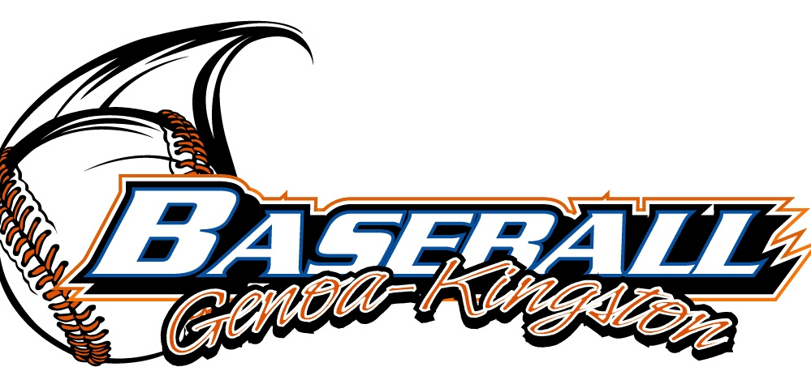

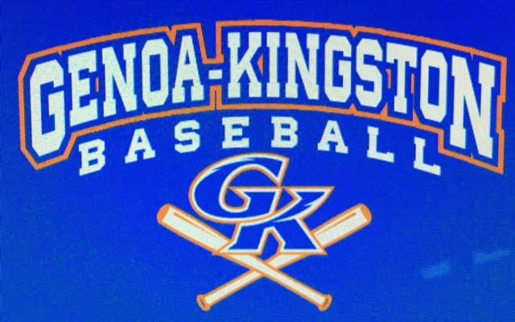

MISC.

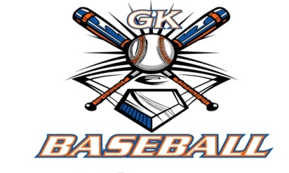
2016-2017 Attendance Attended Not Attended
- Ed Frye
- Larry Creadon
- Dan Awe
- Scott Franson
- Jerry Kline
- Chris Welch
- Matt Ides
- Chad Pacey
- Steve Kleba
- Matt Krueger
- Dave Grimm
- Steve Younker
- Chad Peterson

