****8th ANNUAL TOMMY DELL NOVICE TOURNAMENT****

A tourney to celebrate Tommy Dell and the lives he touched!!

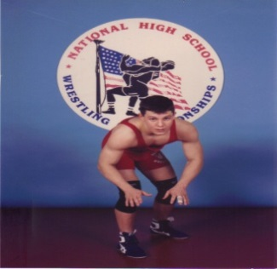

Date/Location: 14 January 2018; Manchester Valley HS, 3300 Maple Grove Road, Manchester, MD 21102.

*This tourney is for 1st & 2nd year novice wrestlers, and is limited to the first 275 entries.*
Weigh-ins: 7:30-8:30 am. Wrestling begins at 10:00 am.

WEIGHT CLASSES

Bantam (7 years old and under): 40, 45, 50, 55, 60, 65, 70, 80, UNL
Midget (8 and 9 years old): 55, 60, 65, 70, 75, 80, 85, 90, 95, 100, UNL
Junior (10 and 11 years old): 65, 70, 75, 80, 85, 90, 95, 100, 107, 115, 122, 130, UNL
Intermediate (12 and 13 years old): 75, 80, 85, 90, 95, 100, 107, 115, 122, 130, 140, 150, UNL

Format: Six man brackets, seeded at random, with full wrestle-backs. We reserve the right to group weight classes. All matches will be 3, one-minute periods, with one-minute OT, followed by 30 second tie breakers.

Awards: Trophies will be awarded to all six places!

Pre-Registration Fee: $20.00/wrestler if registered prior to 9 Jan 2018; mail bottom-half of this form and a check made payable to “North Carroll Recreation Council” to: Doug Dell, 975 Sullivan Road, Westminster, MD 21157 to pre-register.

Fee for Walk-ins on Day of Tourney: $25/wrestler.

INFORMATION: Jason Myers: 410-913-9563: jkmyers01@yahoo.com
Andy Kiler: 443-244-0276: apkiler@yahoo.com

There will be refreshments on sale throughout the day. Due to school regulations, there will be no smoking on the property, and no food or coolers will be allowed in the gymnasium. We ask that coaches and parents be responsible for their wrestlers at all times.
--------------------------------------------------------------------------------------------------------------------------------------------
WRESTLER’s NAME________________________________ TEAM Name: ______________________

GROUP: 7 & UNDER 8&9 10&11 12&13 WEIGHT CLASS ________ ACTUAL WEIGHT_______

DATE OF BIRTH: _____________________ PHONE NUMBER: _________________________

We, the parents of assume full responsibility for our child in case of an emergency or injuries he/she may incur during the wrestling tournament, held by the North Carroll Recreation Council at North Carroll High School, or while traveling to or from the place of the event. We also certify that the entrant is a first or second year (novice) wrestler.

PARENT'S SIGNATURE DATE _______________________

