Dear Business Owner,

BE PART OF THE WEST MIFFLIN TITAN HIGH SCHOOL BASEBALL EXCITEMENT!
Become a 2017 Sponsor and share in the pride of supporting of our prestigious baseball program!
Titan Baseball has made many strides in creating a strong, successful high school baseball program. The 2016 was another exciting season. Titan Baseball is well-represented in the baseball programs of colleges and universities in the surrounding area as many of our alumni have received scholarships for academic and athletic achievement. Our success is attributed to the hard work and dedication put forth by both the players and coaches, along with our tradition of the team traveling south to participate in a strenuous week of Spring Training as they prepare themselves for the season.

This yearly trip has exhausted many of the player's individual accounts, which leaves minimal funds to support regular playing season expenses. The players themselves actively participate in multiple fundraisers to help raise money for the team.

Along with our Community involvement and the need to offset funds, we now offer a SPONSORSHIP PROGRAM that highlights our valued Community Supporters. Our team prominently displays a LARGE Sponsor Banner at our home baseball field which has become the talk of the other High Schools in the WPIAL. Our baseball complex regularly hosts WPIAL Baseball and Softball games with the banner being displayed. You also have an option to list your business on our popular Titan Baseball website which to date has posted over 49,500 visits! We are respectfully asking that you consider being a part of our support team by electing one of the Sponsorship levels listed on the back of this letter that is comfortable for you. The banner will be going to print by end of February, so we are asking that all responses are received by February 20th.
On behalf of the West Mifflin Titan High School Baseball Team, thank you in advance for your generosity and support.
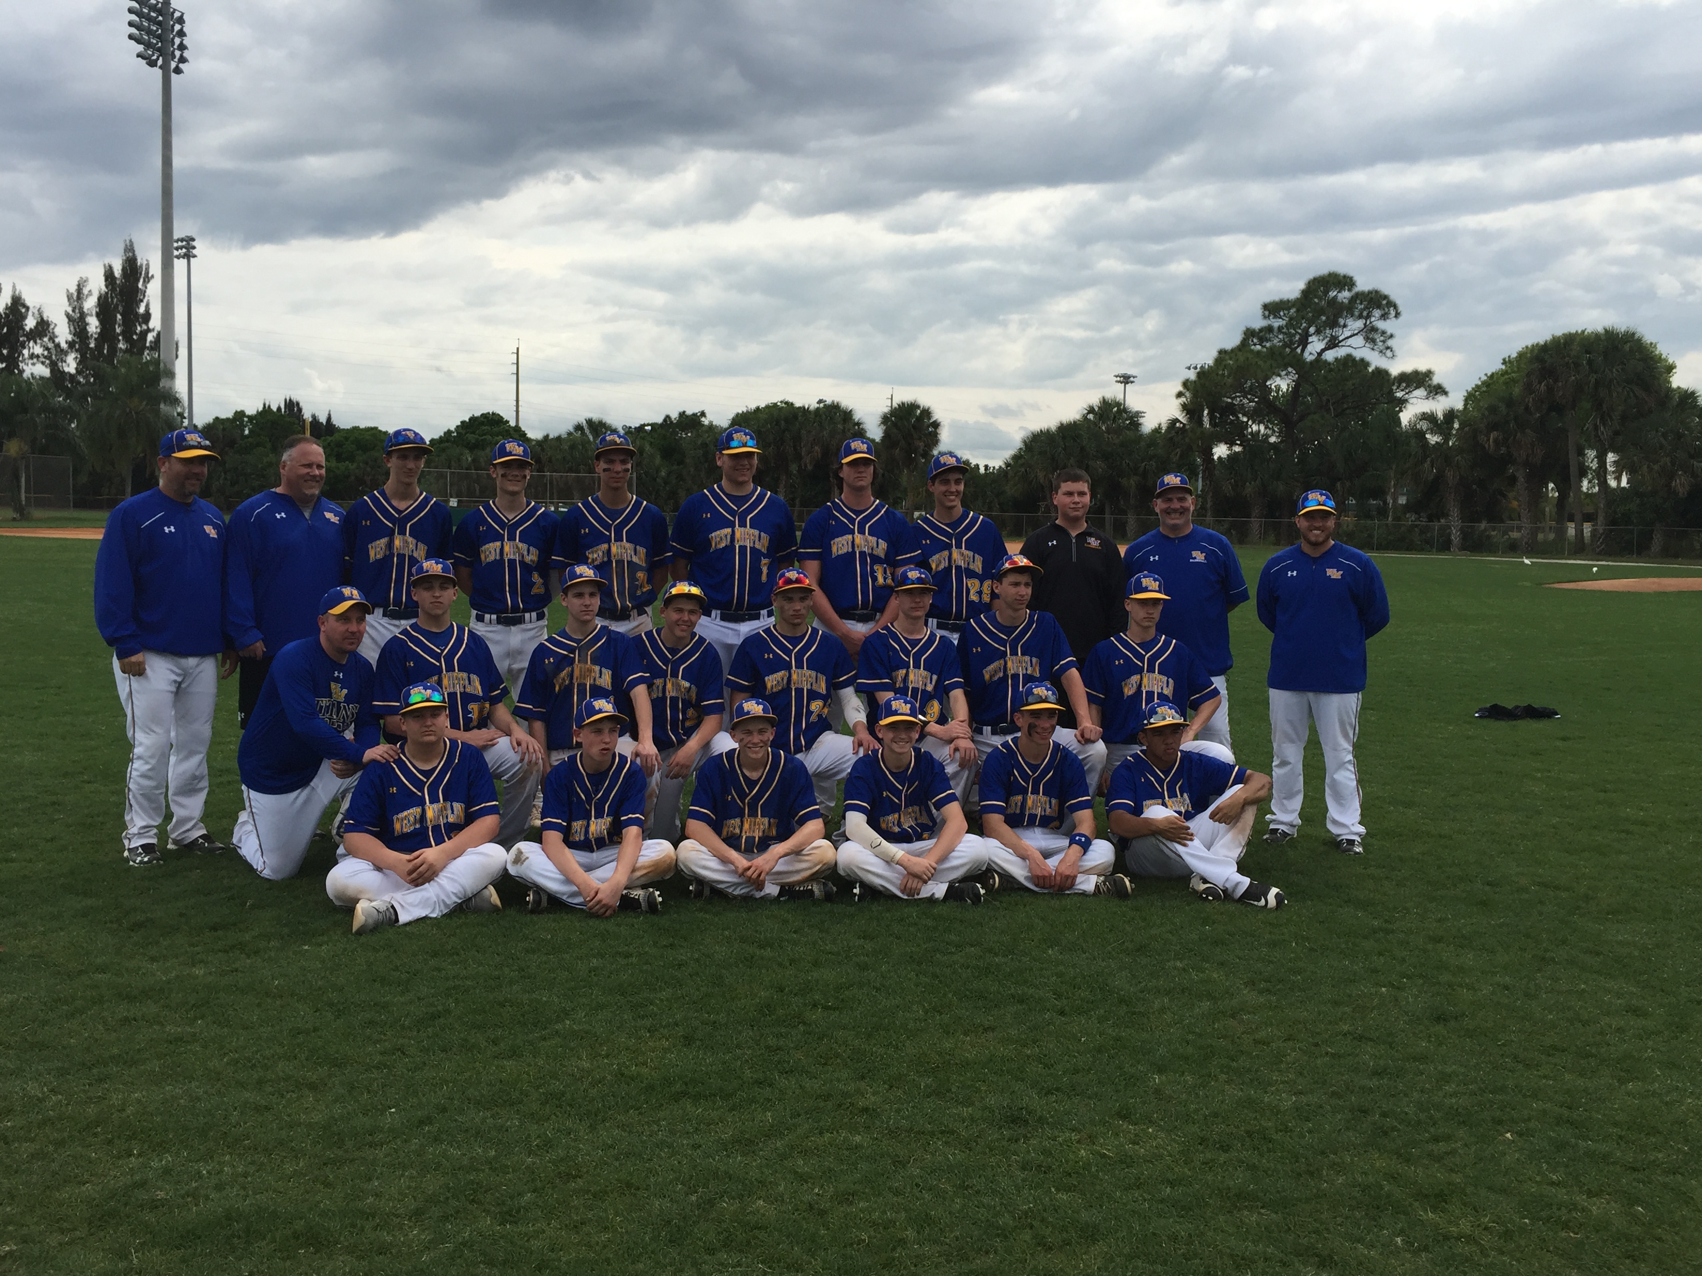
With deepest appreciation,

The West Mifflin Titan
Baseball Organization

p.s. Be sure to check out the Sponsor Section of
our Titan Baseball website at:
www.leaguelineup.com/wmtitanbaseball.
West Mifflin High School Varsity Baseball 2016
Any questions can be directed to Danelle White at
(412)805-8192

.
SPONSORSHIP LEVELS

GRAND SLAM
($250+ donation)
Letter of Acknowledgement
Name on Sponsorship Banner
Name listed on our Website
Website Link to your Business
Team Photo
Sponsorship Plaque to proudly display Team Photo



DOUBLE
($100 donation)
Letter of Acknowledgement
Name on Sponsorship Banner
Name listed on our Website

PLEASE RETURN THIS COMPLETED PAGE WITH YOUR DONATION TO:
WALK
(under $50 donation)
Letter of Acknowledgement
SINGLE
($50 donation)
Letter of Acknowledgement
Name listed on Sponsorship Banner
TRIPLE
($150 donation)
Letter of Acknowledgement
Name on Sponsorship Banner
Name listed on our Website
Website Link to your Business
HOMERUN
($200 donation)
Letter of Acknowledgement
Name on Sponsorship Banner
Name listed on our Website
Website link to your Business
Team Photo

Mail to: West Mifflin Titan Baseball
c/o Danelle White
218 Bluemont Drive
West Mifflin, PA 15122

Checks Payable to: West Mifflin Titan Baseball
Questions: (412) 805-8192

We would appreciate any contributions being received by February 1st, 2016
(Although we will also accept donations after that date)
Banner will be printed at end of February.

Name or Company:
Address:
Phone:

Contact Person:

Email:

Sponsorship Level (circle one):

Walk Single Double Triple Homerun Grand Slam
< $50 $50 $100 $150 $200 $250+

Donation Amount: Check No:

Fill in name EXACTLY as you would like it to appear on Banner / Website:

Your Business Website Address (applicable with donations of $150 or more):

