- Basic layup drill (with left and right hand) - For the standard lay up drill, simply form two lines on each side of the basket about 20 feet back. One line rebounds, the other drives in with the ball and shoots. The rebounder passes to the next person in the shooting line and goes to the end of the shooting line. The shooter goes to the end of the rebounding line. After a few minutes, stop the drill and put the ball on the other side for left hand lay ups. Left hand lay ups will be nearly impossible for youngsters who have not tried them. But this is a critical skill to learn. It will take time and is a must by middle school. Be sure to show your players the correct form -- they should jump off the left leg when shooting a right hand layup. And shoot off their right leg when shooting a left hand layup. It will be difficult but work on it. They should also dribble with their left hand when shooting left hand lay ups.
- Follow Your Shot Drill. A coach throws a pass to a player a few feet inside the foul line, and the players are to catch the ball and shoot it without putting it on the floor. The reason for this is that if the kids are in this close and open, there is no need to put the ball on the floor. The kids then are encouraged to follow their shots twice, so that they learn the importance of staying at it and fighting for a rebound.
- Cone or Chair Dribbling - Simply set up some cones or chairs about 10 feet apart. Instruct your players to weave in and out of the cones, changing directions each time they reach a cone. They can start with a basic cross over, switching hands when they reach each cone. Then you can progress to spin moves and behind the back. This is a really simple yet fun drill that helps young players improve their dribbling skills.
- The "Protect the Basketball" Drill. This is a great drill. We have two kids dribbling the ball while, at the same time, trying to take the ball away from one another. This drill compels the kids to angle in toward the defender and dribble the ball slightly behind them, near their hips.
- Basic partner passing - Have your players partner up, each group should have a ball. Have the children pass the ball back and forth, starting with chest passes, progressing to bounce and over head passes. Make sure they are making accurate passes and using proper form. As a variation, you can have them run up and down the court passing back and forth.
- Triple threat drills - Simply form two lines around the 3 point arc. One line is for passing line and the other is for catching, pivoting, and driving to the basket. Once the receiver catches the pass, they should pivot with their knees bent facing the basket. Require them to pause in a triple threat position. They should be ready to pass, shoot, or drive. Knees should be bent and feet square to the basket. Once you say go, they should drive to the basket.

- Basic defensive slides - This is the first defensive concept our players should learn. They are a variety of sliding drills you can use but for beginning use the zig zag drill.
  - Focus on proper form (wide base, butt down, knees bent, arms extended to the side, etc).

- Rebounding – 2 on 2 (See below).
- Offensive and defensive player on each side of the lane. |  | 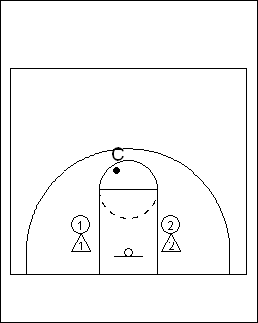

- The coach throws up the ball, defense blocks out, offense goes after the rebound. |  | 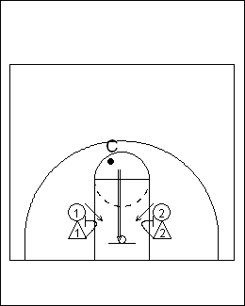

- If the offense gets rebound, they try to score. If the defense rebounds, they pass the ball out to the coach.

