**2018 GHYLA PLAYOFFS & ALL-STARS**

**Dates:**

Weekends of April 21 & 22, 2018 and April 28 & 29, 2018 (Playoffs – Rd. 1/Quarters/Semis(7U only))

Weekend of Saturday & Sunday, May 5 & 6, 2018 (Playoffs – Semis/Championships & All-Star Game)

**Location:**

Camp Sienna Fields, 7725 Camp Sienna Trail, Missouri City, TX 77459

**GHYLA Dues, 2018:**

Non-Playoff Teams:        $85, per team

Playoff Teams:                  $165, per team

**Registration & Payment via** [**GHYLA.Org**](http://GHYLA.Org)**, Due April 6, 2018:**

[**www.GHYLA.org**](http://secure-web.cisco.com/1138IUD3vkBkQT2yUQy9zS29FL_OiwITp9CcMlgcVEpCpYgrBbp1SEqQfi9cqx4pn4HkwnEg2UxItobgGiqzBWIzA6E7JVPeU4C6s7mLQikW8Ea45kKKfArPRRh-XP8NblyHxPuu49gwrSUhFqggX67R_ocKQPkhwi4ZQ0c7aebYH1esrXVVtk_ycu8tDMqEGUPZ0YFPMKHHINI0Bl7gGJTGgkzRcxrwiZhdx10WHAgbbJ2HZcAJzWQ6_Dha2vaIF/http%3A%2F%2Fwww.ghyla.org%2F)**(Registration Online link at top right of webpage)**

**This season, the GHYLA is not taking any checks or cash. Credit/Debit Cards & E-Bank Drafts are all available.

**GHYLA 2018 Playoff Dry Fit T-shirts & Ladies Tank Tops:**

**Purchase Link:** <http://assn.la/Reg/?r=2:174059>

**Purchase Deadline:** April 20, 2018

**Pickup:** May 5th & 6th at Camp Sienna Fields

**PREORDERS ONLY! NO PURCHASES DAY OF PLAYOFFS!**

**Design:**

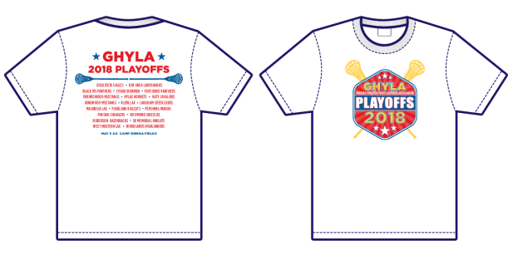

**Playoffs Structure:**

**Playoff Eligible Divisions 4U, 6U, 8U**

Step #1: Top 3 teams from each Playoff Eligible (PE) conference (North, Central, South), Teams 1 to 9

Step #2:          Top 9 teams are ranked based upon - same opponents, points for and points against to force rank teams from 1 to 9.

Step #3:               Remainder of teams from all PE conferences are compared - same opponents, points for and points against to determine Team 10.

Step #4: Weekend of April 21st & 22nd (and with all the rain, perhaps April 23rd & 24th) - Teams 7, 8, 9 & 10 play Playoffs Round 1 with each other for a spot in the Quarter-Finals

(higher ranking team hosts the game at home).

Team 7 vs. Team 10  Winner 7

                                             Team 8 vs. Team 9          Winner 8

Step #5:               Weekend of April 28th & 29th:  Teams 1 to 8 play in the Quarter-Finals (higher ranking team hosts the game at home).

                                                Team 1 vs. Winner 8    Winner 1

                                                Team 2 vs. Winner 7 Winner 2

                                                Team 3 vs. Team 6     Winner 3

                                                Team 4 vs. Team 5     Winner 4

Step #6:              PLAYOFFS - Saturday, May 5th:  Winners 1 to 4 play in the Semi-Finals and Championship Games at

Camp Sienna.

                     Field 9:

 9:30am 8U Semi-Finals (Winner 1 vs. Winner 4) Winner 1

11:00am 4U Semi-Finals (Winner 1 vs. Winner 4) Winner 1

12:30pm 6U Semi-Finals (Winner 1 vs. Winner 4) Winner 1

2:00pm 8U Championship Game (Winner 1 vs. Winner 2) Winner

3:30pm 4U Championship Game (Winner 1 vs. Winner 2) Winner

Field 10:

9:30am 8U Semi-Finals (Winner 2 vs. Winner 3) Winner 2

11:00am 4U Semi-Finals (Winner 2 vs. Winner 3) Winner 2

12:30pm 6U Semi-Finals (Winner 2 vs. Winner 3) Winner 2

2:00pm 7U Championship Game

3:30pm 6U Championship Game (Winner 1 vs. Winner 2) Winner

Step #7:               ALL-STARS (6U & 8U ONLY) – Sunday, May 6th:  All-Star Games at Camp Sienna.

All PE 8U teams will submit 2 players each and all PE 6U teams will submit 3 players each via email for the All-Star Roster by April 14, 2018 (more detailed instructions to be distributed separately).

Field 10:

1:00pm – 8U All Stars

Field 9:

2:30pm – 6U All Stars

**Playoff Eligible Division 7U**

Step #1:               The six PE 7U Teams are ranked 1 to 6.

Step #2:               Top 3 teams, are in the Semi-Finals.

Step #3:               Weekend of April 21st & 22nd (and with all the rain, perhaps April 23rd & 24th) - Teams 4 and 5 will play a Round 1 Playoff game for a spot in the Semi-Finals (higher ranking team hosts the game at home).

                                                Team 4 vs. Team 5           Winner 4

Step #4:               Weekend of April 28th & 29th:  Teams 1 to 4 play in the Semi-Finals (higher ranking team hosts the game at home).

                                                Team 1 vs. Winner 4       Winner 1

                                                Team 2 vs. Team 3           Winner 2

Step #5:              PLAYOFFS – Saturday, May 5th:  Winner 1 and Winner 2 play in Championship game at Camp Sienna

Field 10:

2:00pm 7U Championship Game (Winner 1 vs. Winner 2) Winner

Step #6:               ALL-STARS (7U ONLY) – Sunday, May 6th:  All-Star Game at Camp Sienna

Each PE 7U team is to submit 4 players per team, via email for the All-Star Roster by April 14, 2018 (more detailed instructions to be distributed separately)

Field 9:

1:00pm - 7U All Stars

**Current Standings:**

The current team standings document will be distributed on Wednesday evenings, starting Wednesday March 28, 2018, and every Wednesday thereafter.

The current team standing document will also be posted on [GHYLA.org](http://GHYLA.org).